Contents

Intune 1

Setup MDM Authority 1

Configure the Device Enrollment 1

Apply Wallpaper and Lock Screen 4

Apply the Company Logo and Microsoft-365 9

Enable Windows Hello 12

Account Lock Restrict 15

Integrate Intune with Microsoft Business Store Business 17

Configure the windows Update 21

Install the Apps 25

Create a Local user and add to the local administrator 30

Customize the company portal 34

Activate the Bit-locker 36

Device Enrollment Restriction 40

Setup Android Enrollment 41

Endpoint Manager, Android device Enrollment of Personally Owned Device with work profile 41

Communication Compliance 46

Information Governance 52

Information Protection 60

Data Loss Protection 68

Sensitive Info types 76

# Intune

Microsoft Intune is the cloud-based service which allows an organization or IT professional to manger different devices platform like: - Windows, Android, IOS. You can have control over these mention devices when you enroll these devices into Microsoft Endpoint manager or Intune. You can have control over the devices and application, likewise you can enforce the policy into device level and even the application level. For example, we can configure the policy and enforces it into and have control over the application that is installed. You can avoid the email send outside of the organization and so on. hence, we can say that we can regulate the policy and have a control over each and every aspect of the devices and application that are enrolled or installed via Endpoint manager.

The documentation is going to step by step process of elaborating the Lab assign by our senior.

## Setup MDM Authority

1. GO to <https://endpoint.microsoft.com/>
2. Provide Login credential **UserName** and **Password.**
3. Under Mobile Device Management Authority choose your MDM authority.
4. Click the Intune MDM Authority. You can see the radio button screenshot below.

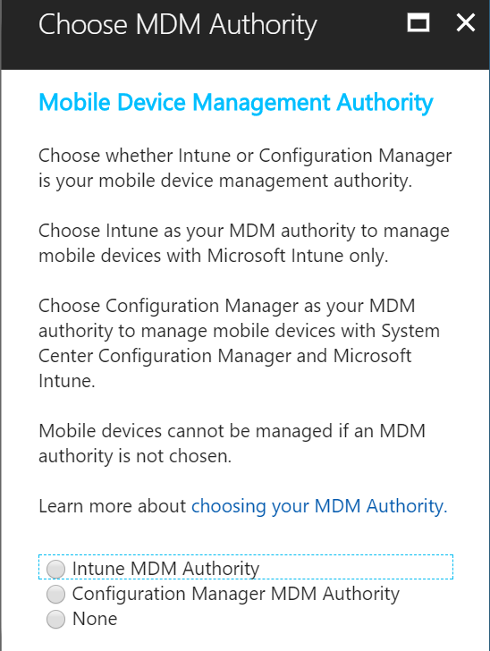

## Configure the Device Enrollment

1. Got to <https://endpoint.microsoft.com/>
2. Provide Login credential **UserName** and **Password.**
3. Endpoint manager admin center home page will appear.

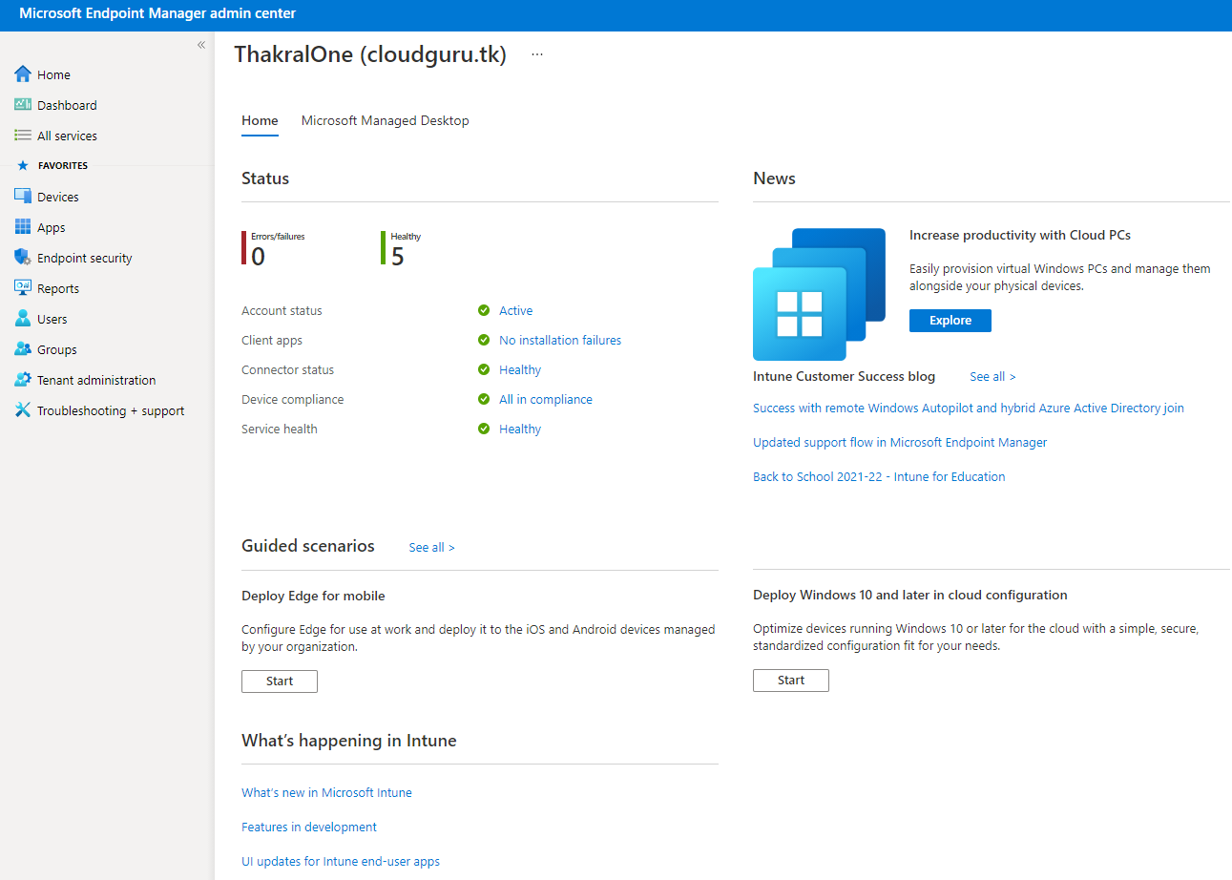

1. Click on Device Blade

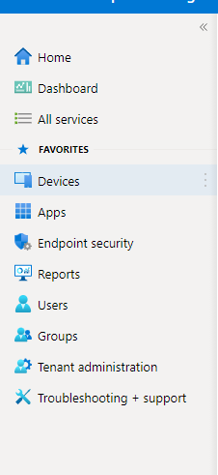

1. Device blade will navigate you to the Device overview page. 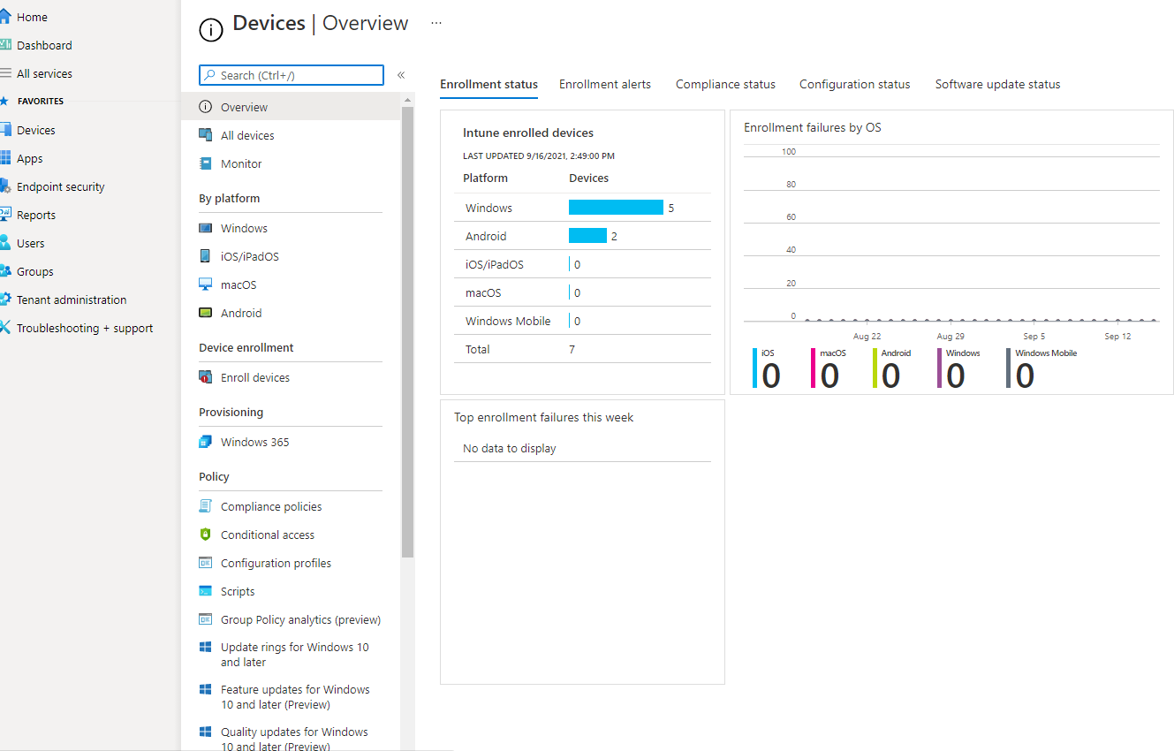
2. Click on Enroll Device > Automatic Enrollemt.

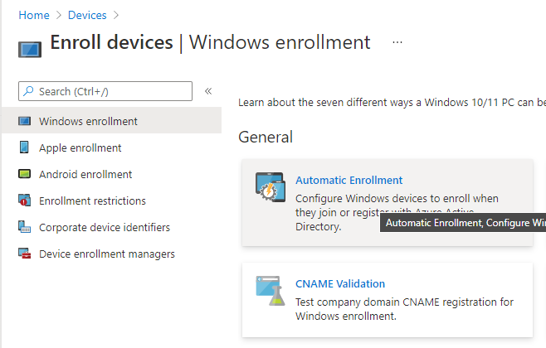

1. Finally, you can see Configure Device enrollment page.
2. You can see the MDM User scope and MAM User Scope.
3. You can toggle the switch to > **ALL** or you can follow along with the screenshot below.

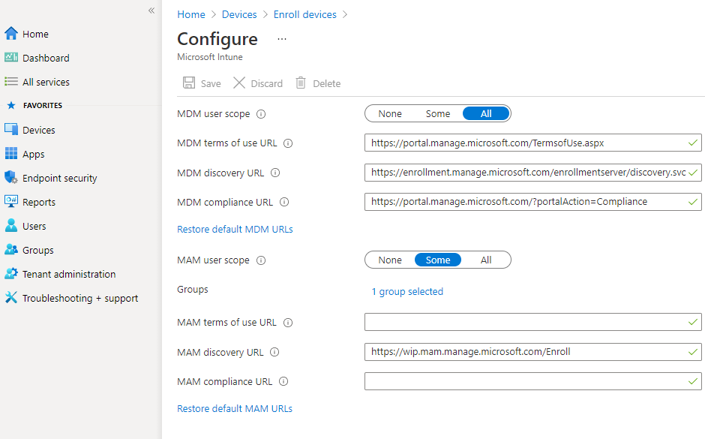

# Apply Wallpaper and Lock Screen

1. Go to <https://endpoint.microsoft.com/>
2. Provide **UserName and Password.**
3. Login screen will Navigate you to **Endpoint Manager Admin center**.
4. Click on **Device** blade

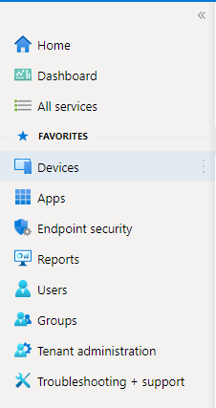

1. After clicking on **Device** blade will navigate you to **Device Overview** page.

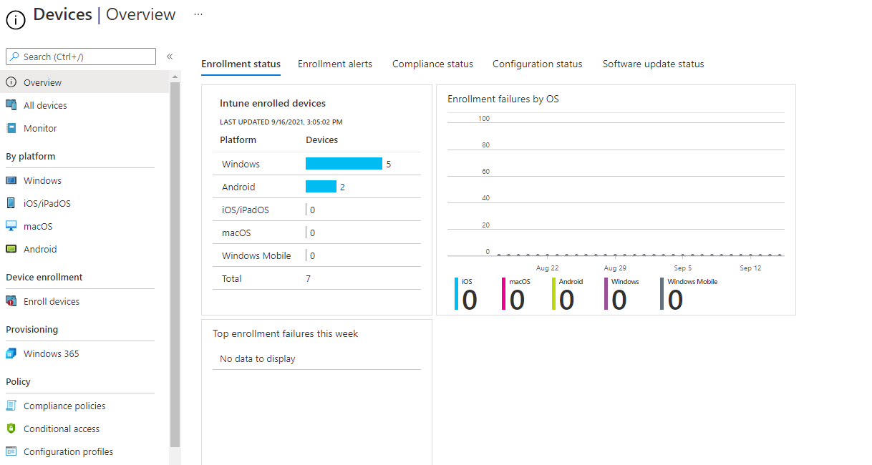

1. On **Device overview** page you can see **Configuration Profiles** on right side of the screen click on it.
2. After Clicking on **Configuration Profiles**. You can see configuration profile section where you can create policy as screenshot below.

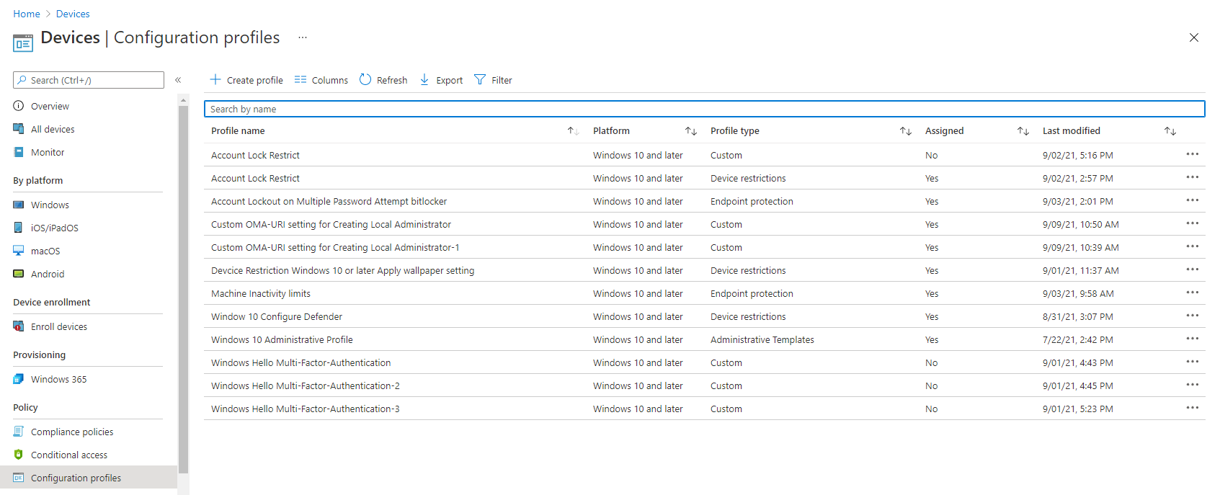

1. Click on ** Create Profiles** on top right corner of your screen.
2. After clicking** Create Profiles** it will open **Create a Profile** sidebar for left side of the screen.
3. Select the **platform** and **Profiles types** according to your requirement as of now our requirement is to create wallpaper so we will create **Window 10 and later** as **Platform** and **Template** as **profiles types.**
4. After selecting the **Profiles types** as **Template.** list of Template Option will appear shown on screenshot below.

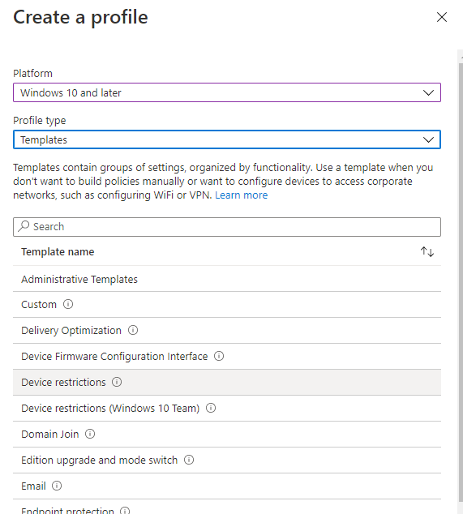

1. Click on **Device Restriction** mention above or follow along with screenshot.
2. Click on **Device Restriction** template will navigate you to **Basic section.** Provide the **Name** and **Description** and click on **Next**.

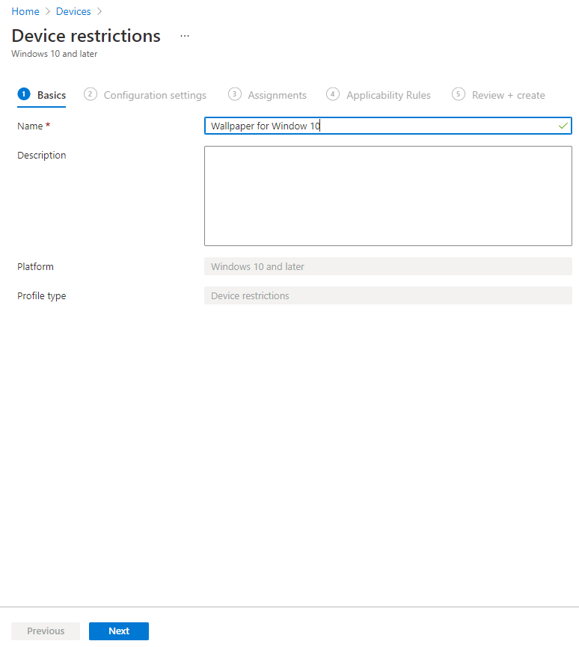

1. Clicking on Next button will Navigate you to **Configuration setting**, Again click on **Personalization** and you will see > **Desktop background picture URL** **textbox >** Paste the Image url into the textbox.

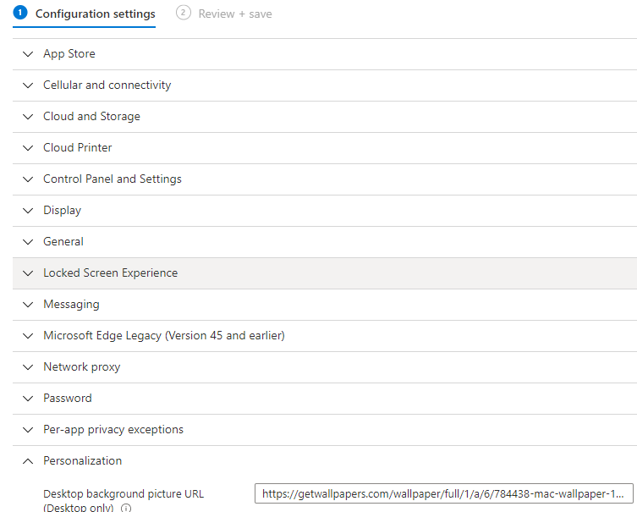

1. Likewise, you can also configure the Lock Screen Wallpaper on this section. Click on **Locked screen Experience >** paste the Desire wallpaper into the **Locked screen Picture Url textbox**
2. Click on next **Scope Tags** will appear again click on **Next** > **Assignment Section** > **Add groups**.

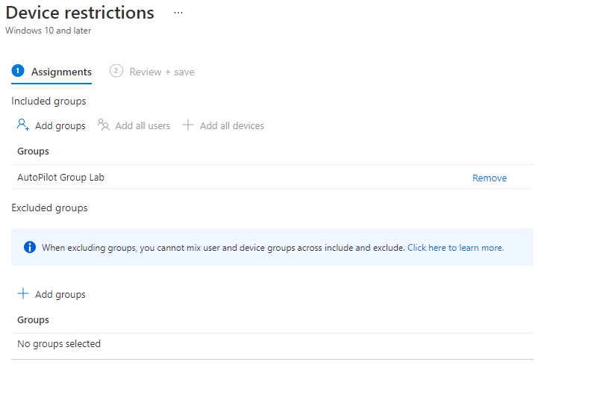

1. Click on **Add groups** > assign the Group you want to assign the policy and again click on **next** > click on save.
2. On the Client Machine you will see the Lock screen wallpaper and desktop wallpaper screenshot below.

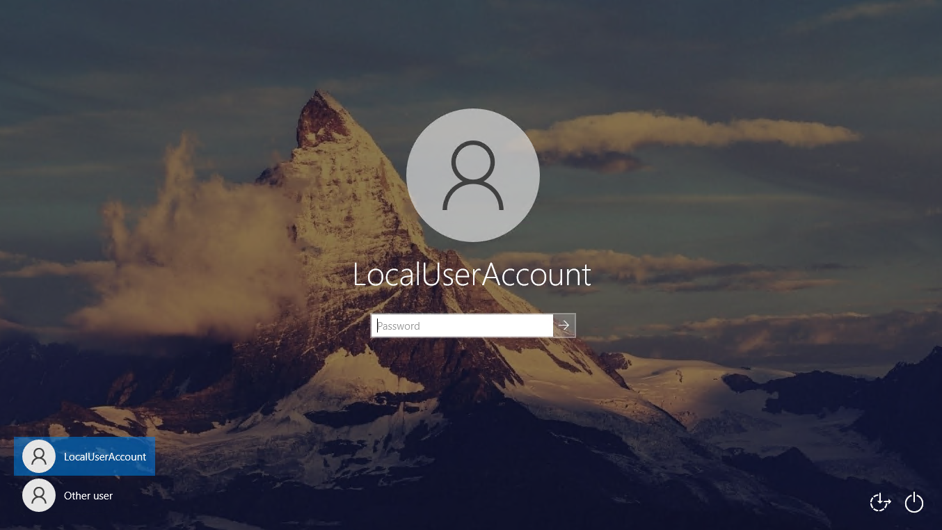



# Apply the Company Logo and Microsoft-365

1. Go to <https://Portal.azure.com>
2. Provide Login Credential.
3. Click on Azure Active Directory will navigate you to Company Overview Page.

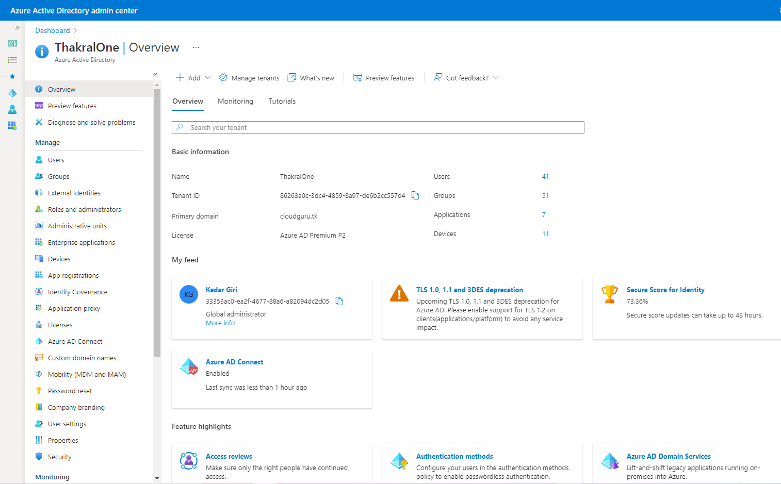

1. Under Manage section click on > **Company Branding** Blade.

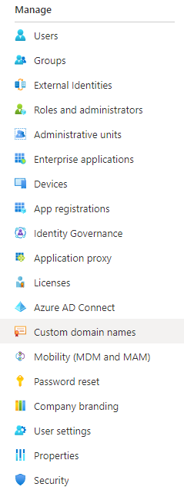

1. **Company Branding** will navigate you to **Company Branding page** > click on Default shown on screenshot below**.**

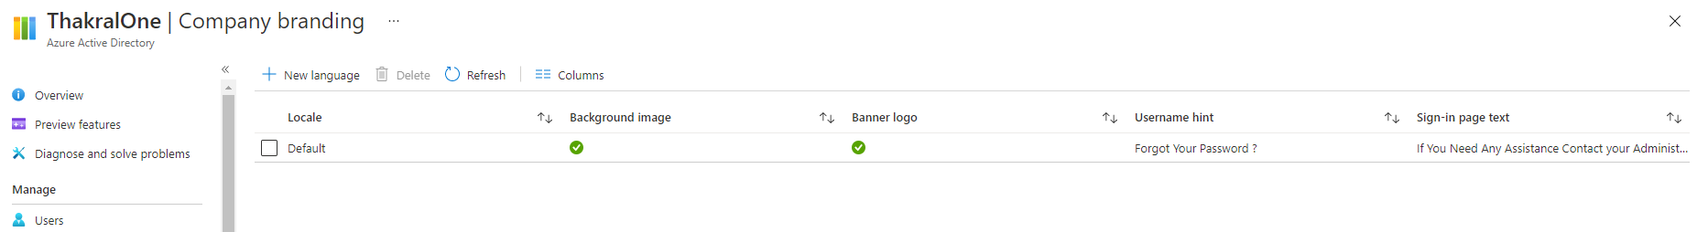

1. After clicking on **Default** will open Sidebar panel to Right side of you screen.

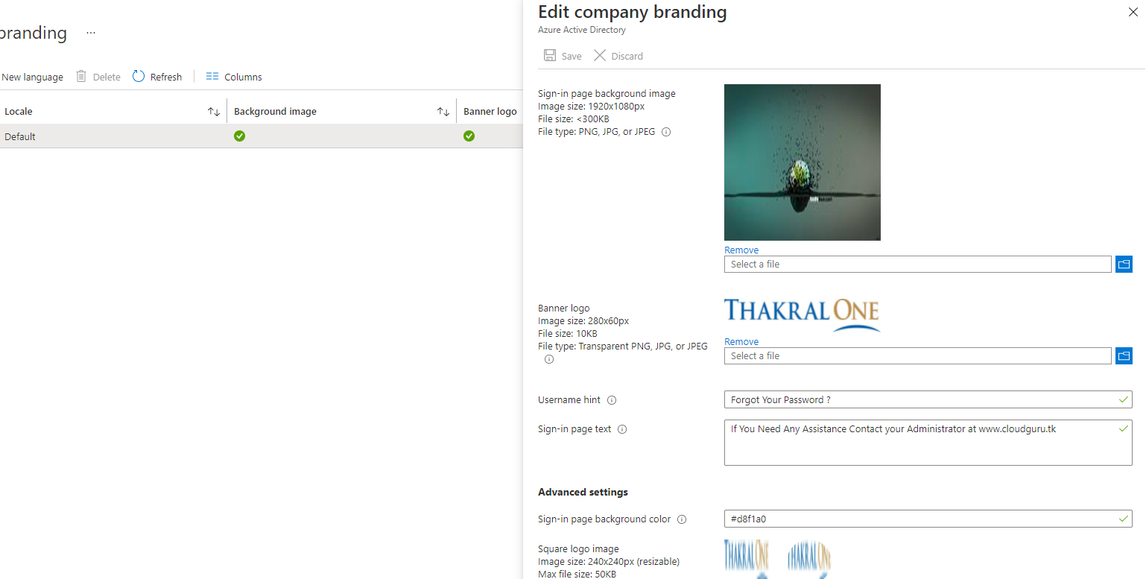

1. Upload the Background Image, Banner logo, Username hint etc. upload or fill the details according to you requirement and click on Save button will is place in TOP left corner of Sidebar panel.

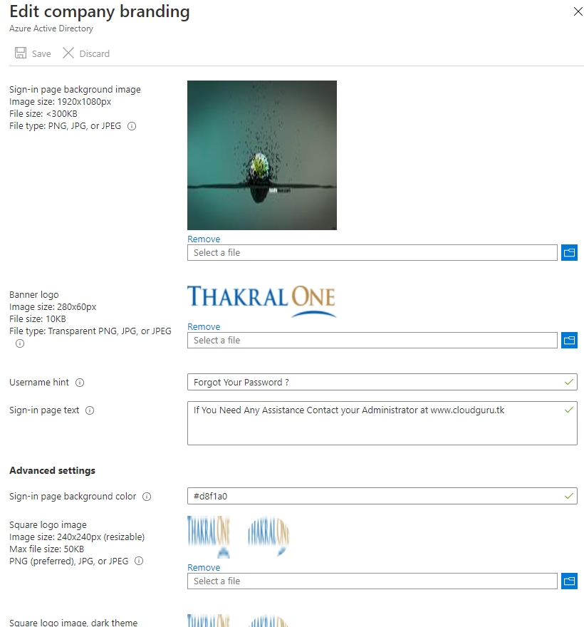

1. After Saving the Company branding Setting the end result should look like the screenshot below.

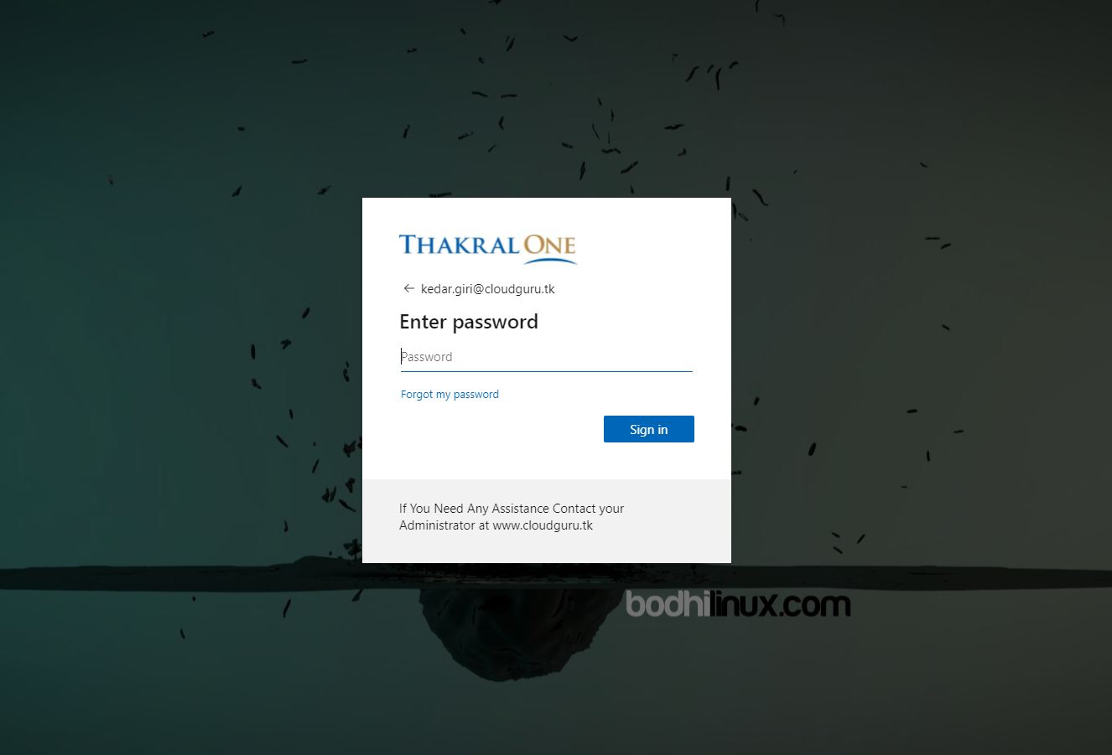

# Enable Windows Hello

1. Go to <https://Endpoint.Microsoft.com>
2. Provide Login Credential.

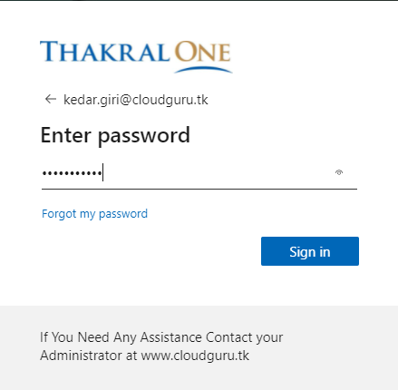

1. Successful login will navigate you to Endpoint manage admin center Dashboard.
2. Click on **Device Blade > Enroll Device**

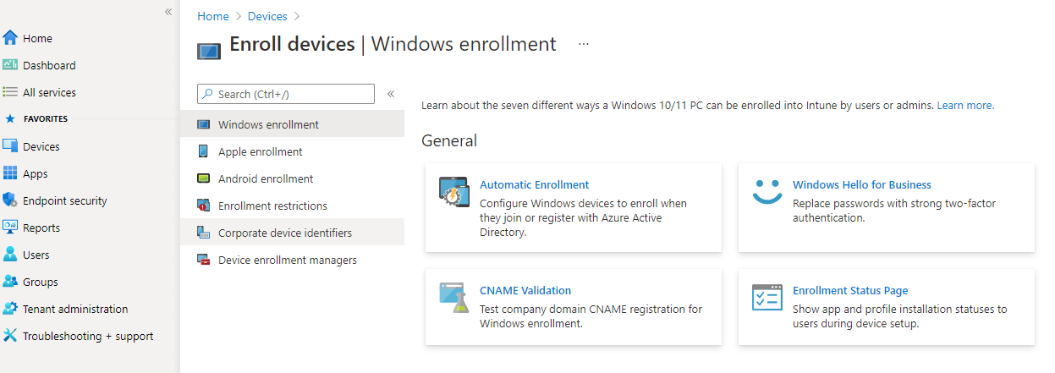

1. Click on **Windows Hello For Business** will open sidebar panel.
2. By default, windows hello is enable but you can configure if it is not.

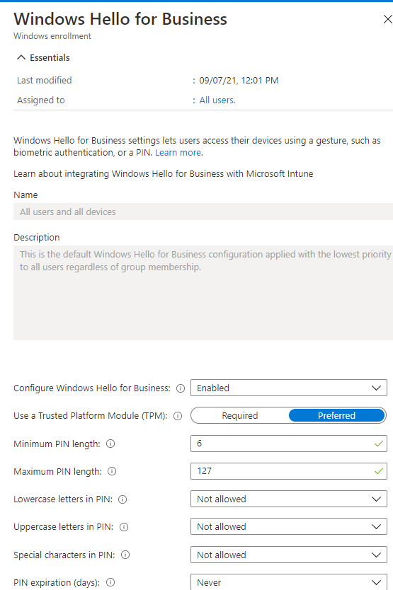

1. You can see Configure **windows Hello For Business** and Click on Dropdown and Set it to **enable**.
2. You can set **Minimum pin length, Maximum pin length** and different setting based on your requirement and click on **save** button.

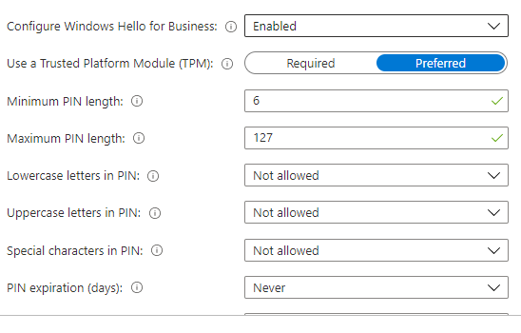

1. The Endpoint result after configuring windows hello for business is screenshot below.

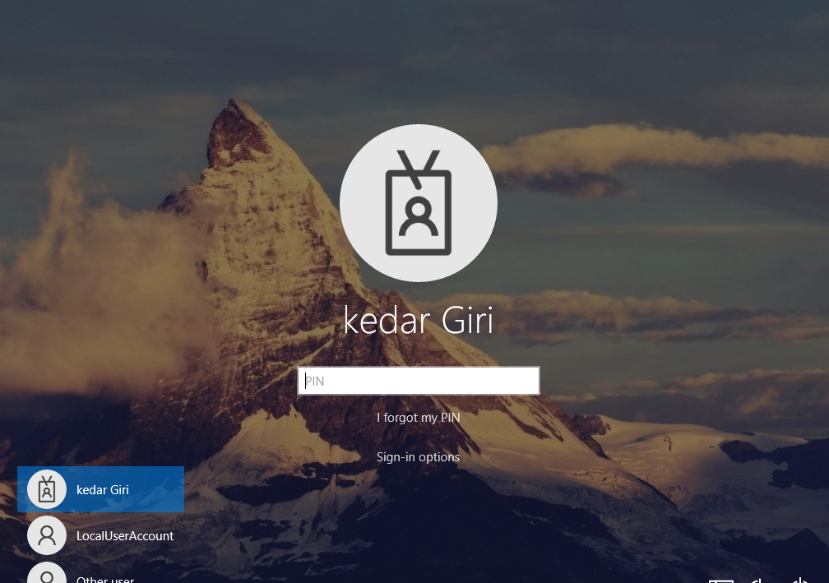

# Account Lock Restrict

1. Go to <https://Portal.microsoft.com>
2. Provide login Credential
3. Click on Azure Active Directory.
4. Click on **Security blade** which is under manage section > **Authentication Methods**

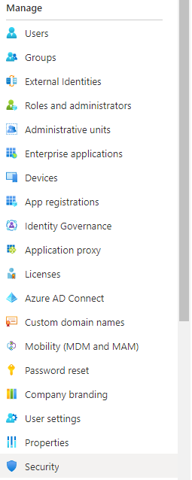

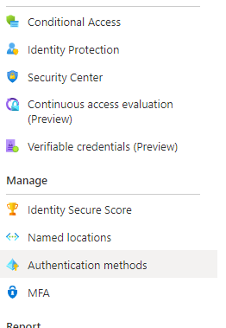

1. After clicking on **Authentication Methods >** click on **Password protection**

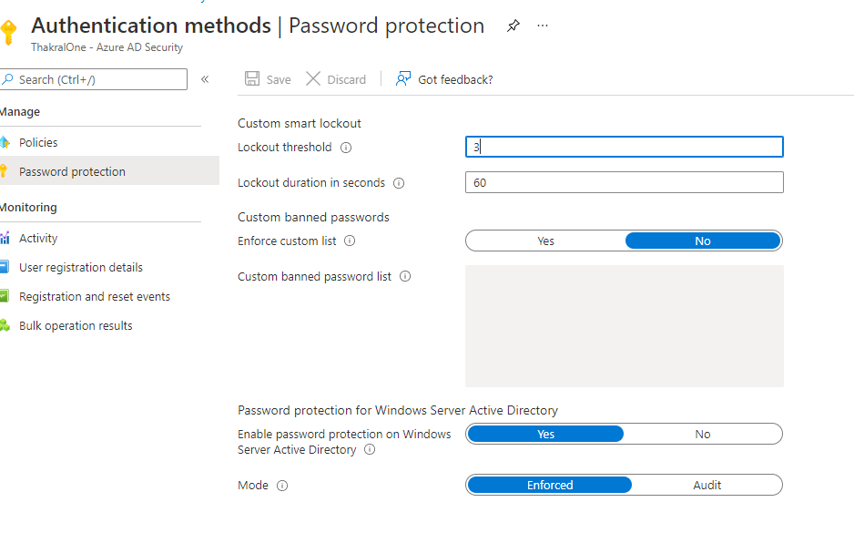

1. Set the Lockout threshold, Lockout duration if you want then you can set custom banned password as well shown in screenshot and click on Save button.
2. The policy should effect on client machine screenshot below.

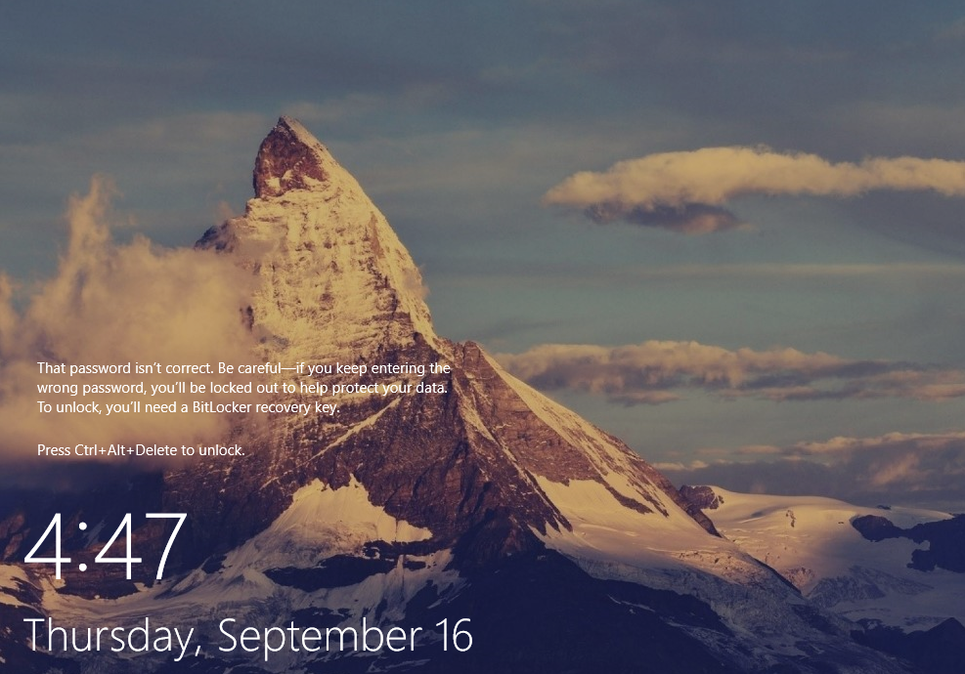

# Integrate Intune with Microsoft Business Store Business

1. Go to <https://Endpoint.microsoft.com>
2. Provide login credential.
3. After providing the Login credential will navigate you to **Endpoint manager Admin center.**
4. You can see on the right sidebar panel on right side on your screen click **Tenant Administration > Connectors and Tokens**

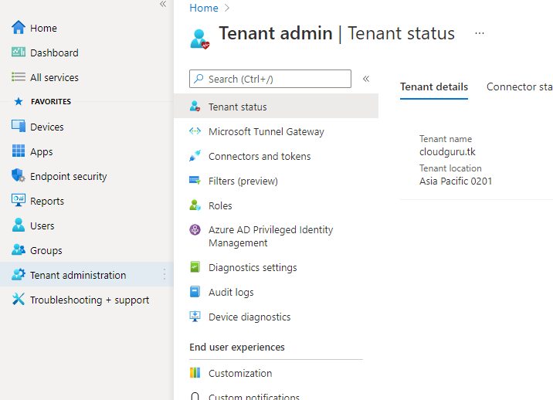

1. After clicking **Connectors and token** will leads you to Microsoft Store for Business page.

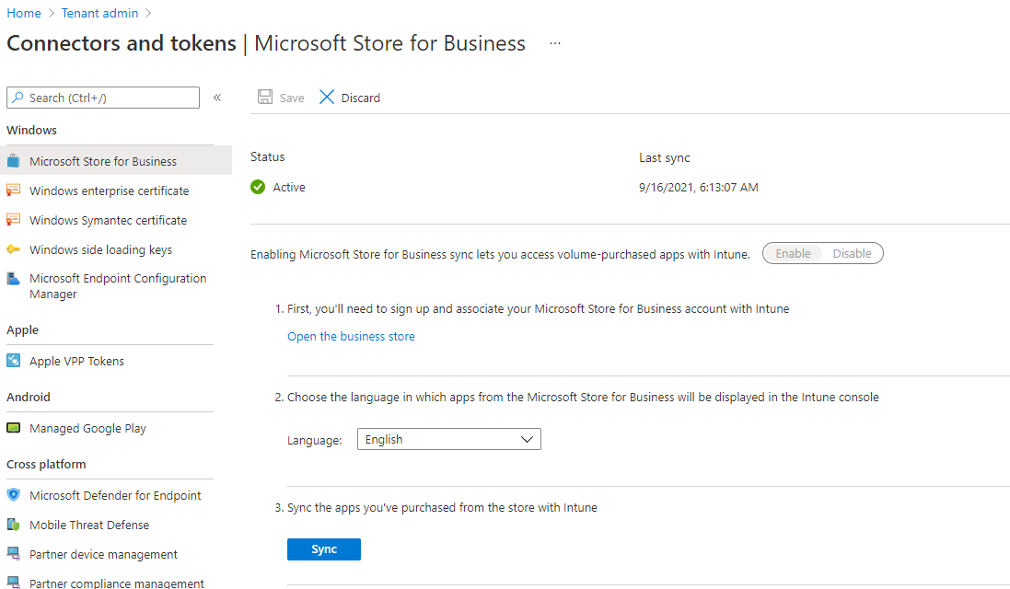

1. Click on **Open the Business store** link and login with the Credential to the Business store.

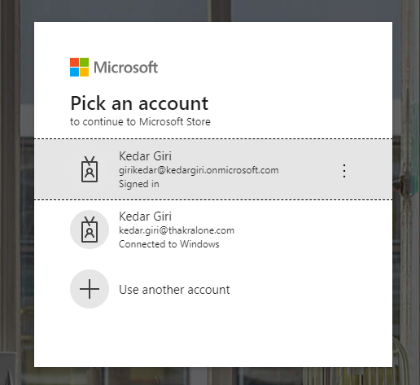

1. After successful login click on **Manage** on the navigation bar.

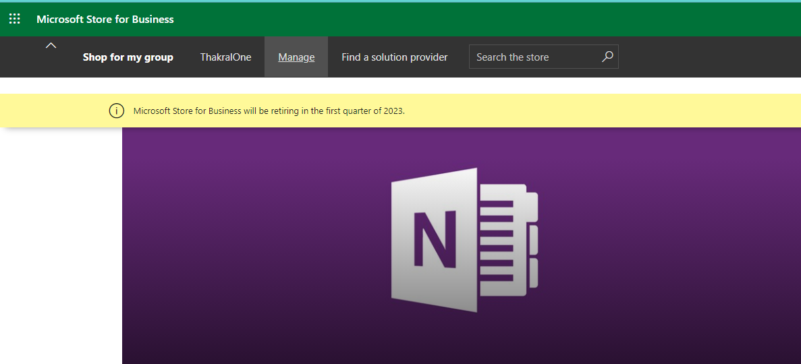

1. Clicking on **Manage** will navigate you to Dashboard **Home** Section.
2. Click **Setting** > and Click on **Distribute** navbar of dashboard.

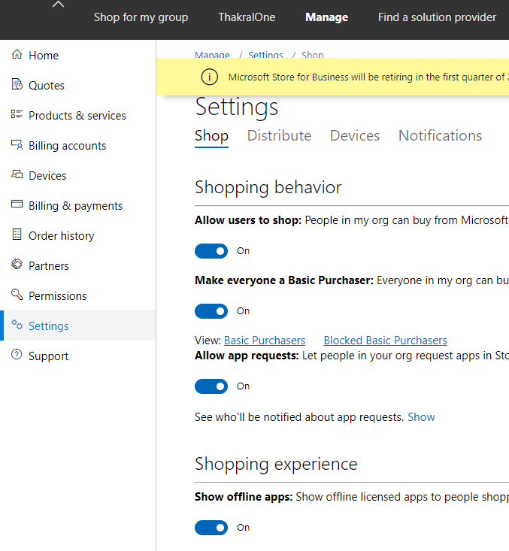

1. After you click on **Setting** > dashboard **Distribute** Navbar you will see the **Management tools** section.
2. Under **Management tools** section you will seen **Microsoft Intune** and **Microsoft Intune** Enrollment Click **Activate**

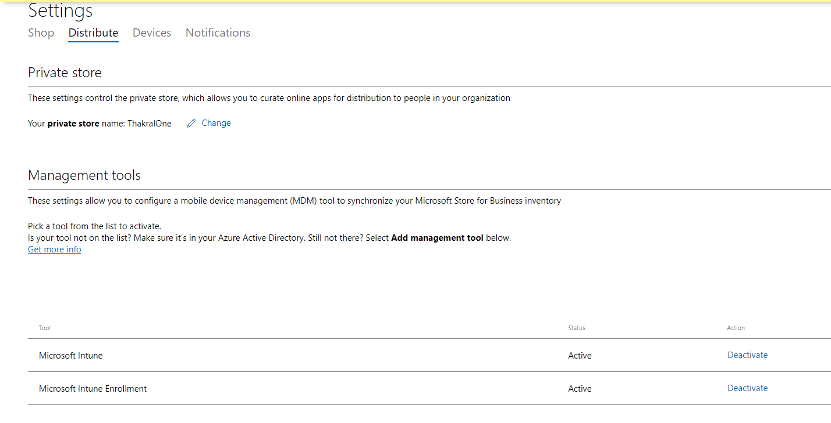

1. After clicking on activate > go back **to Connector and Tokens** > **Microsoft store for business page** and Click on **Enable** toggle bar to Activate the Microsoft Store for Business. As you can see that status is set to activate.

**e**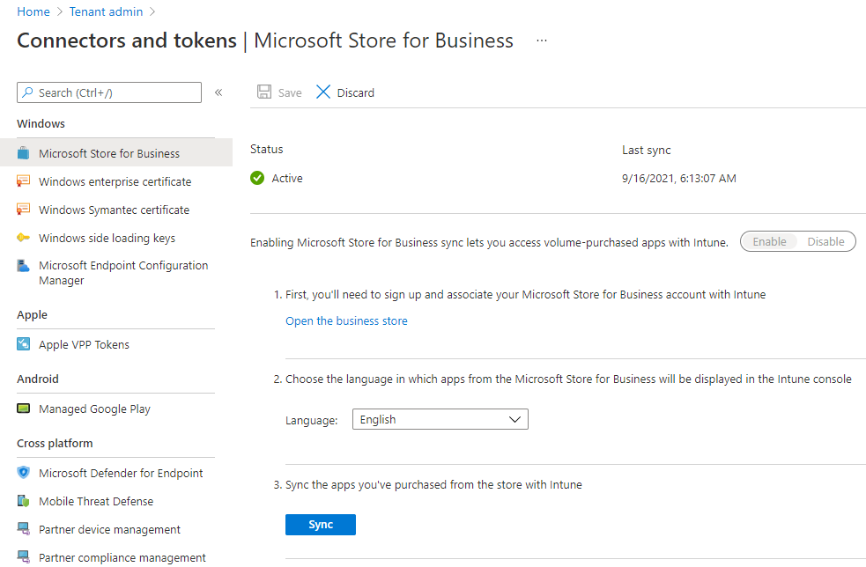

# Configure the windows Update

1. Go to <https://Endpoint.microsoft.com>
2. Provide **UserName** & **Password** to login.
3. Successful login will navigate you to **Endpoint manager admin center**.
4. Click on **Device** blade > Under Policy section click on **Update ring for windows 10 & later**

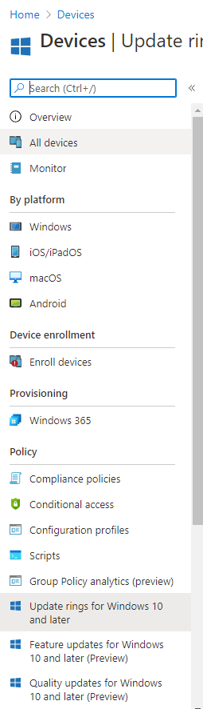

1. Clicking on **Update ring for windows 10 and Later** is where you can configure windows update policy.

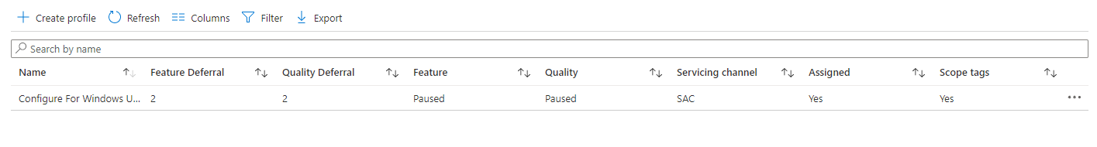

1. Click on **Create Profile** will leads you to Create update ring for windows 10 and later page
2. Provide Name and Description for the Policy you going to create and then click on next button.

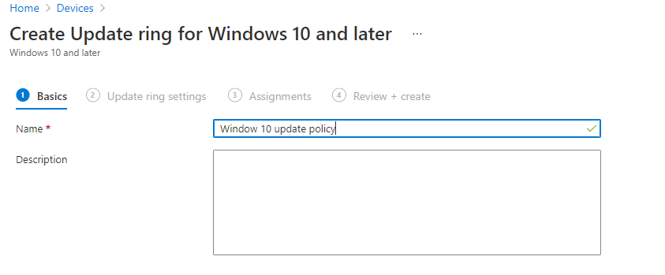

1. After clicking on Next button > update Ring setting will appear where all the crucial setting for update policy resides.

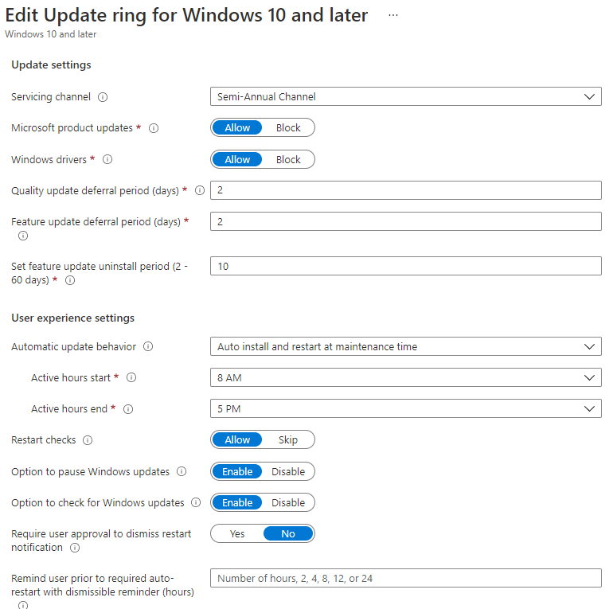

1. Select servicing channel for choosing different option like :- Semi-annual channel, semi-annual channel for targeted for 1809 and below, windows insider-fast etc. for now we are going to select Semi-annual channel.
2. Configure the setting according to your requirement or follow along with the screenshot mention below.

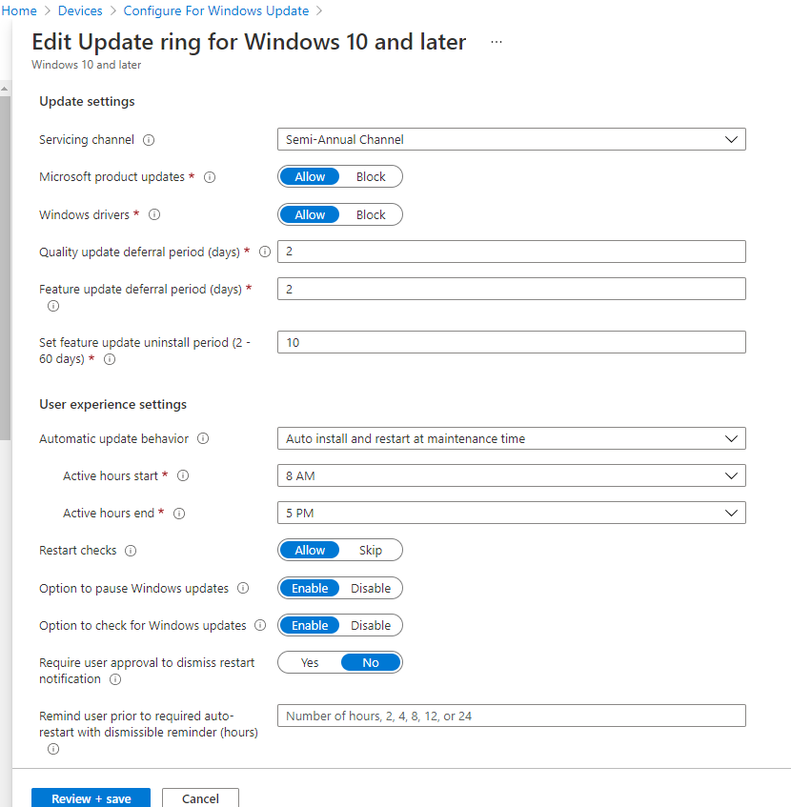

1. Click on next button > Assignment tab will appear.

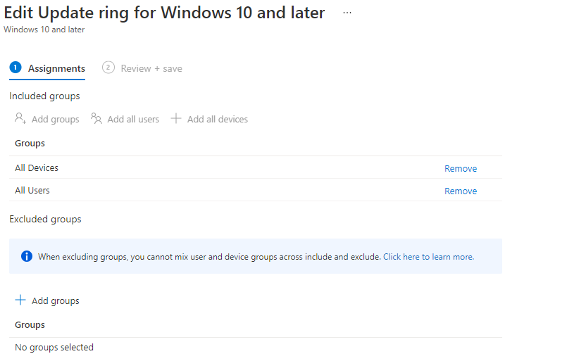

1. Click on **add group** and assign the policy to the endpoint and save the policy.
2. The finally the Endpoint result look like screenshot below.

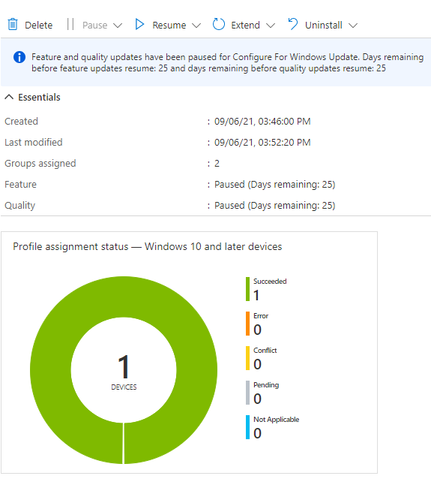

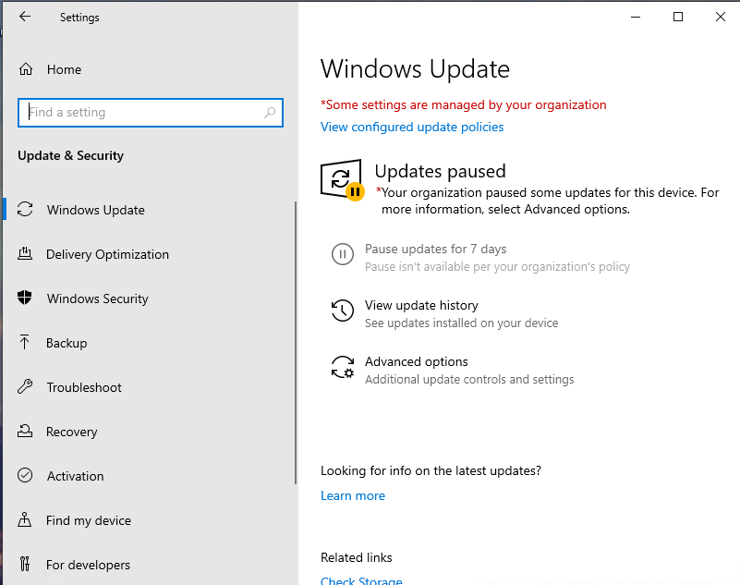

# Install the Apps

1. Go to <https://Endpoint.microsoft.com>
2. Provide login credential.
3. Successful login will lead you to **Endpoint Manager Admin Center**
4. Click on **Tenant Administration >Connector and Tokens > Microsoft store for business**

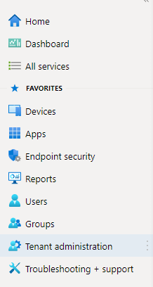

1. After you navigate into **Microsoft Store for business** you will see **Open the business store link** click on it, will navigate you to **Microsoft store for business.**

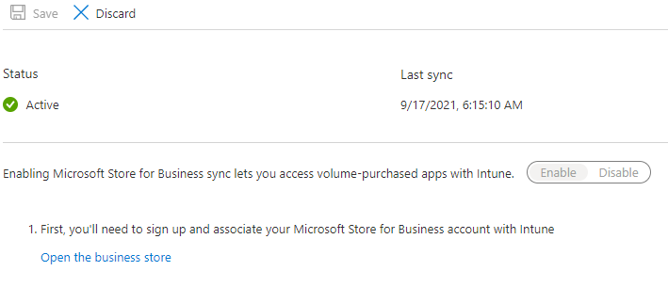

1. In **Microsoft Store for Business** you will see search box where can search for you desire app.



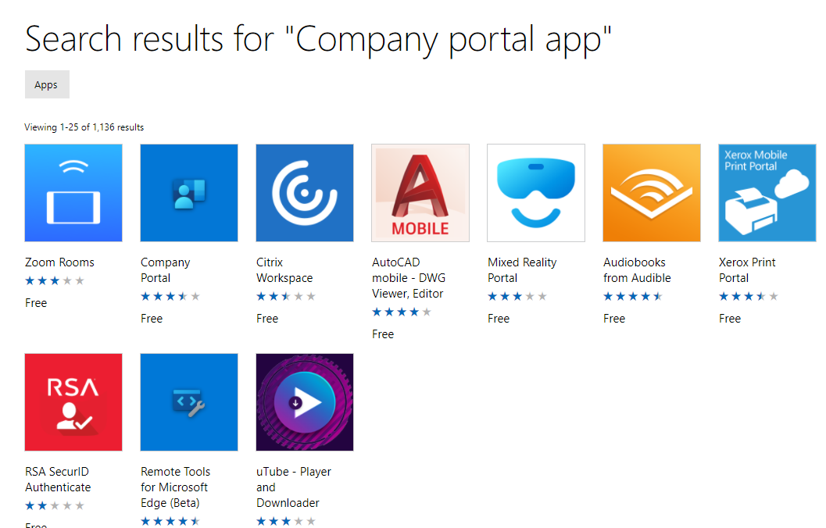

1. Click on **Company portal app** will navigate you to company portal app overview section.
2. Click on **Get the App**

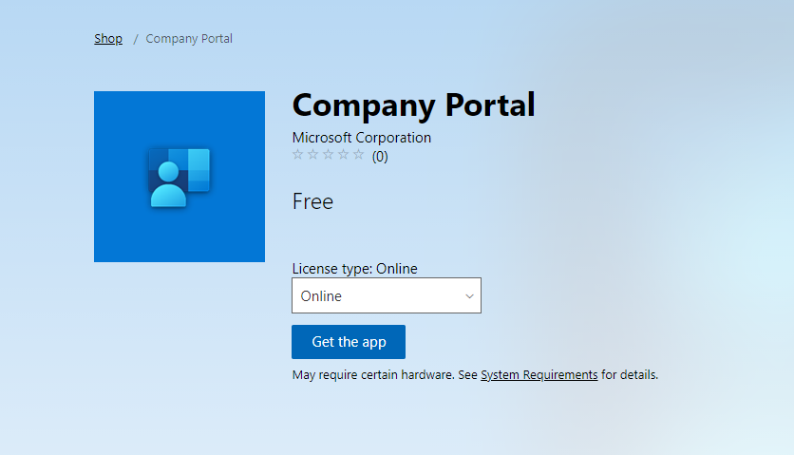

1. After clicking on  **Get the app >** click on **Mange** which is on **Navigation bar** and again you will see **Product & Services** blade on sidebar  **click on it.**
2. You will see **Product & services** that you have purchase as shown on screenshot below.

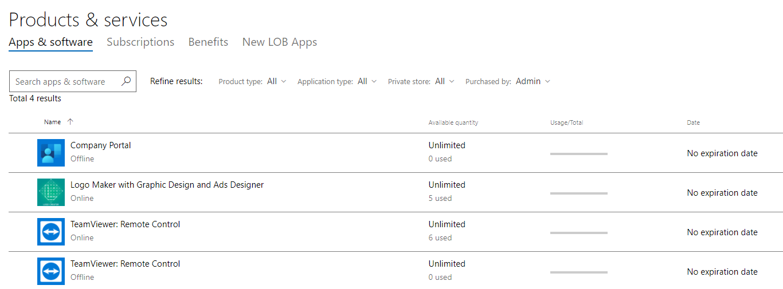

1. After you the purchase you again need to recheck whether the purchased app is populated in Endpoint Manager **Apps** section.
2. Go to **Endpoint Manager Admin Center > Apps.**
3. After you click on **Apps** you can see by platform section. Under by platform section you will see different option like :- Window, iso/ipados, macos etc.

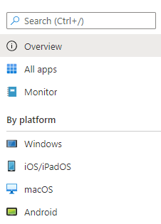

1. For our case, Now we will go to **Windows** and verify weather **Company portal app** is populated in this section or not.



1. After verifying, we Click on **Company portal app > Properties**

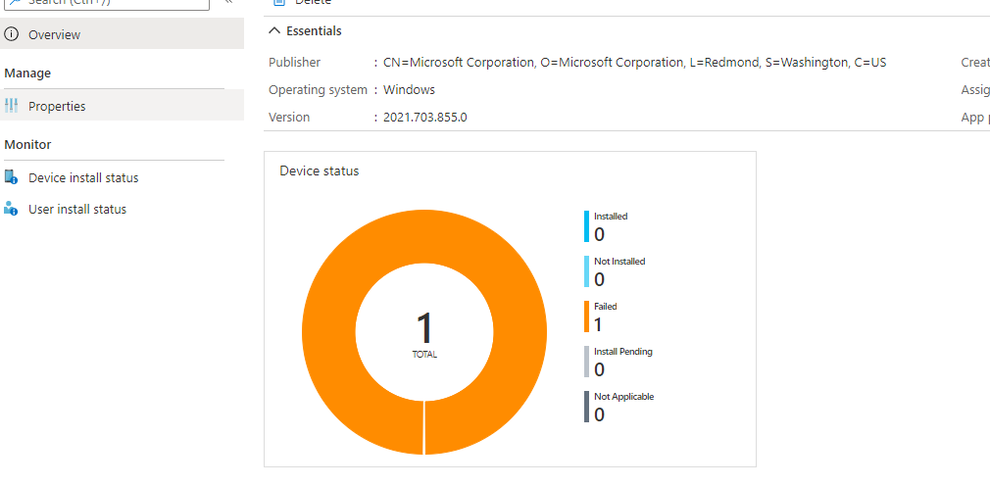

1. After clicking on **Properties > click on Assignment Edit .**

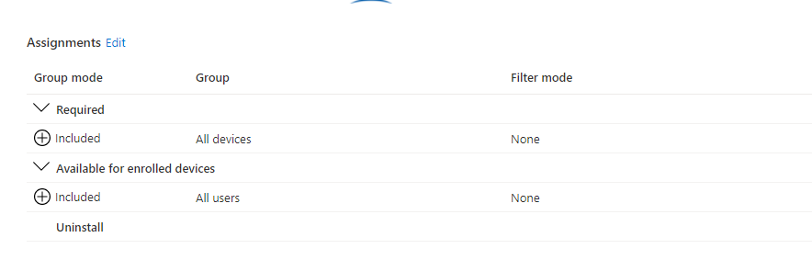

1. After clicking on **Assignment Edit link >** Under required section **click on Add Devices or group.**

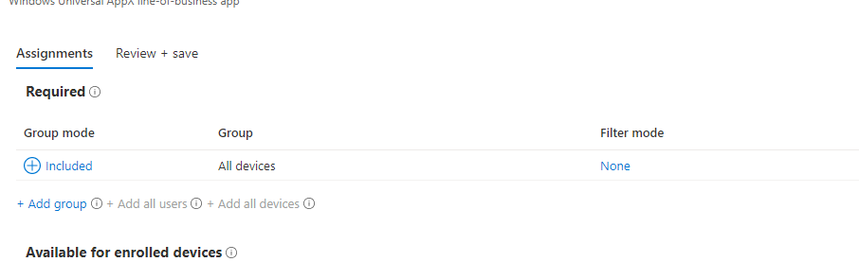

1. After successful assignment of App to the targeted groups or device you again need to go to **overview** section of company portal app to check successful rate of app assignment.

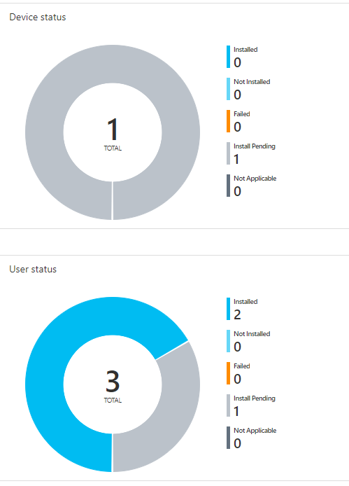

1. At the Endpoint, Client result should look like the following screenshot attached below.

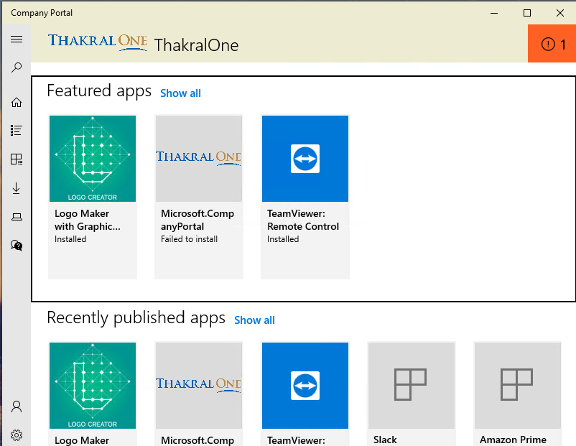

# Create a Local user and add to the local administrator

1. Go to <https://Endpoint.microsoft.com>
2. Provide valid Username and Password
3. Successful login will navigate you to **Endpoint Manager Admin Centre.**
4. Click on **Devices** > Search for Policy section > **Configuration Profiles.**

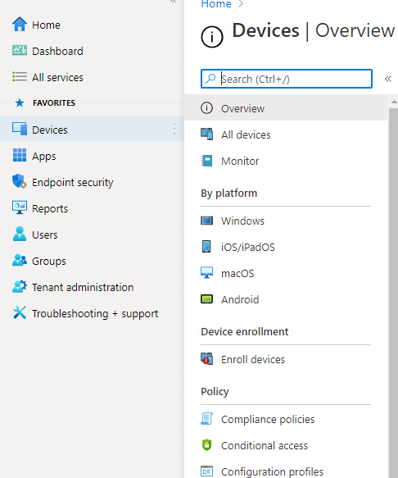

1. Click on ** Create Profiles** Sidebar will open for Right side of you screen. You will see select platform Combobox & profiles types combobox.

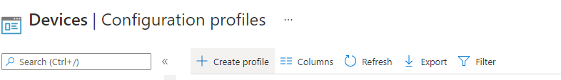

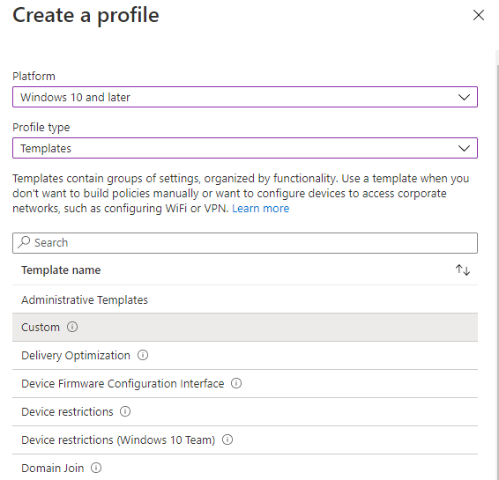

1. Select the **Platform** as **Window 10 and later and** Profiles types as **Template** will populate the bunch of template options Select **custom.**
2. Provide the **Name** & **Description** and click on **Next.**

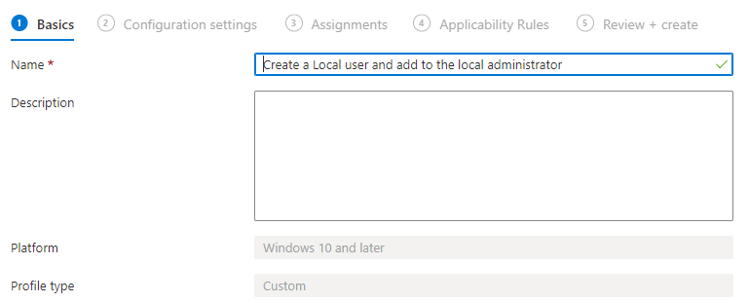

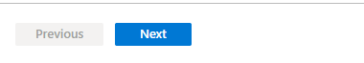

1. Clicking next will Navigate you to **Configuration setting**, again you need to click on **add** button.

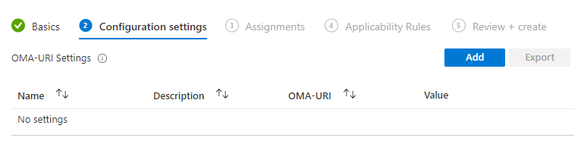

1. After clicking on **Add** button will open sidebar for right side of you screen showing the different controls like :- Name, Description, OMA-URI, Data type.

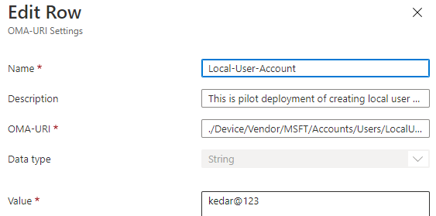



1. Provide the Name, Description

* OMA-URI 🡪/Device/Vendor/MSFT/Accounts/Users/LocalUserAccount/Password
* Data type 🡪 String
* Value 🡪 You Password.

1. Click on save.
2. After Saving the **OMA-URI Settings,** you need to Assign this setting to groups or devices and click on Save.

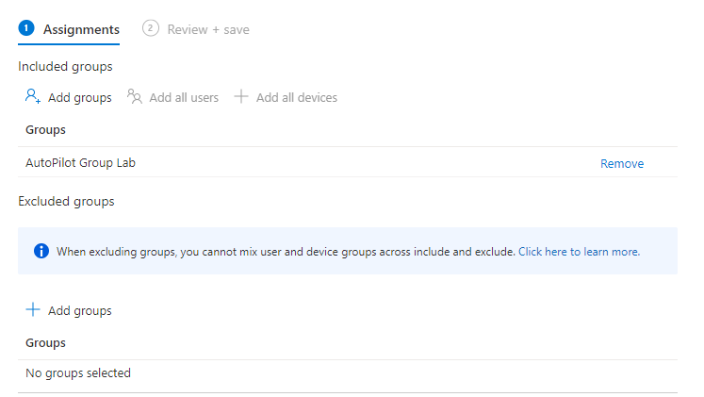

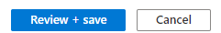

1. After Saving this **Configuration Profiles** you again need to Create another **Configuration Profile** for activating local use to local administrator.

* Provide the Name, Description.
* OMA-URI🡪./Device/Vendor/MSFT/Accounts/Users/LocalUserAccount/LocalUserGroup
* Data Type:- Integer
* Value: - 2

1. After Providing the Related value click on save and again assign the policy to same Group or devices.
2. The endpoint result should look like screenshot below: -

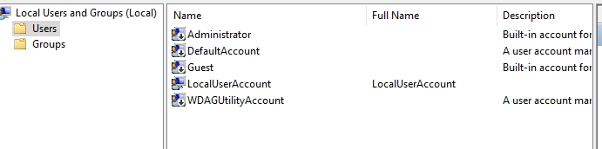

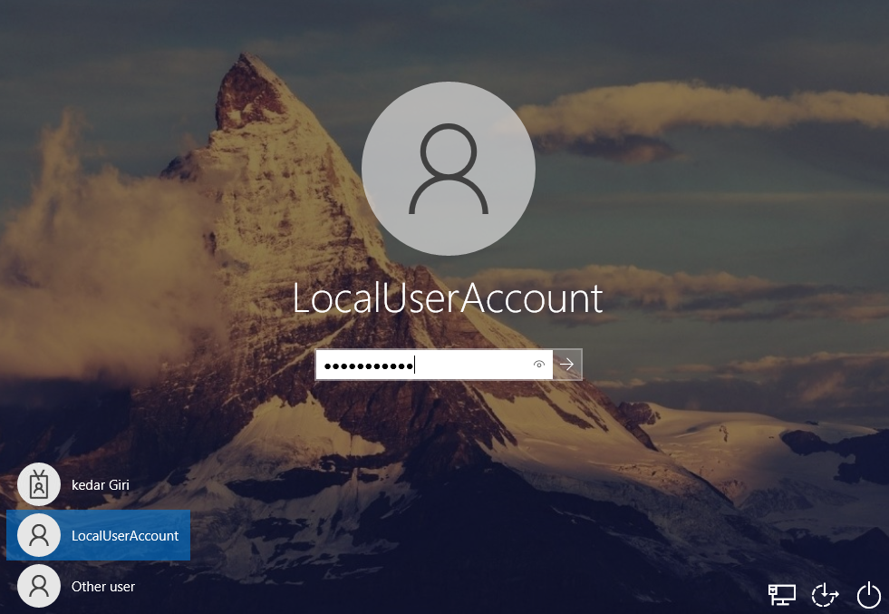

# Customize the company portal

1. Go to <https://Endpoint.microsoft.com>
2. Provide Valid username & Password.
3. Click on **Tenant Admin blade** you will see **End user Experience section** again click on customization blade.

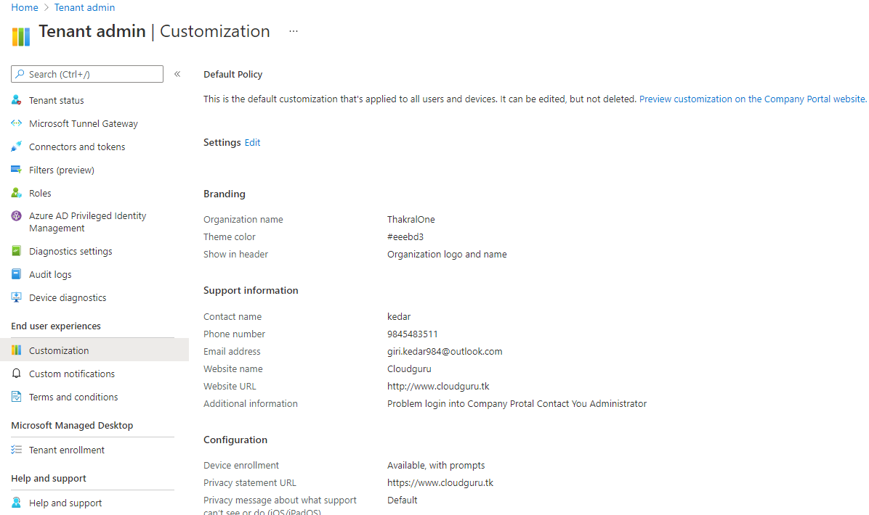

1. After Clicking on Customization, you will see list of configuration setting and **Edit** link right next setting section.
2. After clicking on Edit you will see actual setting screenshot below.

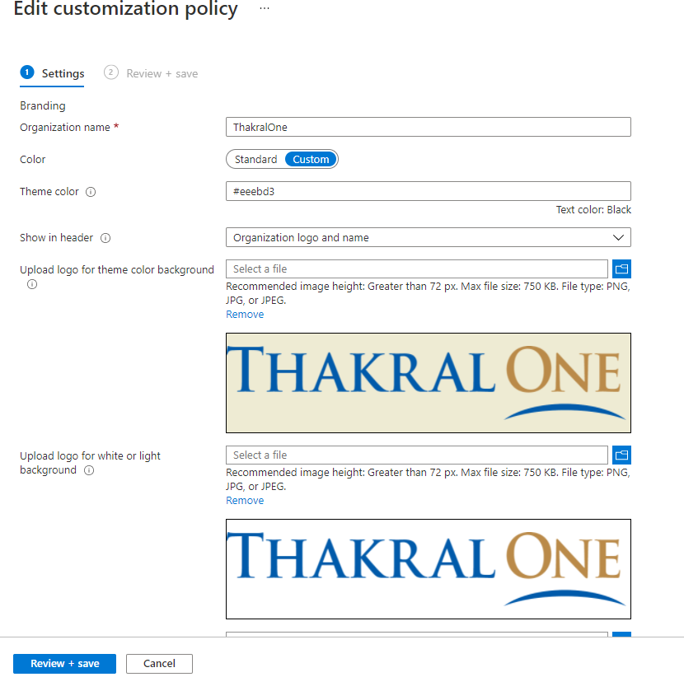

1. Now you need to provide the details and upload the logo and banner according to you requirement.
2. After Providing the Values and uploading files to corresponding controls Finally click on save and to verify the end result go to client machine and open company portal app.

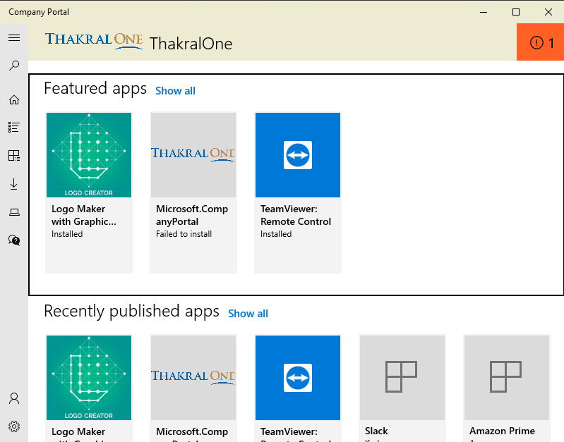

# Activate the Bit-locker

1. Go to <https://Endpoint.microsoft.com>
2. Provide Valid UserName & Password.
3. Successful login will lead you to Endpoint Manager Admin Center.
4. Click on Devices > Configuration Profiles



1. Click on ** Create Profiles** Sidebar will open for Right side of you screen. You will see select platform Combobox & profiles types combobox. 

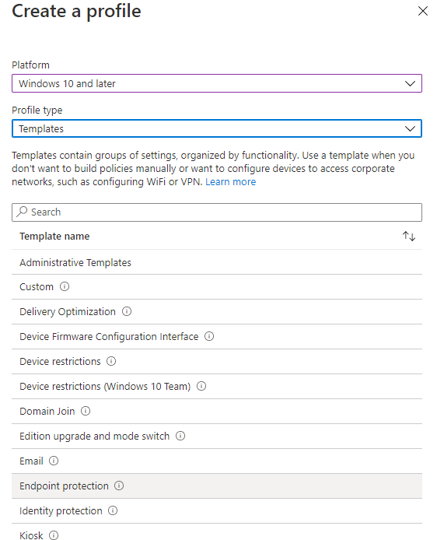

1. Select the **Platform** as **Window 10 and later and** Profiles types as **Template** will populate the bunch of template options Select **custom > Endpoint Protection.**
2. Provide the **Name** & **Description** and click on **Next.**

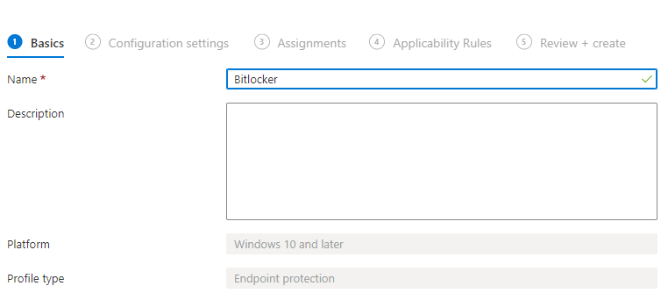

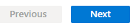

1. Clicking on Next will navigate you to Configuration setting.

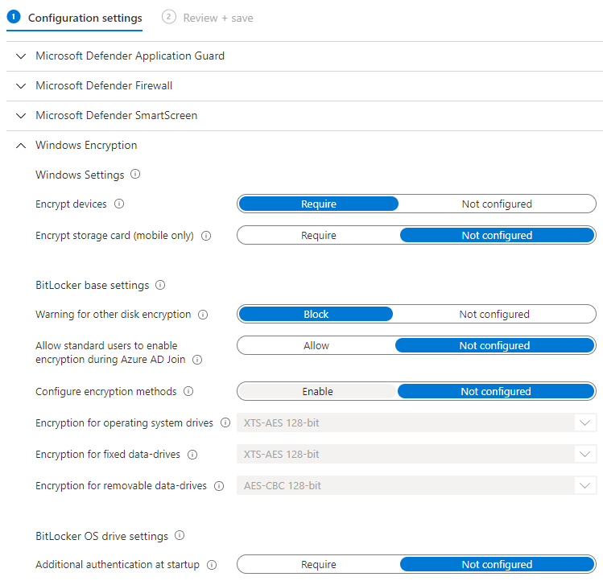

1. Clicking on Windows Encryption will display the various controls for bit locker and many more.
2. You will see Encrypt devices controls you need toggle that switch to **Required** as shown in the screenshot
3. Again you need to save the **configuration settings** and assign it to group or devices.
4. After successful assignment of bitlocker policy you will need to go to client machine and setup the **bitlocker** and save the **bitlocker recovery key** into the machine or to **Azure ad**
5. Bitlocker Recover Key reside in Azure active directory > Users > {UserName}(Kedar giri) > Devices > Device Name { [DESKTOP-TDFL8S8](https://aad.portal.azure.com/) }



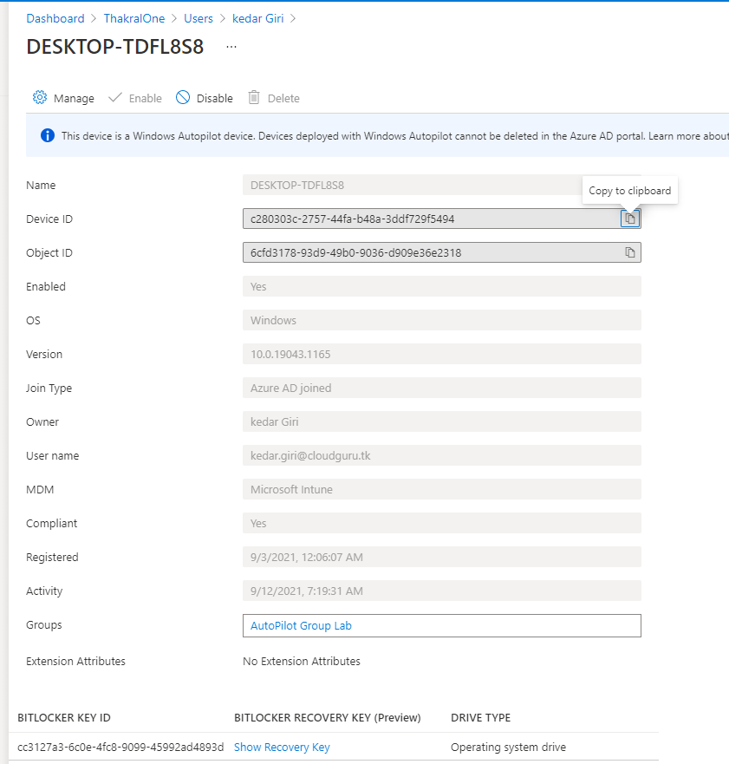

1. Finally the endpoint result should look like the screenshot given below.

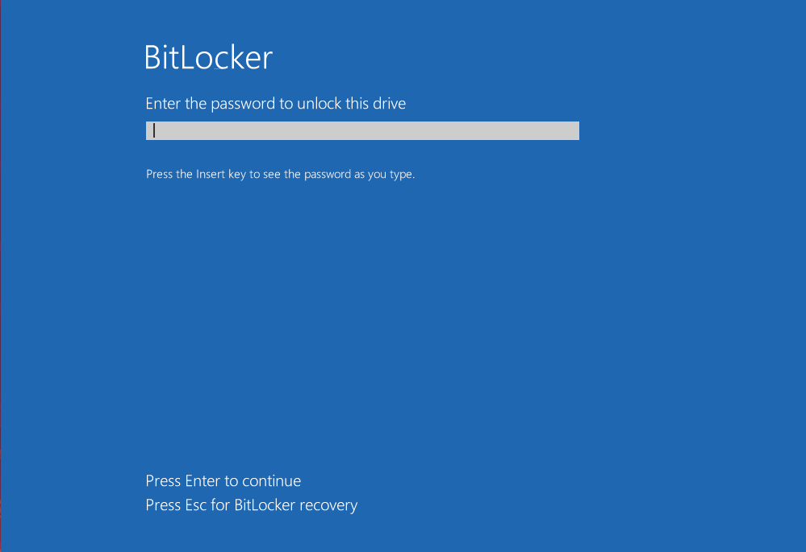

# Device Enrollment Restriction

1. Go to <https://Endpoint.mirosoft.com>
2. Login with valid username & Password.
3. Successful login will navigate you to Endpoint manager Admin center.
4. Click on **Device > Enroll Device > Enrollment Restriction**

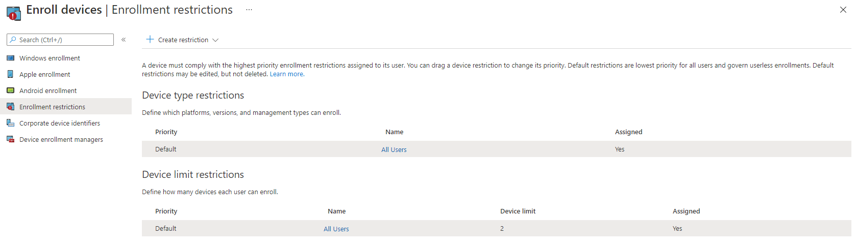

1. ** Create Device restriction** which is top left corner.
2. Clicking Device Resrtiction will navigate you to **Basic** page

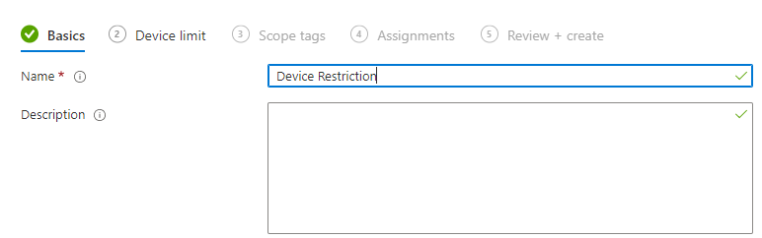

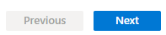

* Provide **Name** & **Description** and Click on next button**.**
* Set the Device Limit and click on Next

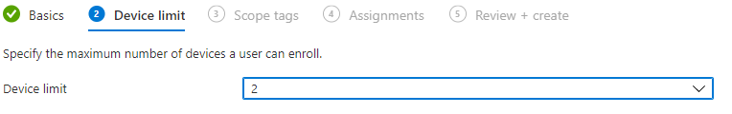

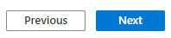

1. Clicking on next will Navigate you to scope tag section leave it as default and click next again.
2. Assign the Policy to the group and save the setting.

# Setup Android Enrollment

## Endpoint Manager, Android device Enrollment of Personally Owned Device with work profile

Enrollment of personally owned device with work profile tab reside in Endpoint Manager, Endpoint manage help you protect, manage and monitor the devices like: - Windows, Android, IOS/MAC.

Device, Apps, Users and groups

The primary reason behind enrolling the devices into Intune is security. Intune manages and monitor suspicious activity based on policy enforced into that device.so the demonstration mentioned below will elaborate how you can perform enrollment of android device into Intune.

1. Go to <https://portal.microsoft.com> and login with the credential.
2. On the **Admin Center** section, below there is **Endpoint Manager** **Blade** click on it.

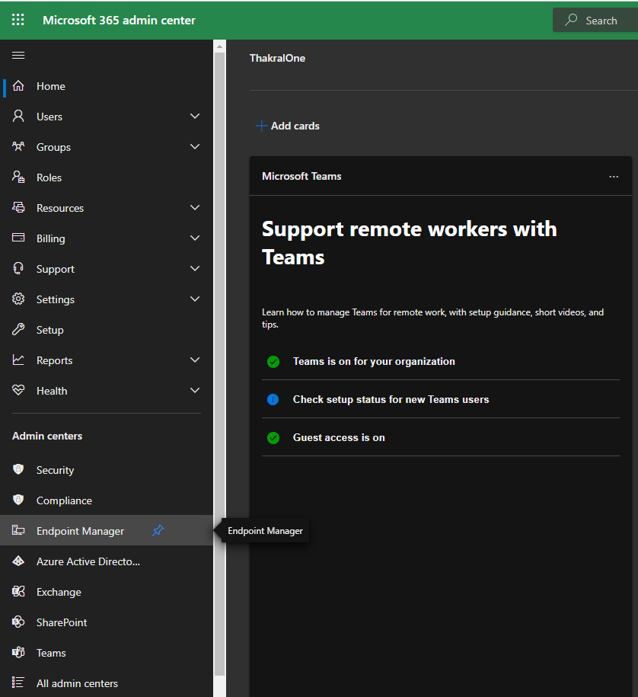

1. **Endpoint Manger Admin Center** Will Open.

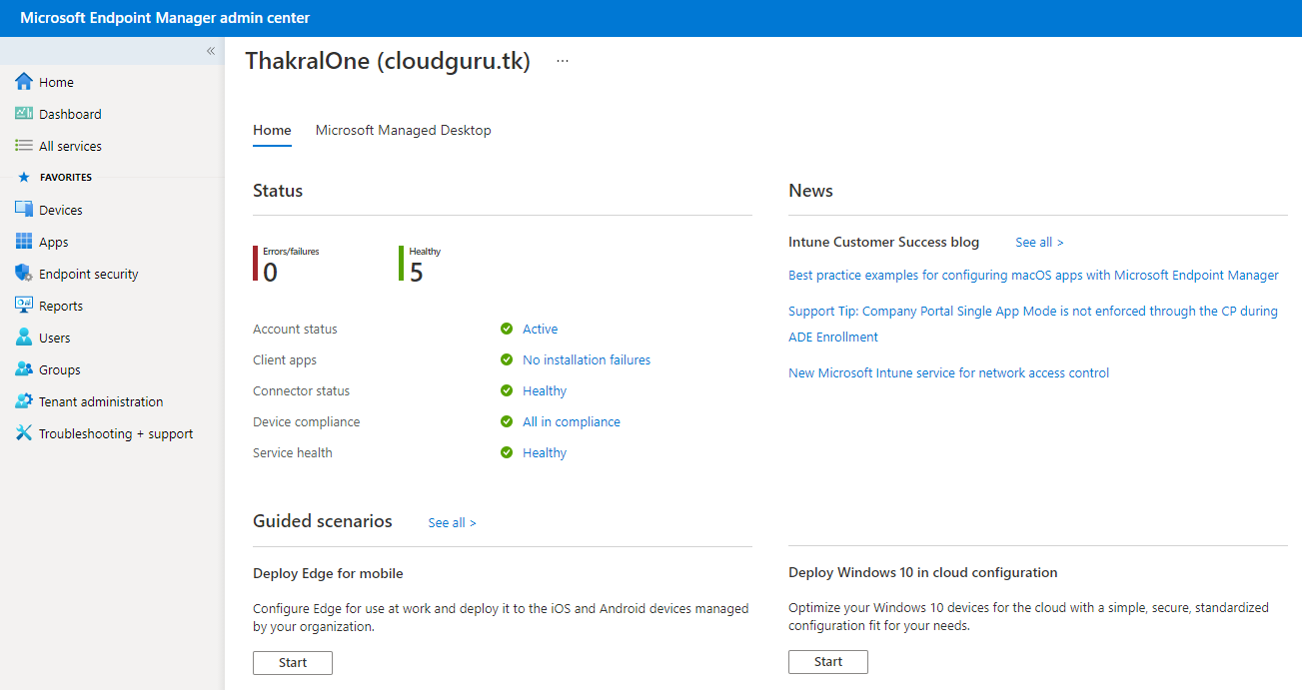

1. Click on **Device Blade.**
2. **Device** Overview page will open with Enrollment status, Enrollment alert and compliance status etc.

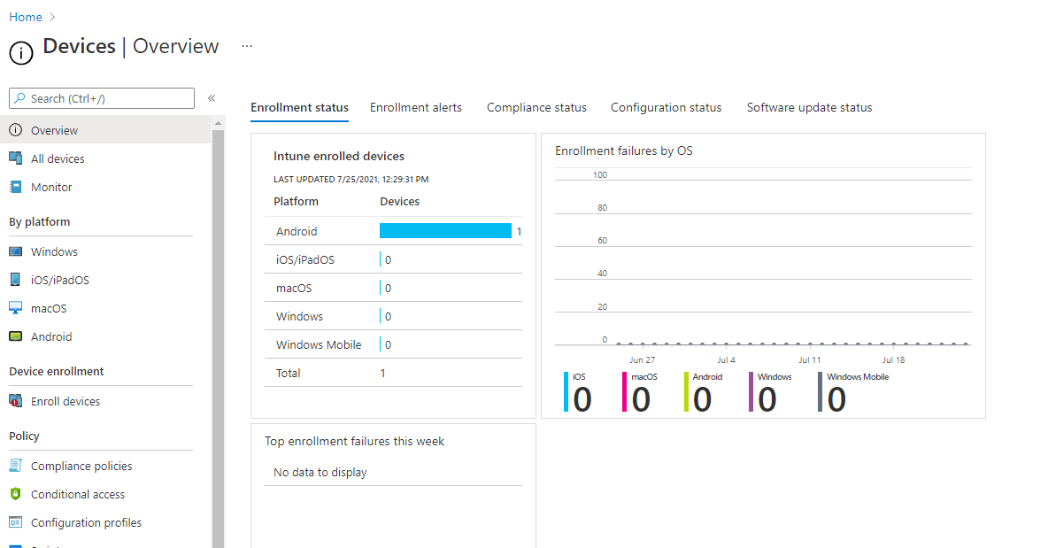

1. Click on **Android** > **Android Enrollment** > **Manage Google Play.**

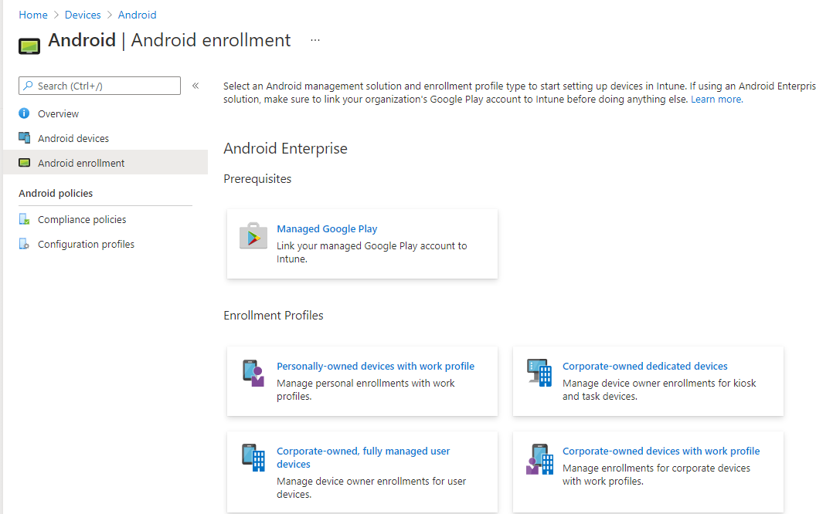

1. After clicking on **Manage Google Play** button another pane will open from right side.

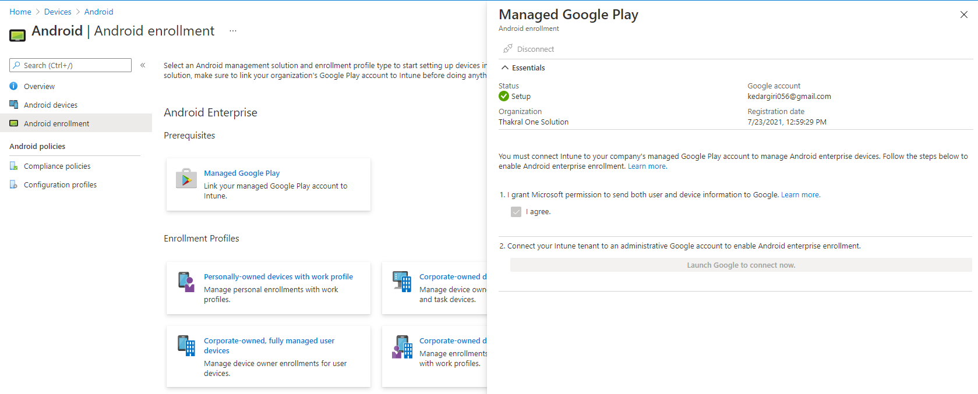

1. Check **√** I agree Checkbox and click on **launch google to connect now**
2. After clicking into launch google to connect now will navigate you to sign with google account page which you will used later to assign the play store app to users.
3. After completion of signup, you will see the green sign screenshot below.

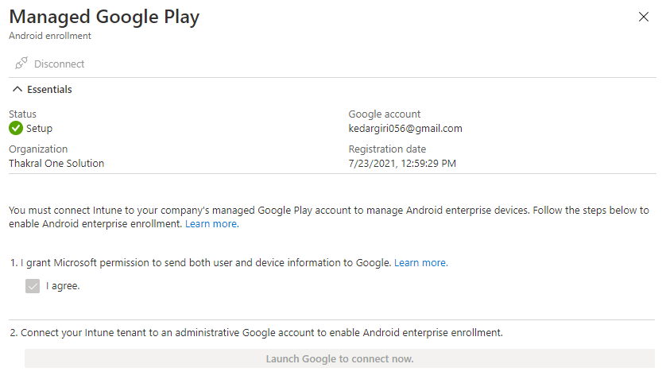

1. Now you will be required android phone and download **Intune Company Portal** from playstore.



1. After you download sign-up with company provided login credential and you will see the assigned app inside company portal app.
2. For to assign play store app to your phone you need to Go to **Tenant Administration > Connector and Tokens > Manage Google Play**



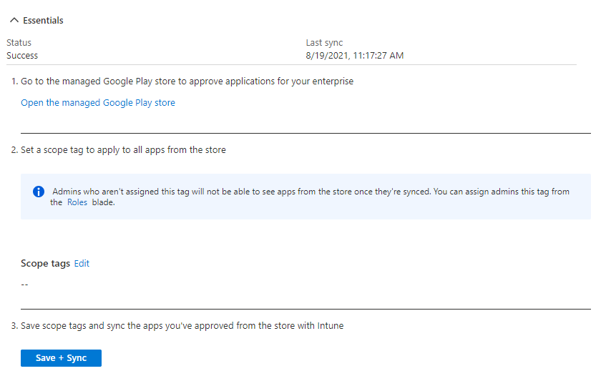

1. Click on **Open the managed google play store** shown inside manage google play > will navigate you to Playstore.
2. Search for the desire app for now we have search for **word app** and click on **Approve.**

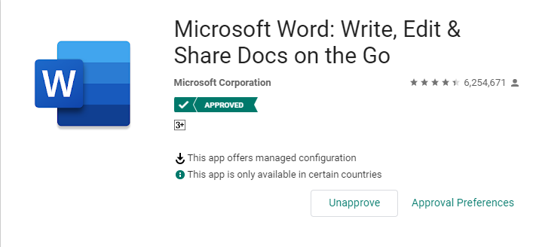

1. After clicking on **Approve,** the Approved app should populate inside **Apps > Android**

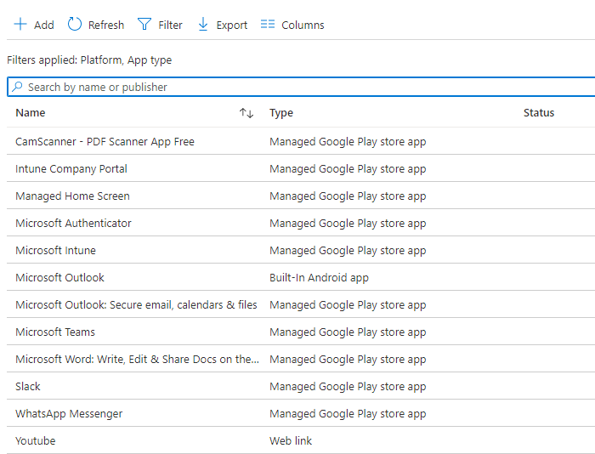

1. After all the configurations. Now you need to open **company portal app** on android device.

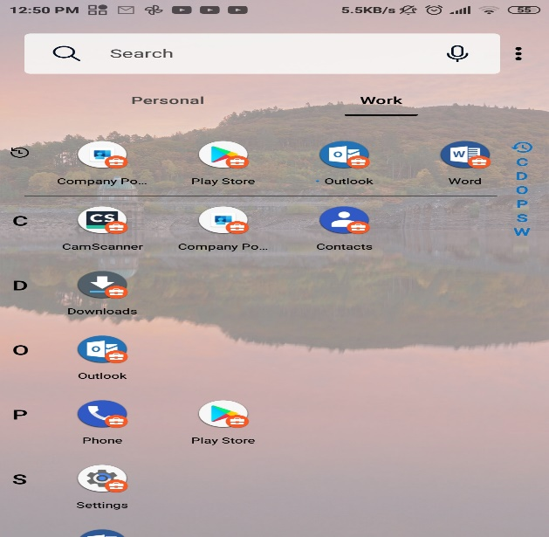

# Communication Compliance

In Microsoft 365 Compliance Center, Communication compliance is the Insider risk solution that helps you to Detect inappropriate talks message in your organization and facilitates you to minimize communication risk. This can be done by either using pre-defined or custom policy. Whenever anyone talk inappropriate or confidential talks with you colleague or anyone(Via teams, outlook, yammer or third-party software) which is against the organization policies then communication compliance act upon those message and stored it for investigation. communication compliance can mitigate various issue like: - we can monitor sensitive information sent outside of your organization or track inappropriate activity such as harassment, threats, Profanity etc. overall, we can say that by implementing communication compliance in organization we can remediate the possible issue that can be faced inside of your organization.

There are following procedure you can follow along for creating policy in Communication Compliance.

1. Go to <https://compliance.microsoft.com>
2. Provide UserName & Password to login.
3. Click on **Communication Compliance** blade

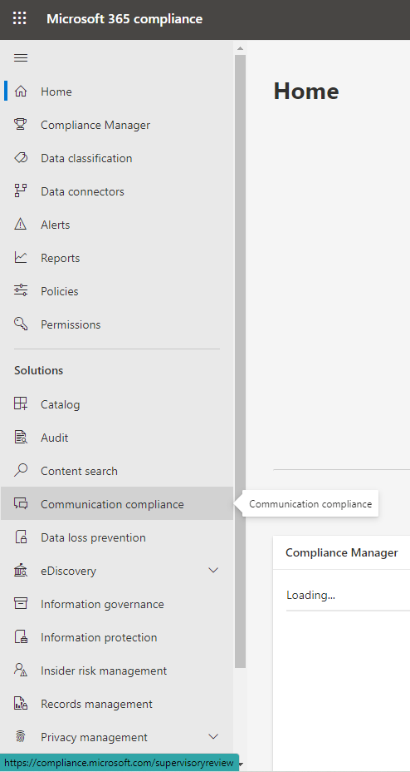

1. After clicking on **Communication Compliance** Blade will open Communication shown on screen shot below

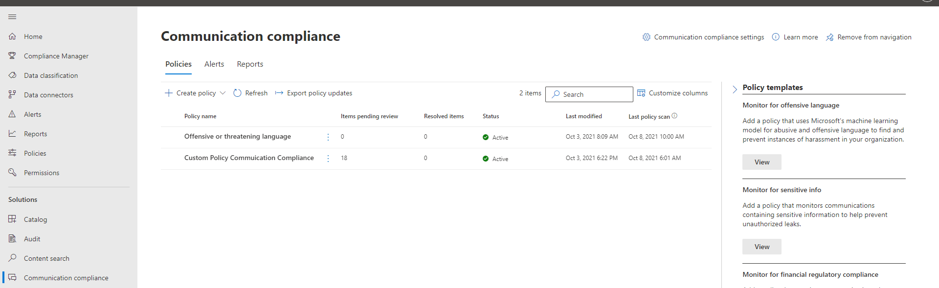

1. Click on **Create Policy** drop down and select Custom Policy

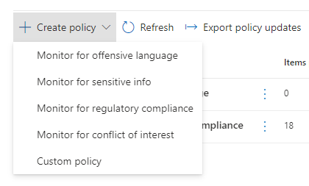

1. Clicking on **Create Policy** drop down and select Custom Policy will navigate you to **Name and Describe your policy** page

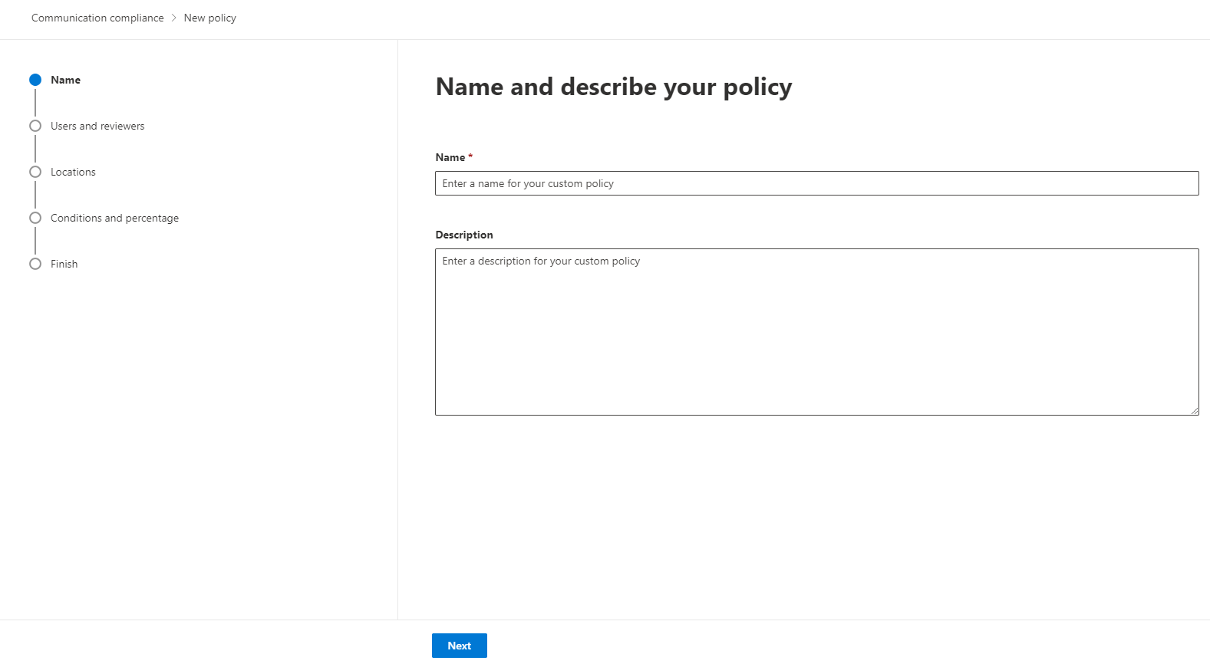

1. Provide **Name & Description** and Click on **Next button.**

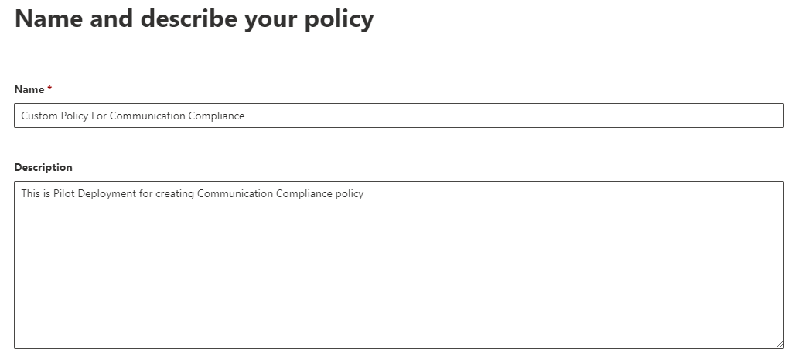



1. After clicking on Next button, you will see **Choose Supervised users and reviewers.**
   * + Select then **Supervised users and Group**
     + Select the **Exclude users & group** that you want to exclude for this policy.
     + Select **Reviewers** for this policy that you want make reviewer.
     + Then, Click on **Next** button or follow with the screenshot below.

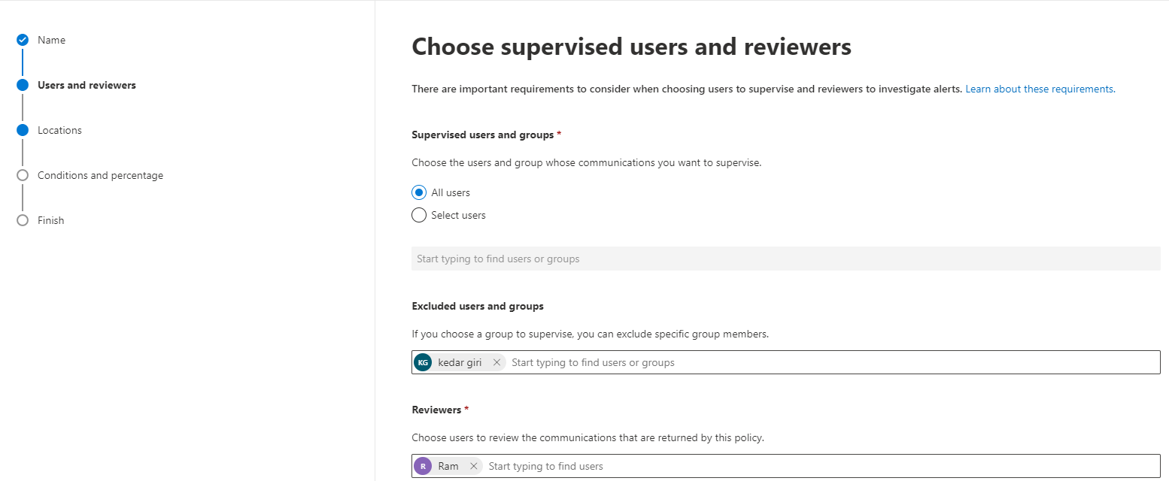



1. After clicking **Next Button** will navigate you to **Choose Location to Monitor Compliance.** You can monitor the communication on the following technology :- (Exchange, Teams, Skype for Business, Yammer etc.) check the check according to your requirement. Or follow along with screenshot.

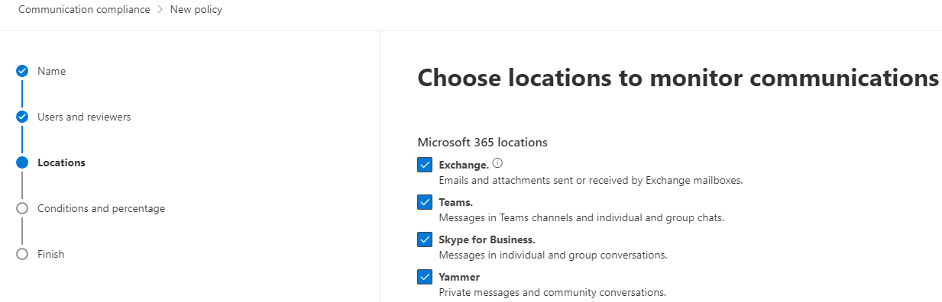



1. After **Choosing location to monitor communication** & clicking **Next Button** will navigate you to Choose condition and review percentage.

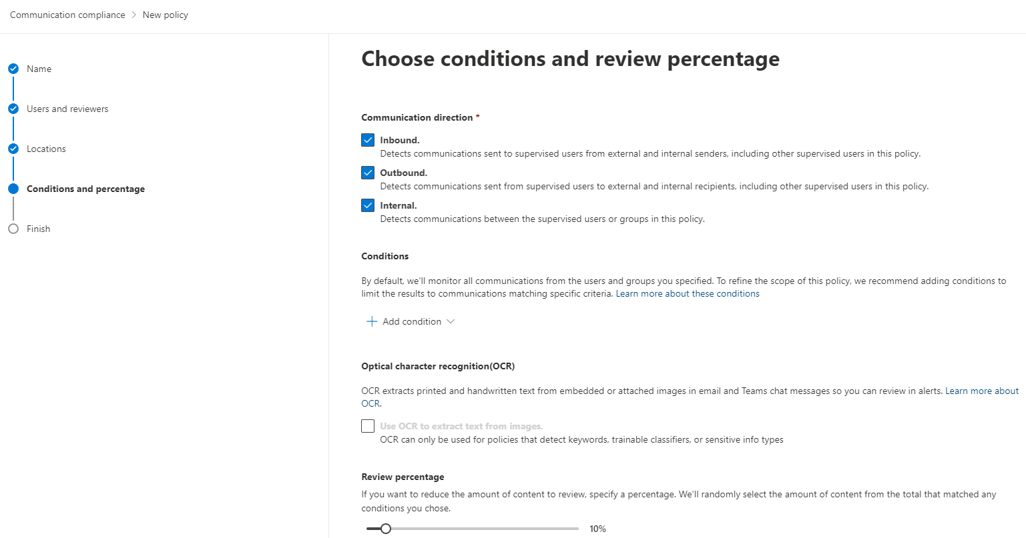



1. There are various controls on **Condition and Percentage** page, Each control have its own impact on policy.
   * + Select the **Communication Direction** based on you requirement for now I have selected each on.
     + You can select the Condition. For now I have selected **Message Contain any of these words.**
     + After selecting the condition you will see **Optical Character recognition(OCR).** Check if you wan to use orc to extract text from image.
     + Finally, you can set the slider bar for **Review Percentage.** Higher the percentage higher the message review vice versa.

Note:- there may be false Positive and false negative review the documentation link given :-

[**https://docs.microsoft.com/en-us/microsoft-365/compliance/communication-compliance-feature-reference?view=o365-worldwide#review-percentage**](https://docs.microsoft.com/en-us/microsoft-365/compliance/communication-compliance-feature-reference?view=o365-worldwide#review-percentage)

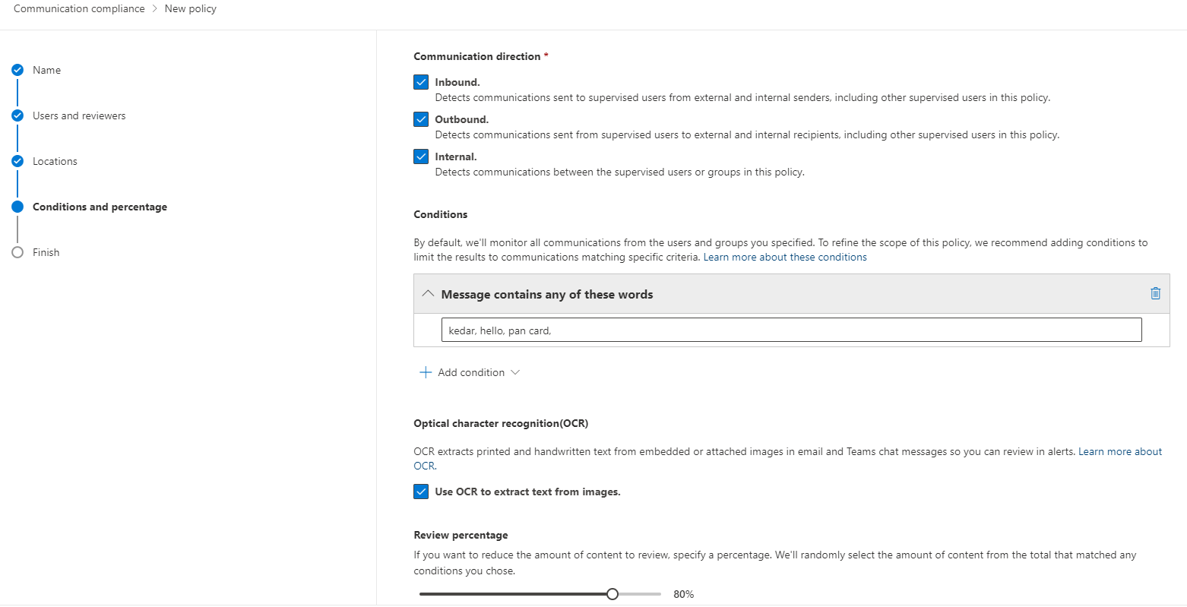



1. After configuring the policy Click on **Next** will navigate you to last Page**.**

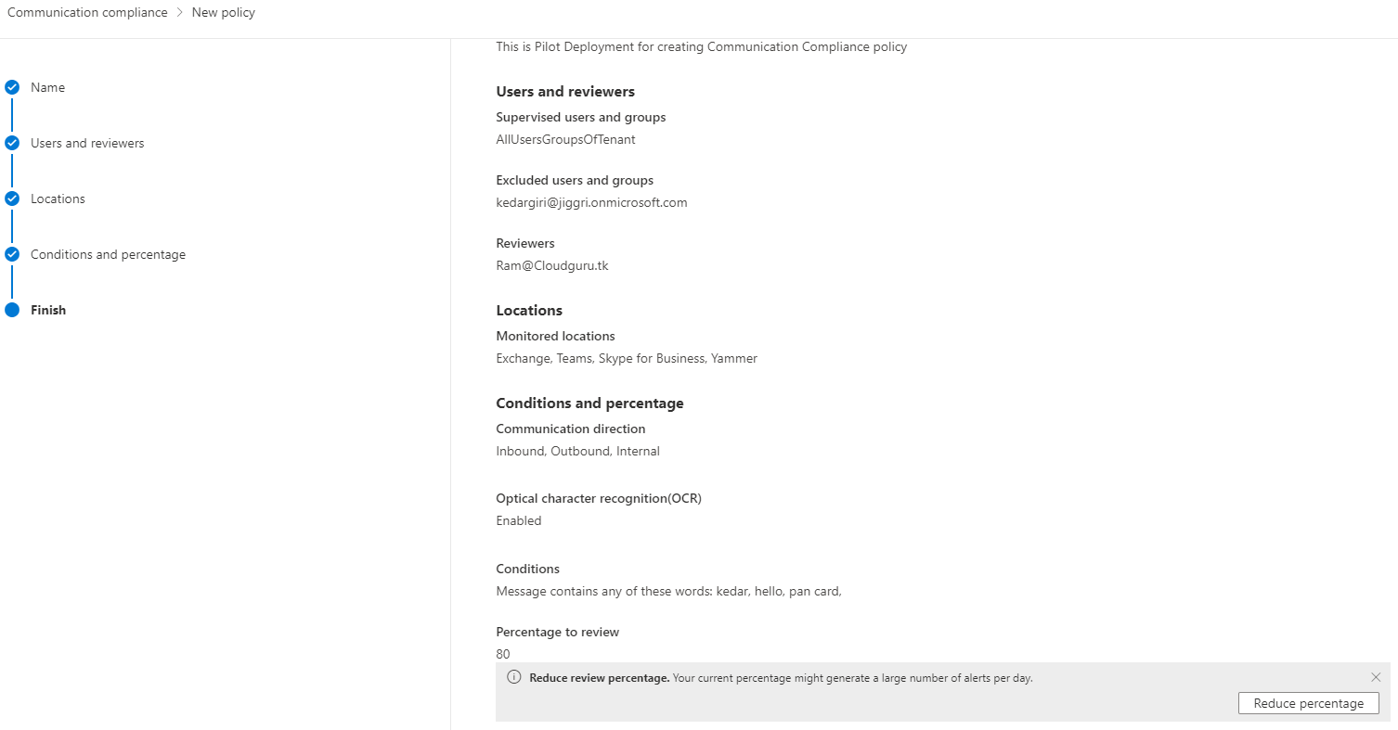



1. At last at **Review & Finish** section, if required review the Policy then after click on **Create Policy button.**

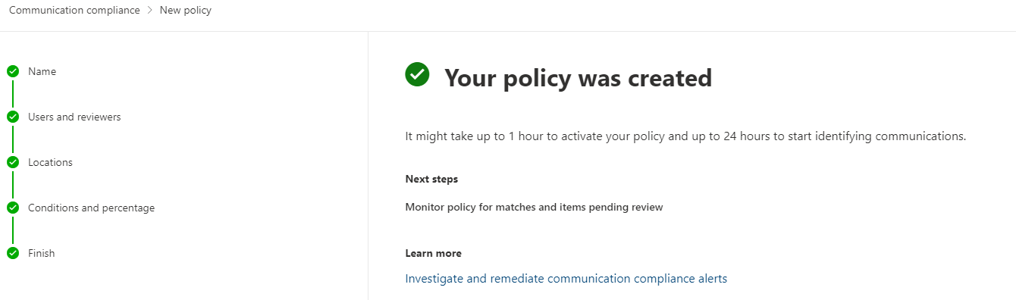

1. Message Displaying with Green  will display and Click On **Done**

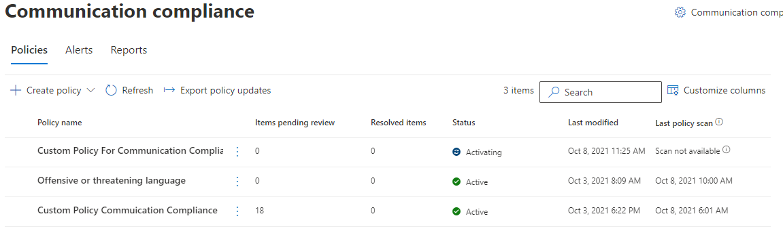

Note: - Permission Role Required to Use this Feature are :- Communication Compliance, Communication Compliance Admin, Communication Compliance Analyst, Communication Compliance Investigator & Communication Compliance Viewer

Note:- For More Information Link is given Below:-

<https://docs.microsoft.com/en-us/microsoft-365/compliance/communication-compliance-configure?view=o365-worldwide#step-1-required-enable-permissions-for-communication-compliance>

# Information Governance

In Compliance center there’s another Blade that is Information governance. Information governance is a great feature in compliance center. Information Governance, name itself say that it governs your data. According to the organizational requirement we can govern our data by setting retention policy. We can delete our data automatically when certain period exceeds, or we can even or ever store our data with the policies management. So, the documentation will Leeds you how you can undertake Retention policy, creating labels & show you roadmap for deploying this policy.

The following are step by step process: -

1. Go to <https://Compliance.microsoft.com>
2. Provide login Credential.
3. After successful will navigate you to **Compliance Center Home Section**

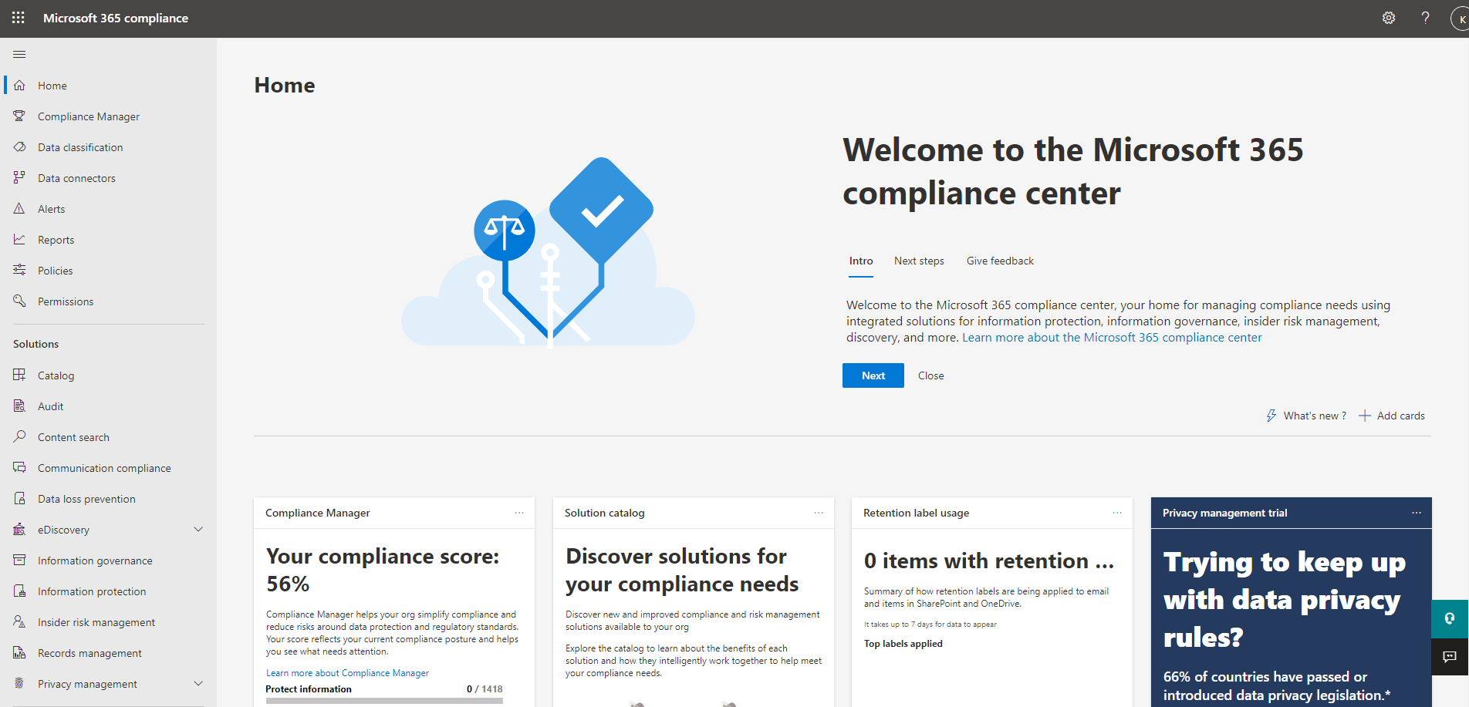

1. Click on **Information Governance Blade.**

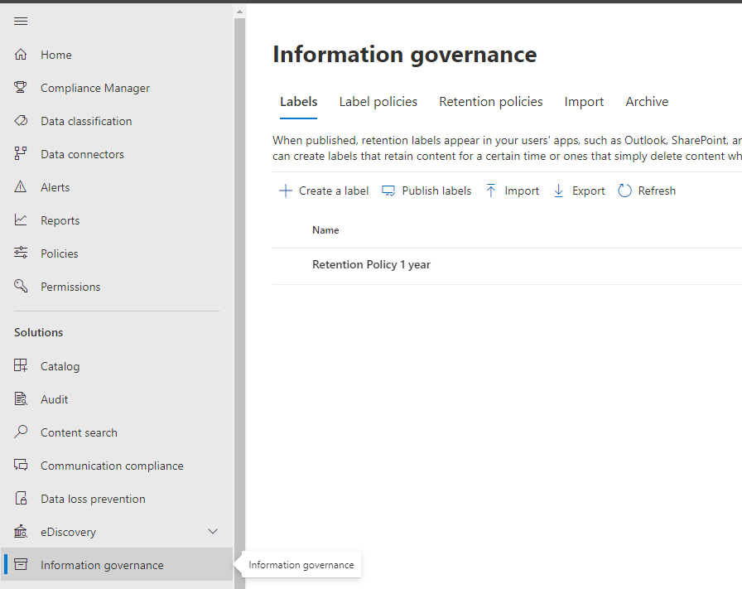

1. After Clicking on **Information Governance Blade** will navigate you to **Labels section**

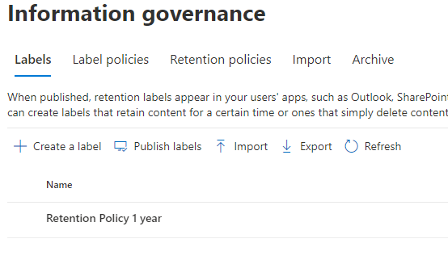

1. Clicking on **Create a Label** will navigate you to **Name your Retention Label** section.
2. Provide **Name, Description for Users & Description for Admins** and click **Next button.**

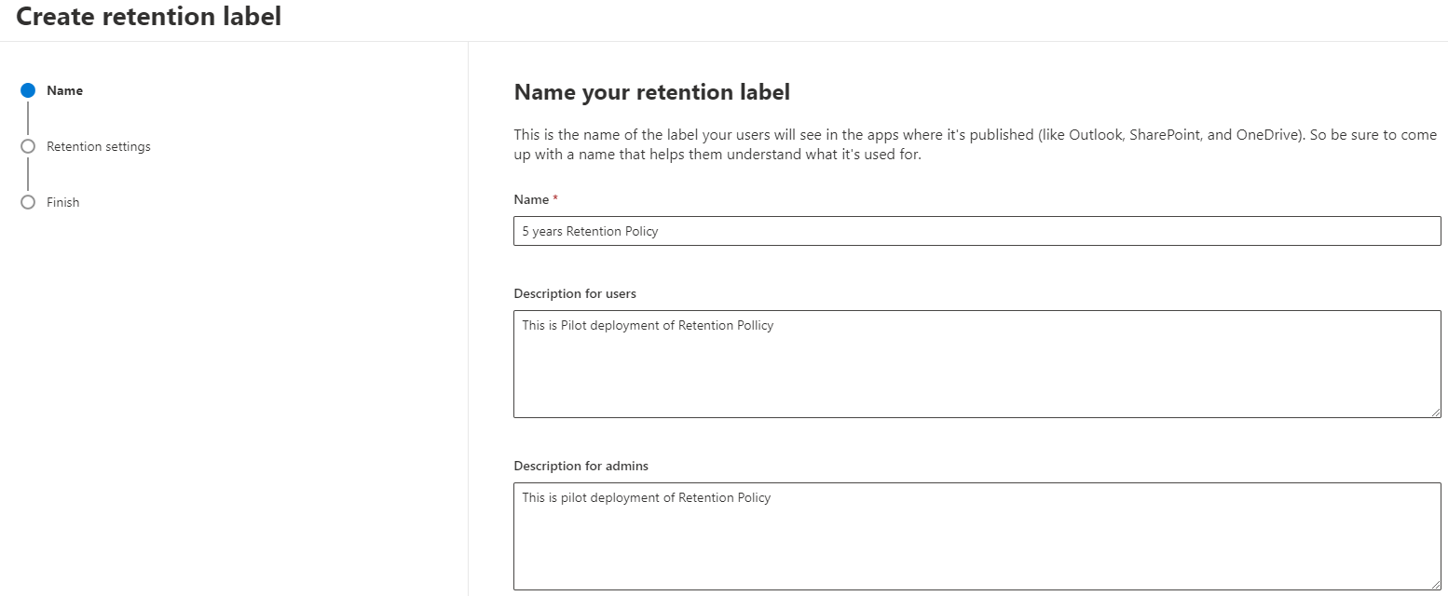



1. After Providing **Name, Description** etc. will navigate you to **Define Retention settings**
   * + Select the **Retain items for specific period** & set the retention Period.
     + Select **start retention period based on** dropdown box for now I have selected > **When Items were created.**
     + Crucial option **at the end of the Retention period.** What to do at the end of retention Period. For now, I have selected **Retain items forever**

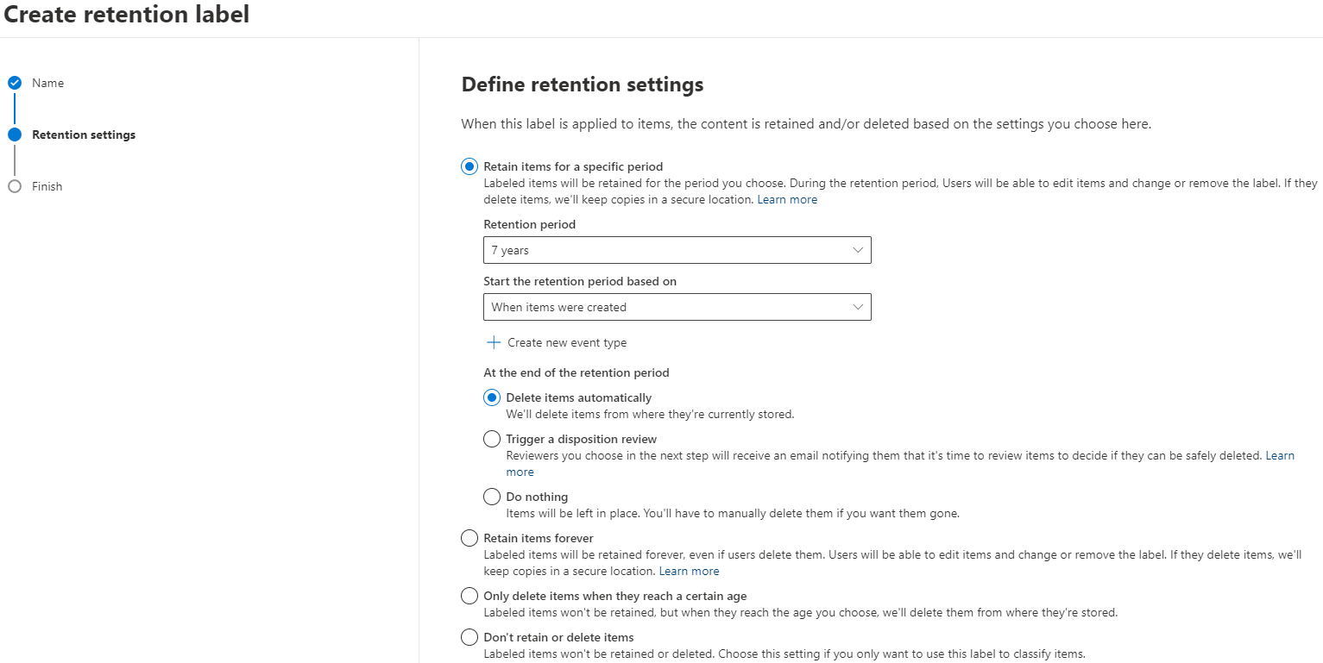

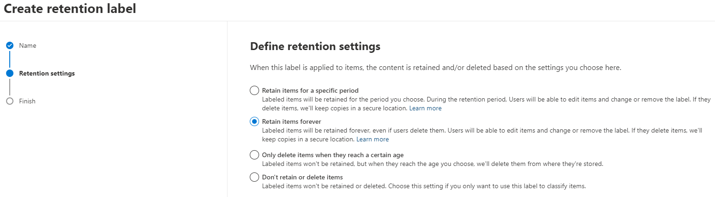



1. After selecting the appropriate setting click on **Next Button.**
2. **Review and finish** screen will appear. If required review the setting and click on **Create Label.**

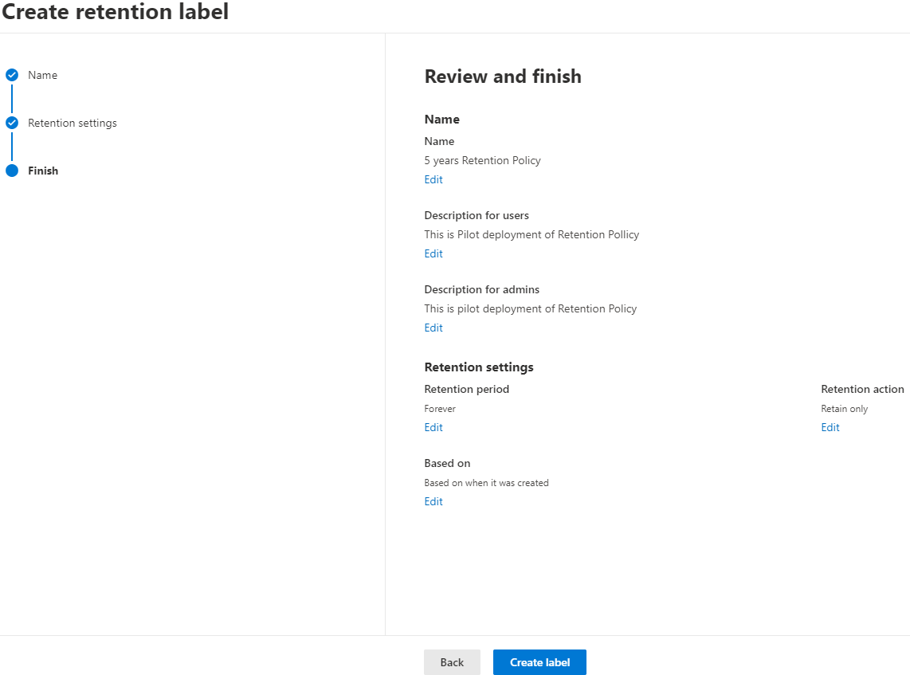

1. After creating retention Label you will see Green  & message displaying with various controls
   * + **Publish this lable to Microsoft 365 locations.**
     + **Auto-apply this label to specific type for content**
     + **Do-Nothing**
2. For now, we are selecting Do-Nothing > DONE
3. After Creating Labels, you need to **Create, or Publish Labels** so click on **Publish Labels.**

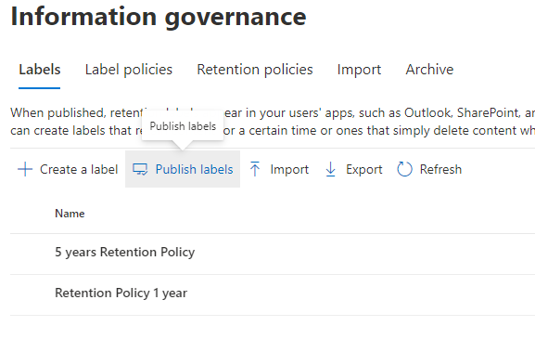

1. Clicking on Publish label will navigate you to **Choose Labels to publish section.**
2. Click on **Choose Labels to Publish > 5years Retention Policy** selected the label you Just Created. Click on next to continue.

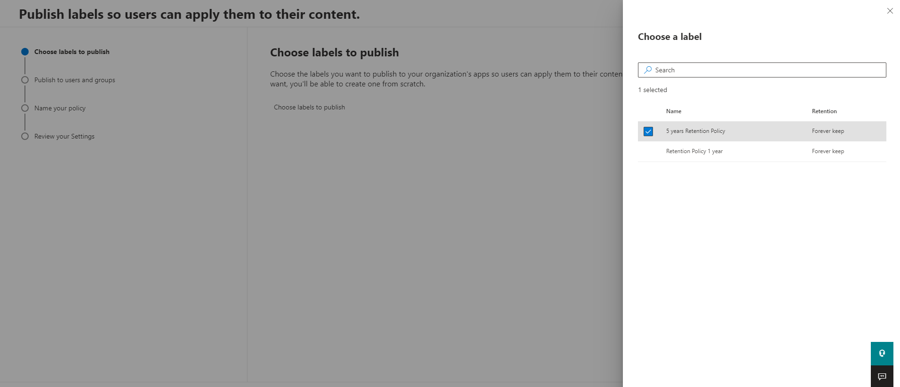

1. **Choose location** will appear, select appropriate radio button > **All location, includes content in Exchange email, office 365 groups, OneDrive & SharePoint Document**

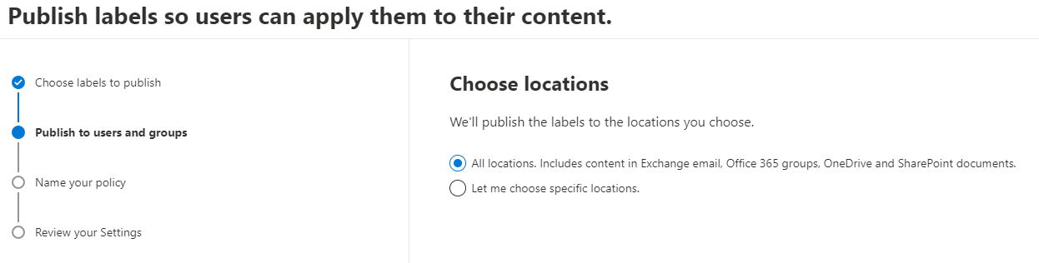



1. Click on **Next button** to Continue will navigate you to **Name your Policy Page.**

* Provide **Name & Description** of the policy.
* Then, click on Next.

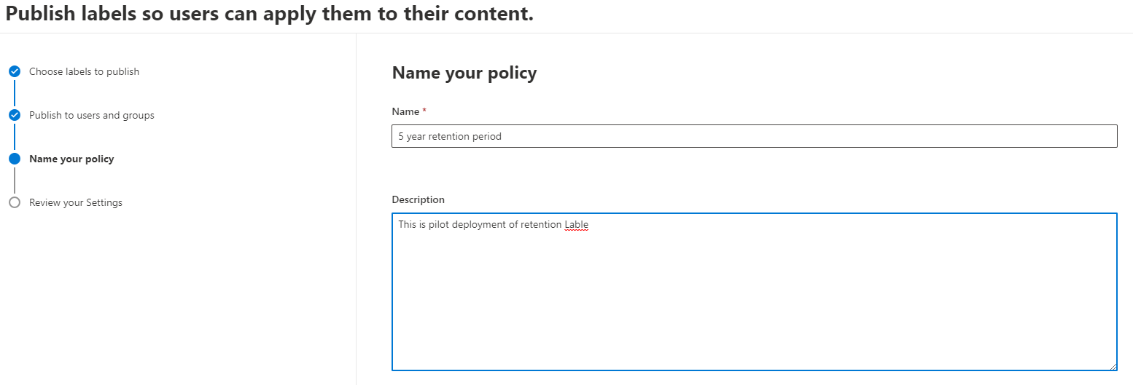



1. Finally, after clicking on next will navigate you to Review **your setting** page, if required review your setting and click on **Submit button.**

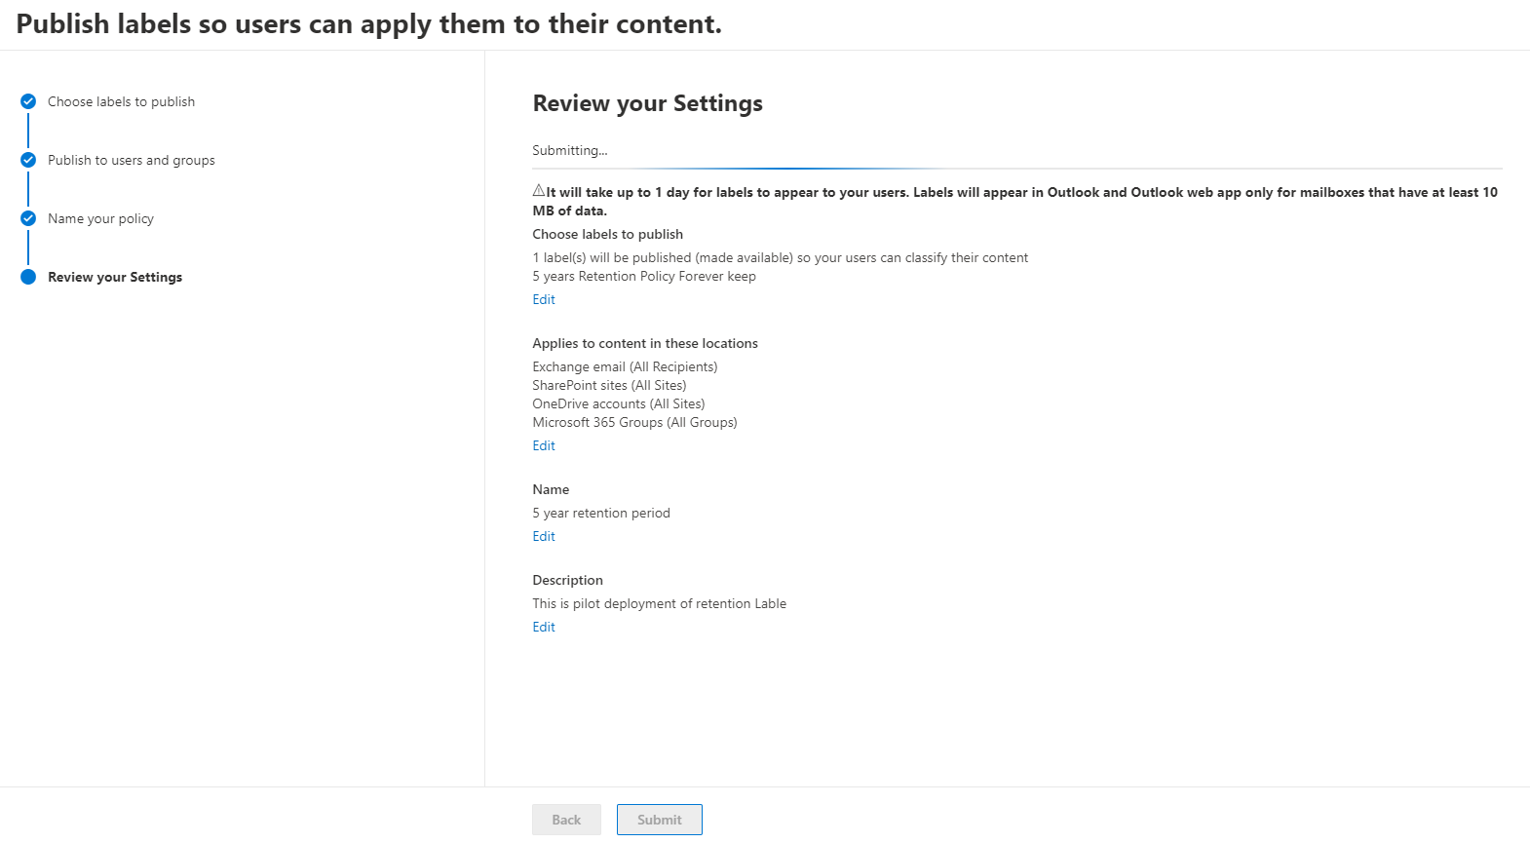

1. After successful completion of Creating **Label Policies** will appear in **Label Polies section**.

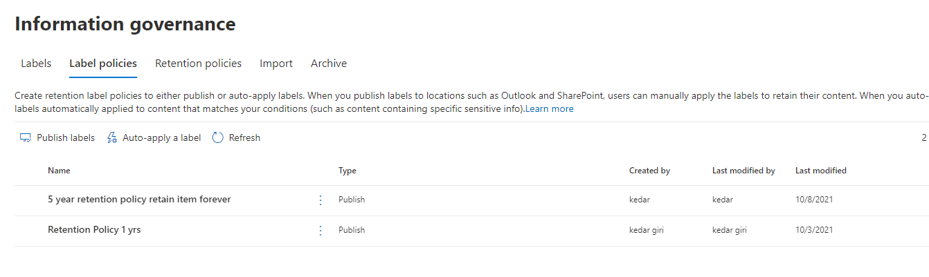

**Retention Policy**

1. To create Retention Policy, Click on **New retention policy**

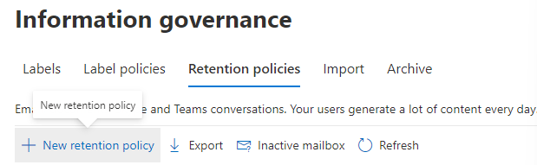

1. Clicking on **New retention policy** will navigate you to **Name your Retention Policy,** Click on **Next Button** to Continue.

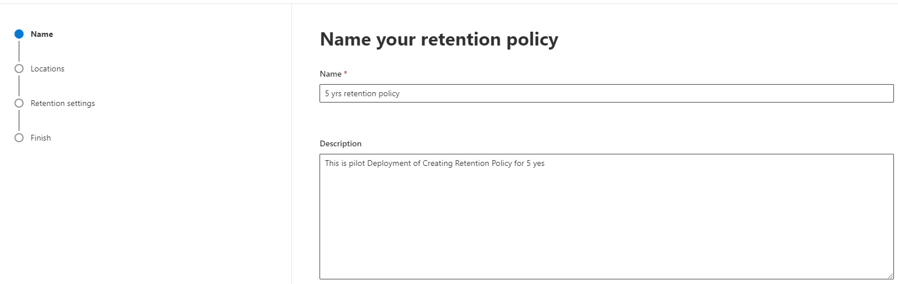



1. **Choose Location to apply the policy** will appear after clicking **Next Button.**
2. Toggle on to Enable the Retention from these apps and click to continue. Or follow along with the screenshot below

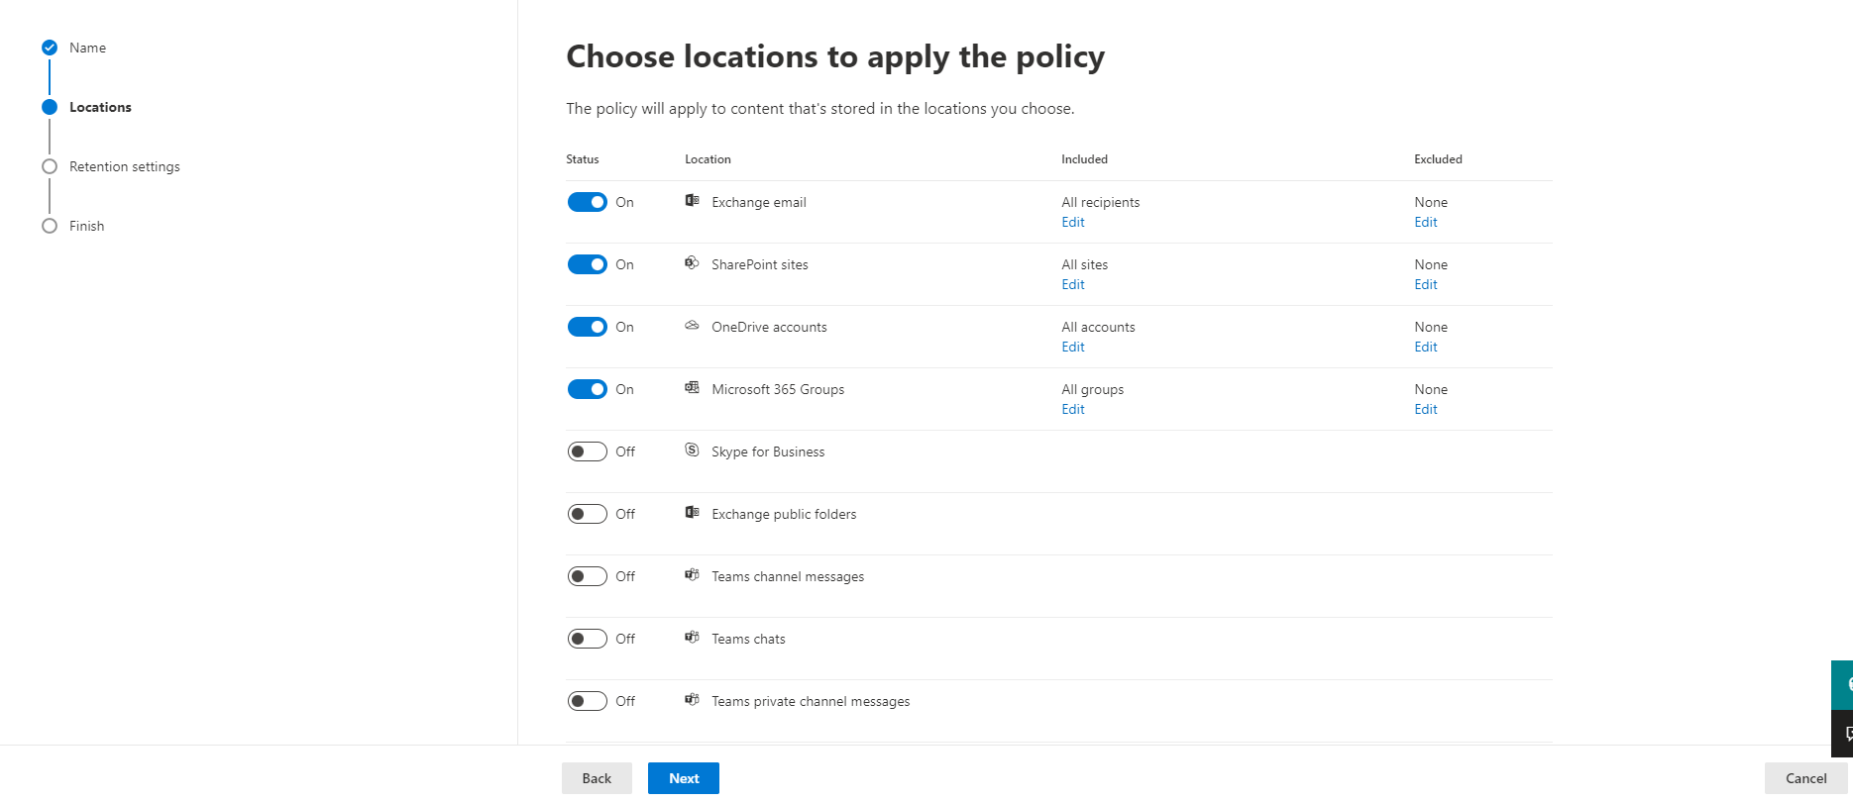

1. Select the **Retention period** and select appropriate option from **start the retention period based on** dropdownbox. For now I have selected retention period for 7years and retention period based on **when items were created.**
2. Click on **Retain items forever** Radio button. Or choose appropriate option according to you requirements.

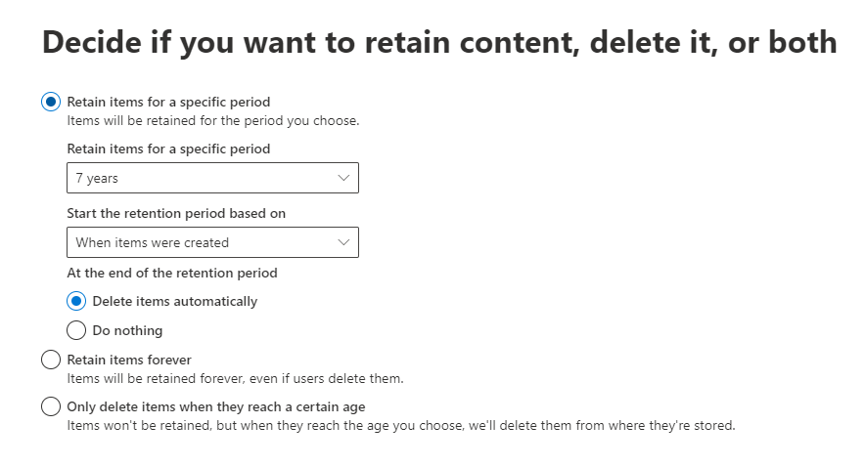



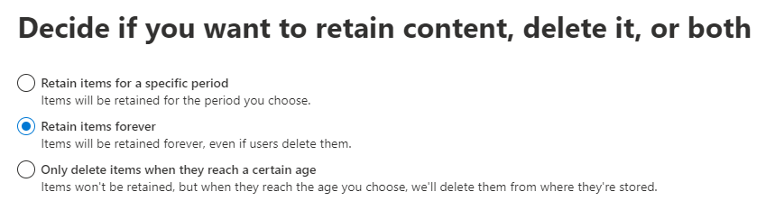

1. Click on **Next Button** to Continue to **Review and Finish section.**

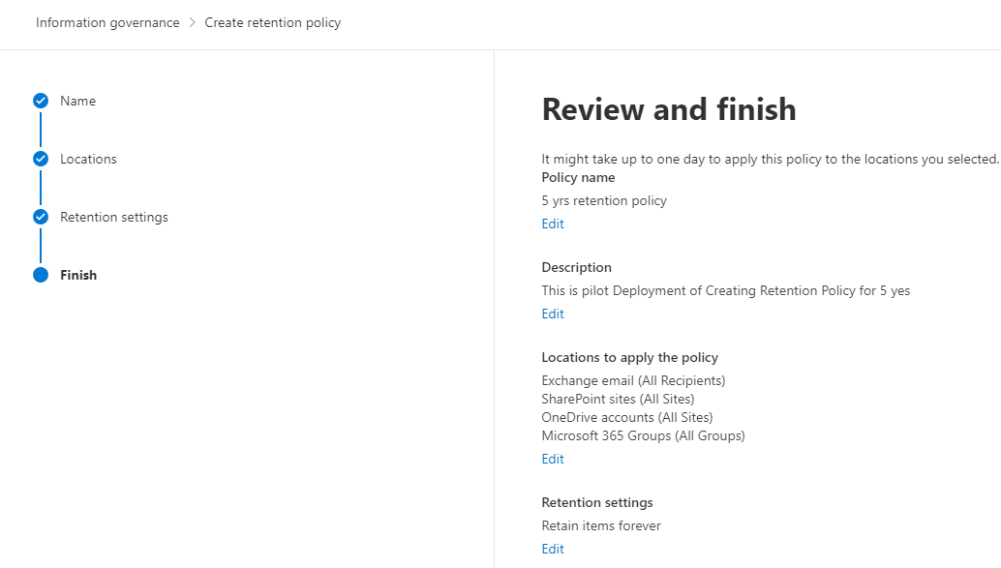



1. And finally click on **Submit button** to complete wizard.
2. Page with Your Policy was created pages will display.

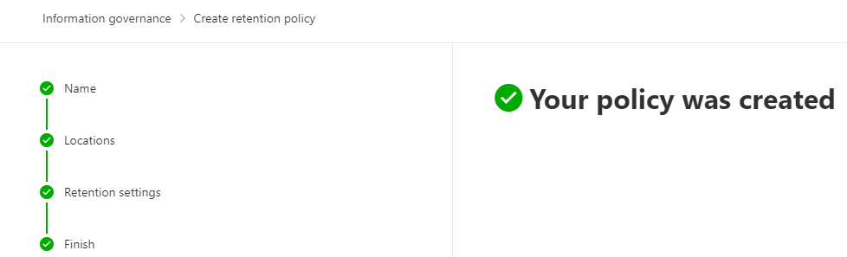

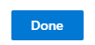

# Information Protection

Information Protection reside inside Compliance center. It is the Vital feature in Microsoft 365 and let helps you to protect Sensitive information whenever it lives, or it travels. We can create a policy that allows users to set the confidentiality for the sensitive information irrespective of anywhere it travels, similarly in Information protection there is another feature where administrator can enforce auto-labeling policy where sensitive information will automatically get encrypted. Thus, we can say that information protection in Compliance center is geat feature for protecting the sensitive information of an organization.

The following step are taken for creating Label & Label police for protecting the Sensitive information of an organization.

1. Go to <https://Compliance.microsoft.com>
2. Provide valid credential to login.
3. After successful login You will see **Home** Screen of Compliance center.

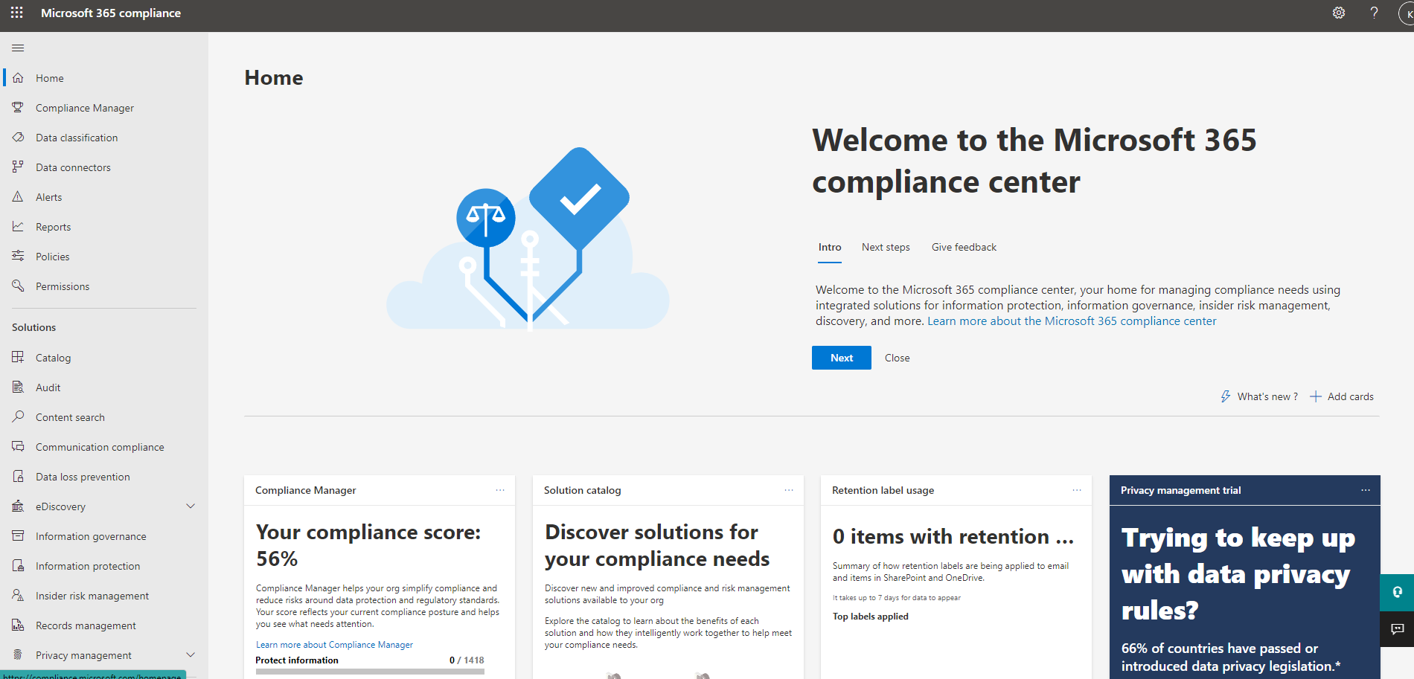

1. On the Left-hand side panel, you will see solution section under that Navigate to **Information Protection** Blade.

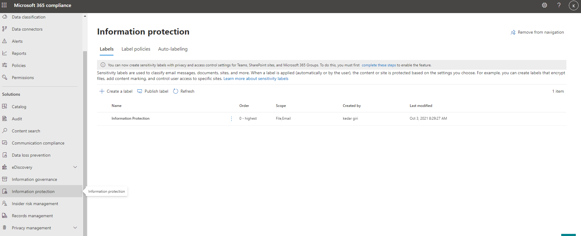

1. After Clicking on **Information protection** Blade Click on **Create a Label.**

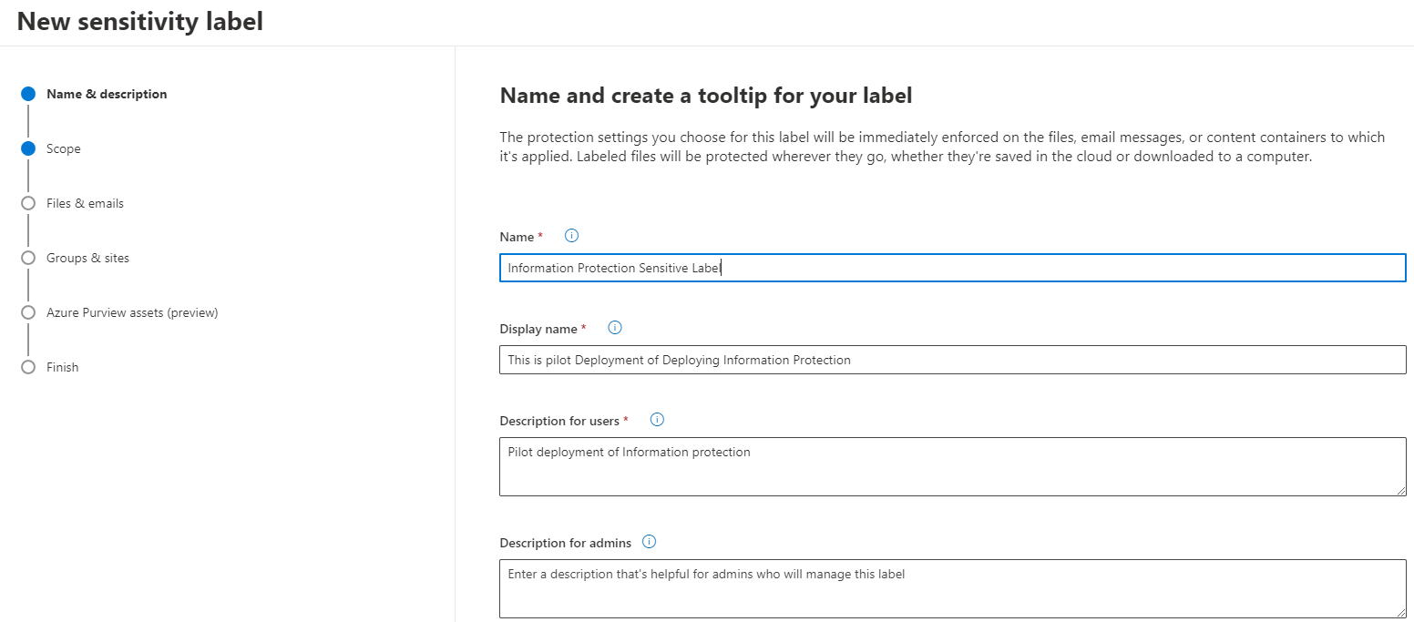



1. After clicking on **Create a Label** will navigate you **Name and Create a tooltip for your label section,** Provide **Name, Display Name, Description for user & Description for Admins** & Click on **Next** Button.
2. After Filling up the Name & Description will navigate you **to Define the scope for this label** Section, Check the related checkboxes & Click **Next** Button or follow along with the Screenshot attached below.

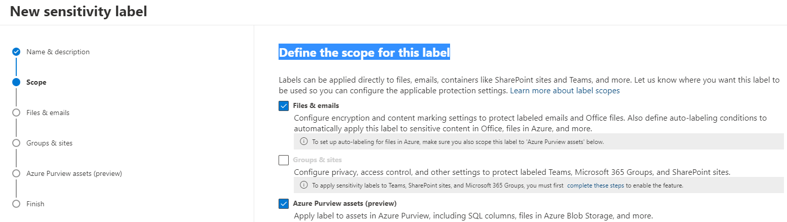



1. After Clicking **Next** Button, You will see **Choose protection settings for files and emails** Section, Check the related checkboxes & click **Next** button or follow along with the screenshot below.

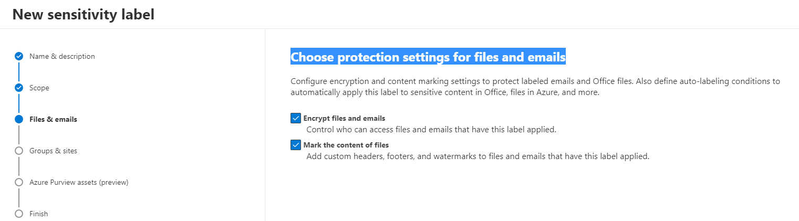



1. **Encryption** Section will open after clicking on **Next** Button.

* You will see bunch of Radio Button for encryption. For now, click on **Configure encryption settings**
* After configuring on **encryption settings** below that you will see **Assign permissions now or let users decide?** Dropdown box. for now select **Let user Assign permission when they apply the label.**
* Below the previous option follow along with the screen shot and click **Next**.

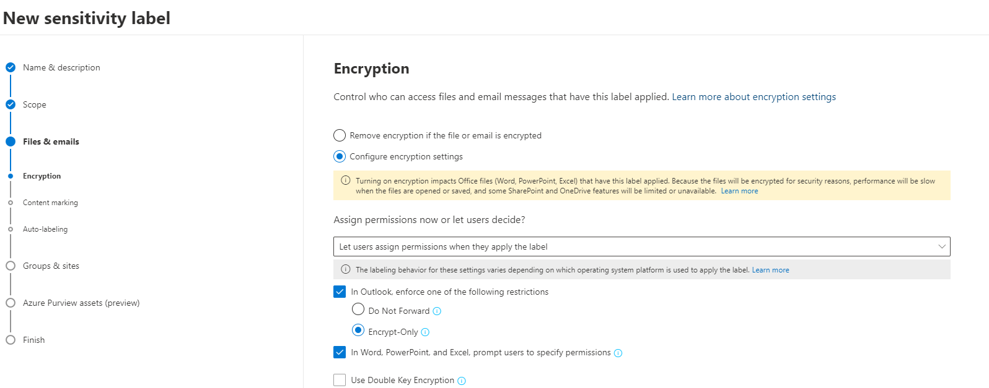



1. After **Encryption** Section there is **Content** **Marking** Section, Toggle content marking to **Enable** and **Add a Watermark** and click on **Next.**

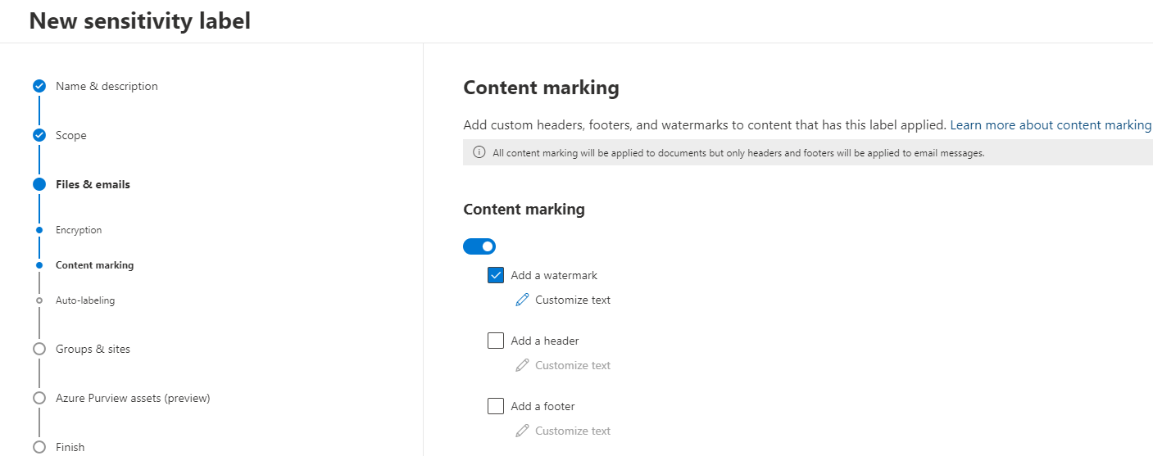

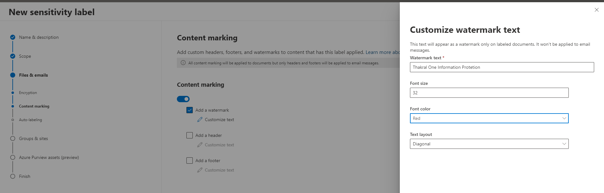

1. After **Content Marking section** will navigate you to **Auto-labeling for files and emails.** For now, we are not enabling click on **Next**, if required you need to Add sensitive Info types or trainable classifiers.

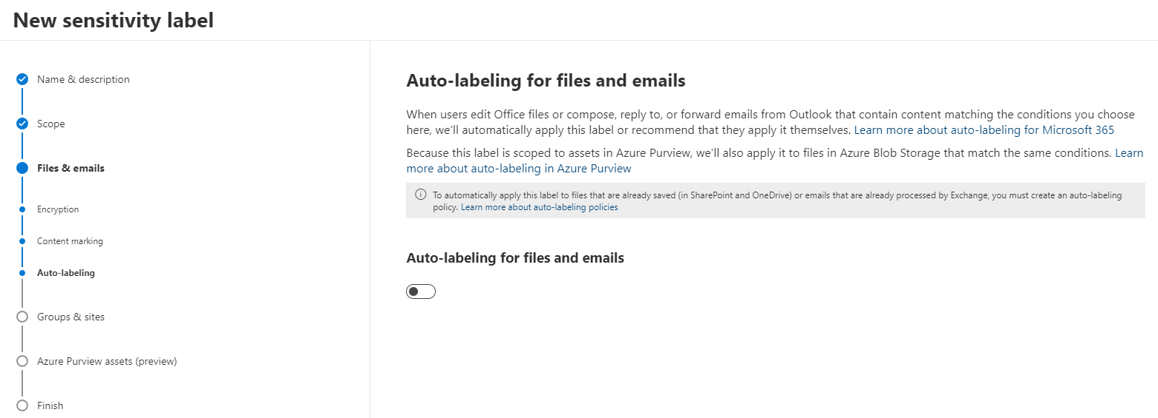



1. Clicking on Next will navigate you to **Define protection settings for groups and sites** Leave as it is and again click on **Next** button.

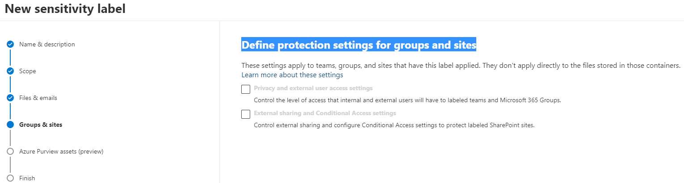



1. Again, Repeat same process Click on **Next** on **Auto-labeling for database columns** Section.

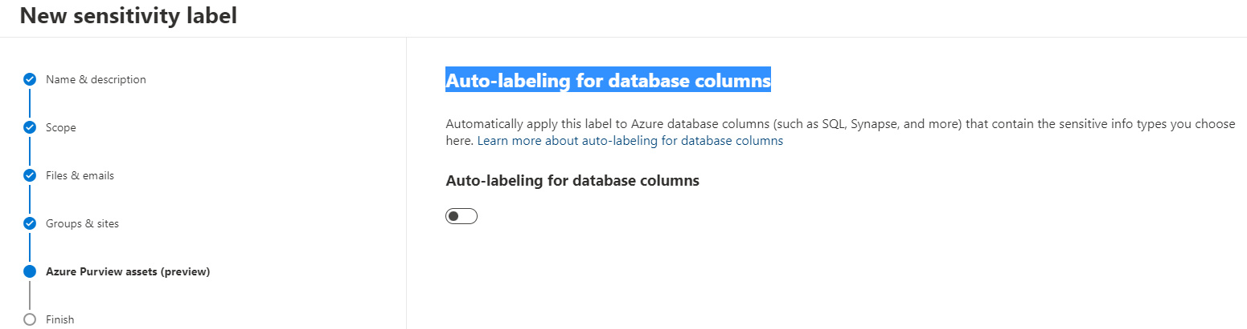



1. Review the policy setting on **Review your settings and finish** and click on **Create Label.**
2. Successful completion of the label will Look exactly like screenshot below, Click on **Done** button.

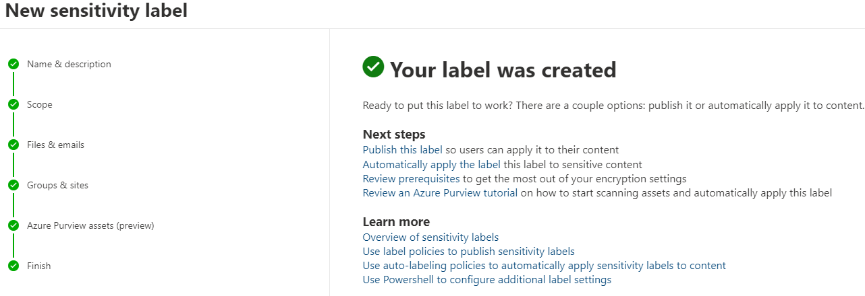



1. After creating **Label,** we need to publish label for that we need to locate and click the label we just created.

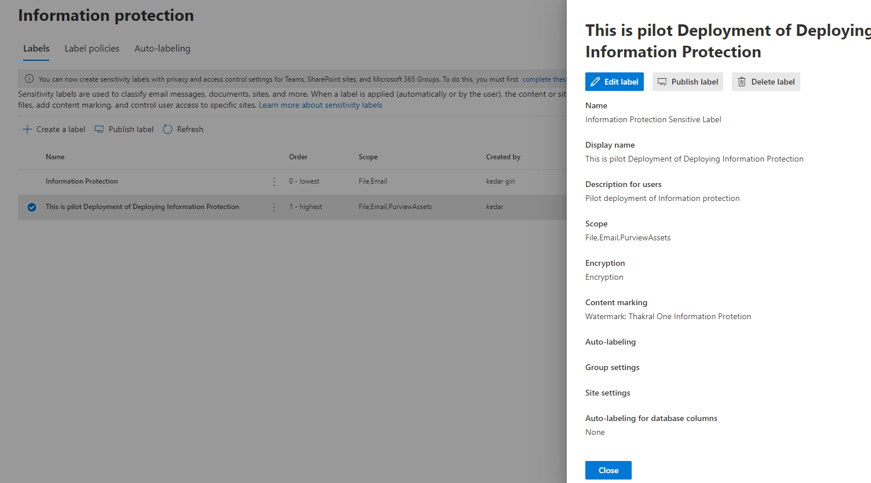

1. Click on **Publish label** will navigate you to **Choose sensitivity labels to publish.**

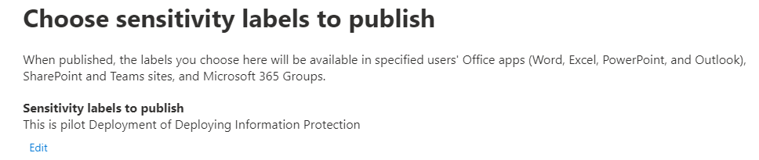



1. Click on **Edit Link** below **Sensitivity labels to publish** and select the label just created and Click on **Add** & Click **Next** or follow along with the screenshot**.**

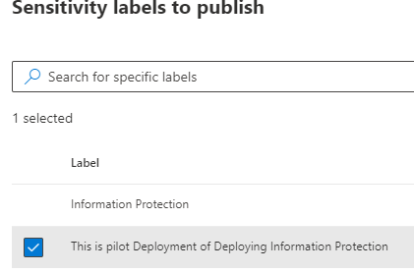

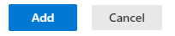

1. After clicking **Next** **button** will navigate you to **Publish to users and groups** Section. Select the desire Users & groups to enforce policy & Click **Next**.

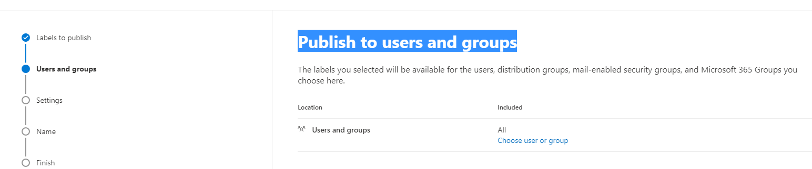



1. After successful configuring the **Publish to users and groups** Section, you have **policy setting** to enable or disable according to your requirement. For now we are leaving as it is.

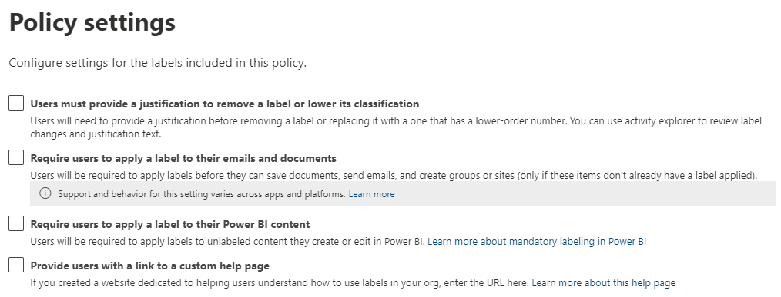



1. Completion of **policy setting** settings will navigate you to **Apply a default label to documents​.** Select the **Default label to document** or follow along with the screenshot below.

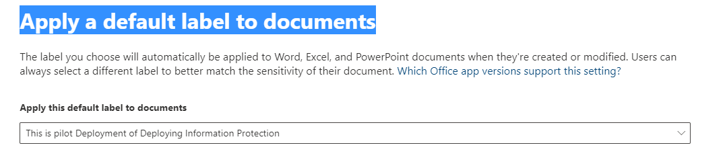



1. Provide **Name & Description** for the policy after the completion of **Apply a default label to document.**

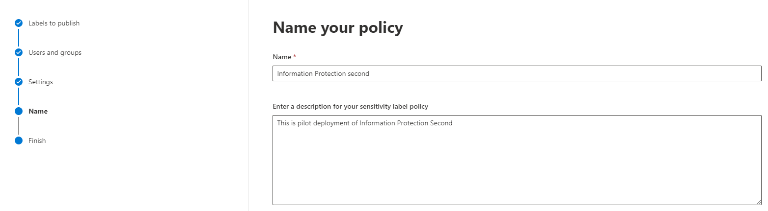



1. Finally, after creating **Name & Description** will navigate you to **Review** & **Finished** sectionclick on **submit**

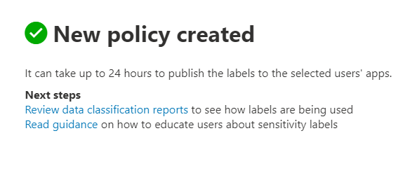



1. Successful Policy creation look Exactly same as above & click on **Done**.
2. To Check whether the Policy is affecting in client machine or not. Open word to and check sensitivity.

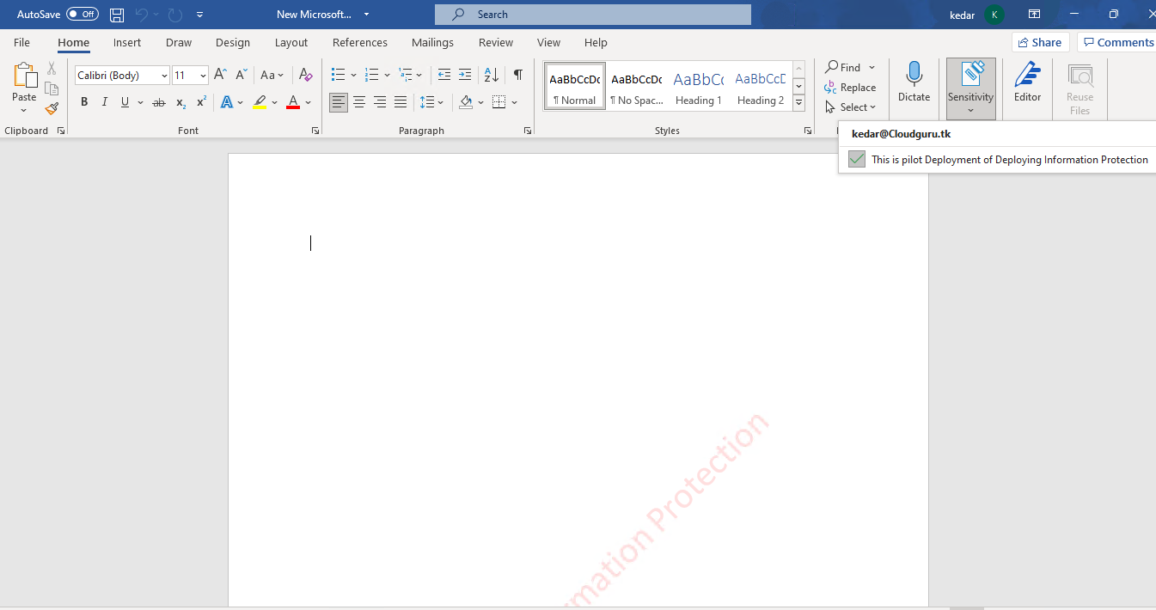

# Data Loss Protection

Data loss protection is the vital feature that resides in Compliance center. It helps an organization to protect their sensitive data. It also helps to prevents inappropriate sharing organizational confidential data like (Financial data, Credit Card details, health record & many more) to leak out of organization. An organization or IT admin need to create a policy to prevent such inappropriate sharing, the approach is known as Data loss prevention (DLP).

The stepwise process of creating Data loss Protection (DLP) are elaborated below:-

1. Go to <https://Compliance.microsoft.com>
2. Provide Valid login credential to login.
3. Successful login will navigate you to Compliance center dashboard.

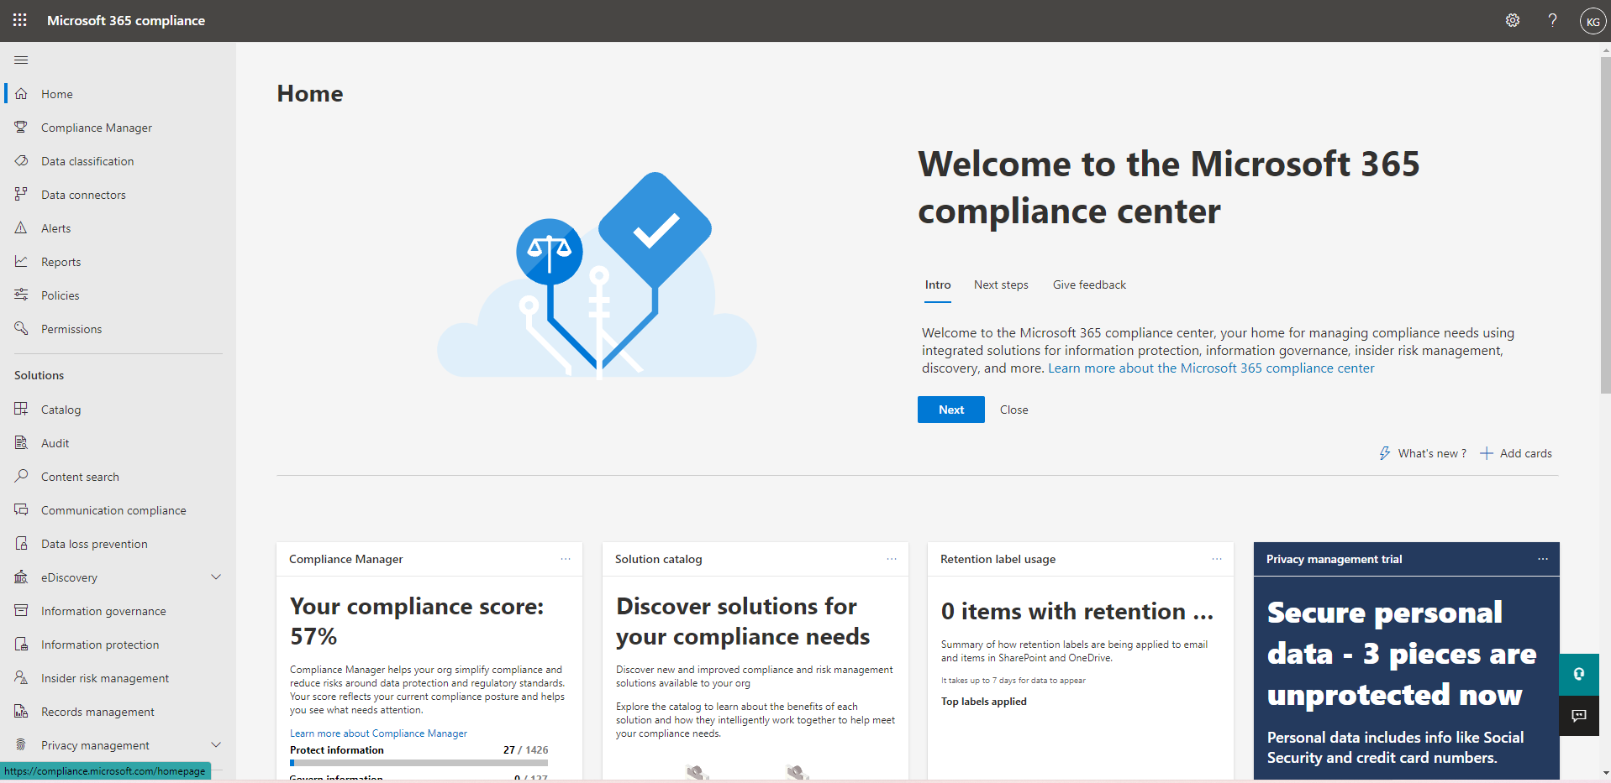

1. Locate the **Solution** section and click on **Data Loss Prevention blade**.
2. Clicking on **Data** **Loss** **Prevention** Blade Will Navigate you to **Overview** section and Click to **Policies** Navbar.

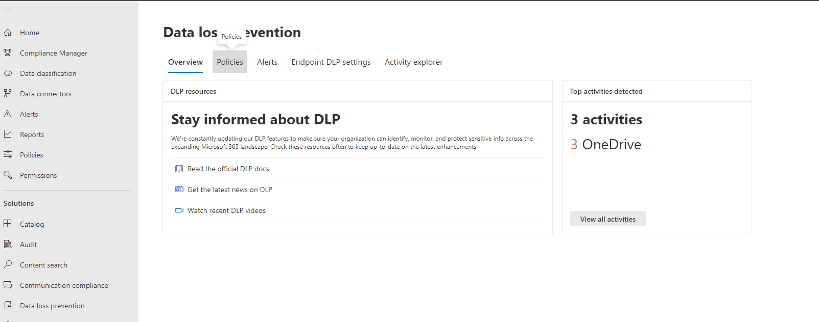

1. After Clicking on **Policies** navbar Click on **Create Policy**, will navigate you to **Data loss prevention** Wizard.

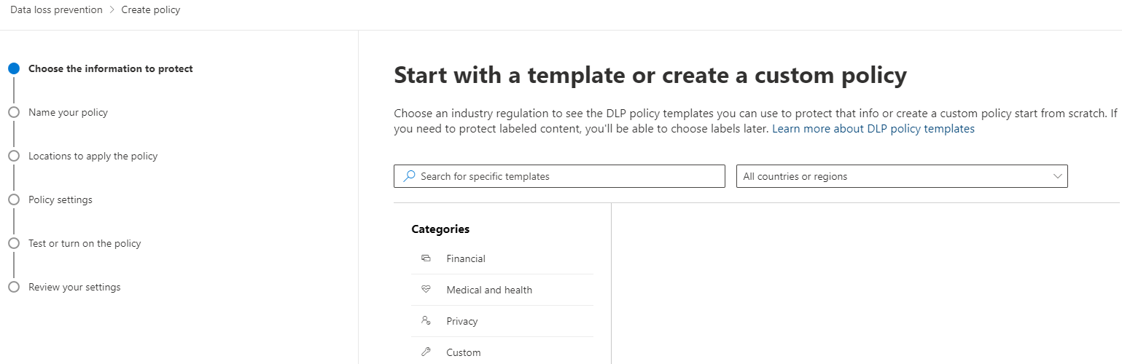



1. If you want to go with existing template, click the template under **Categories** section or else click on **next** button.
2. After clicking **Next** button Provide **Name your Policy, Name** & **Description > Next.**

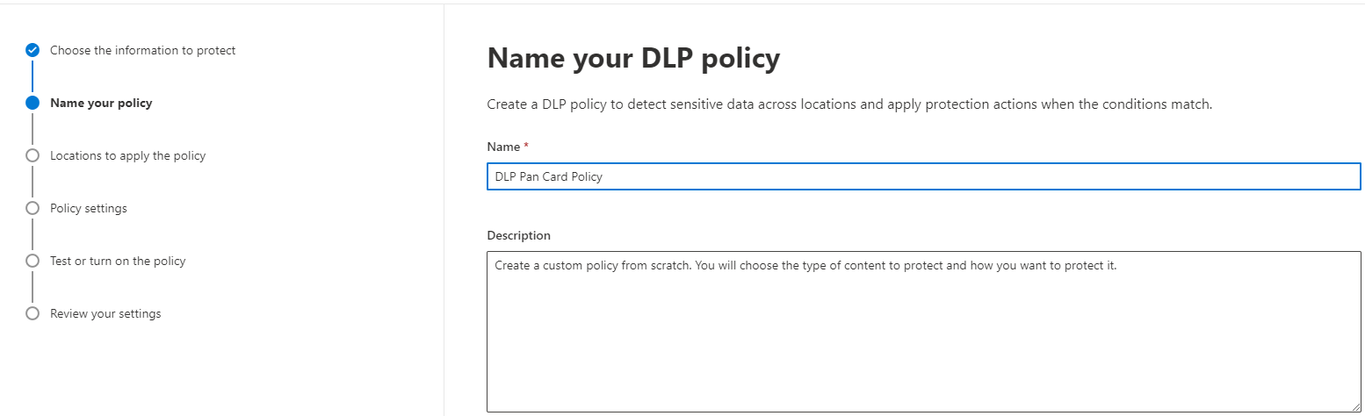



1. Select or **Choose Location to apply the Policy > toggle** switch according to your requirement & Click **Next**, or else follow along with the screenshot below.

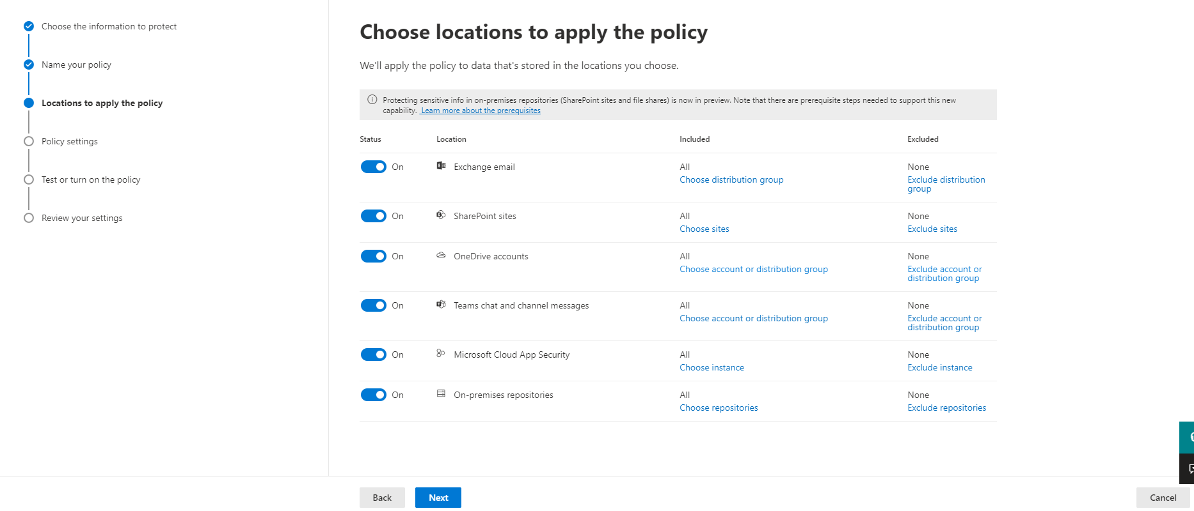

1. After **choosing the Location to apply,** will navigate you to **Define Policy settings &** Click on Next button**.**

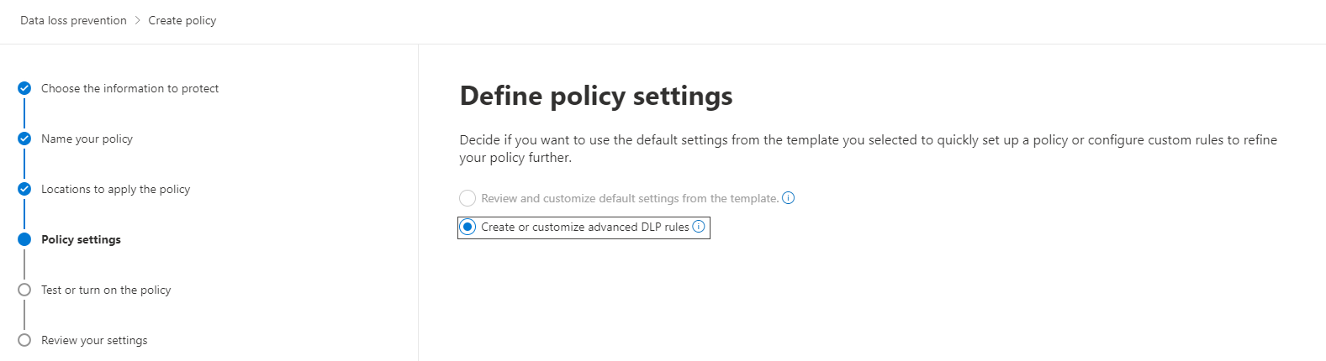

1. In **Customize advanced DLP rules** you need click on **Create a rule.**

* On **Create Rule** section Provide **Name & Description.**

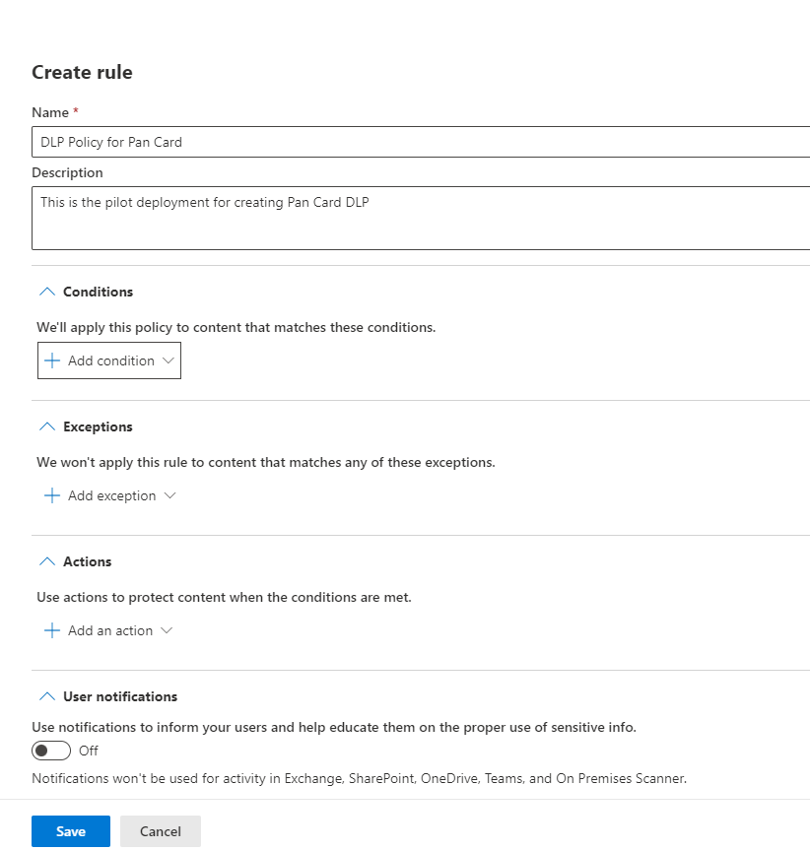

1. Click on **Add Condition Dropdown** > **Content Contains**

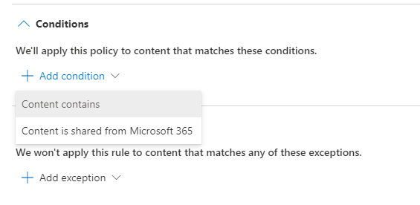

1. Click on **Add > Sensitive info types**

* Clicking on **Sensitive info will open** side panel **Sensitive info types** from the Right side of screen
* Select the **Sensitive info types** From the **Sensitive info types section** and click on **Add button,** or follow along with the screenshot.

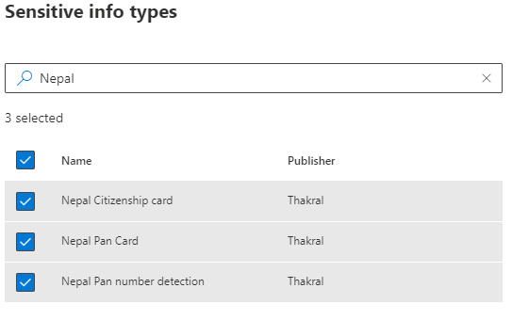

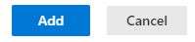

1. After **Adding** the **sensitive info types** click on **Exception to** or click on **Action section.**

* Click on **Add an Action Dropdown > Restrict access or encrypt the content in Microsoft 365 locations.**

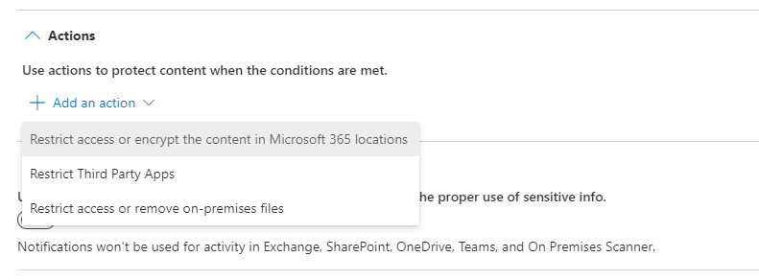

* Check the Checkbox **> Restrict access or encrypt the content in Microsoft 365 locations.**
* Click on **Block only people outside you organization,** or follow along with the screenshot below.

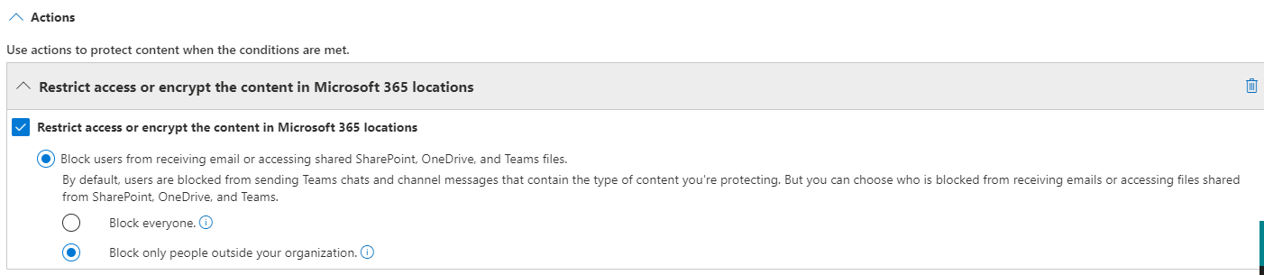

1. After configuring the **Action section** Click on **User Notification Section.**

* Toggle the **User Notifications switch** to On
* Check the **Customize the email text** and add the desire text according to your requirement.

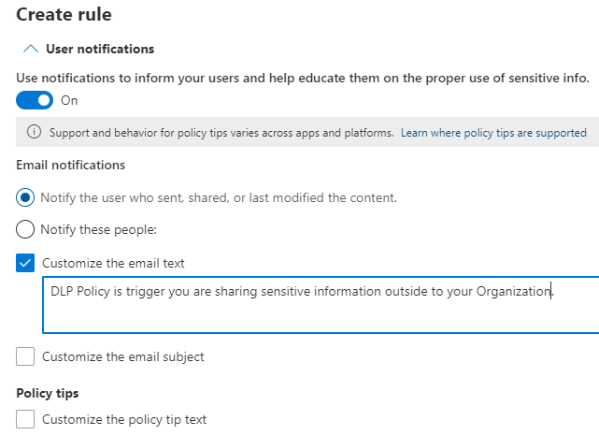

1. After Creating **User Notification** Click on **User overrides** section or Click on **Incident** report.

* **Use this severity level in admin alerts and reports > Medium.**
* **Send email alerts to these people > On**
* Click on **Add or Remove people.** Or follow along with the screenshot.

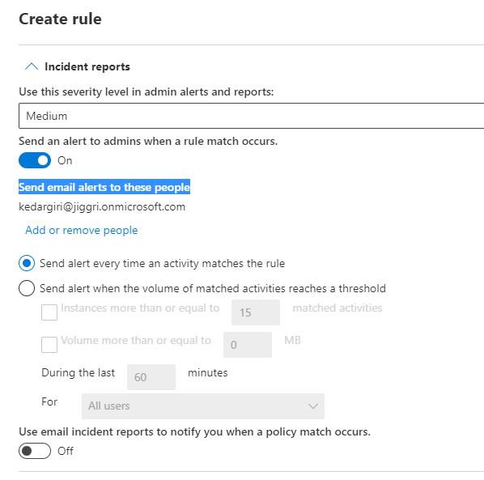

1. Finally, At Additional options set Priority level according to your requirement & Click on **Save.**

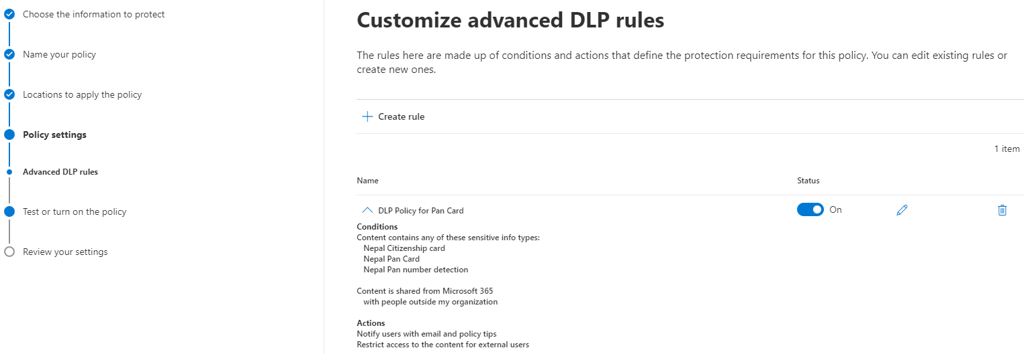



1. After Creating Rule click on Next button.
2. Clicking on **Next** Button will navigate you to **Test or turn on the policy** Section**.**

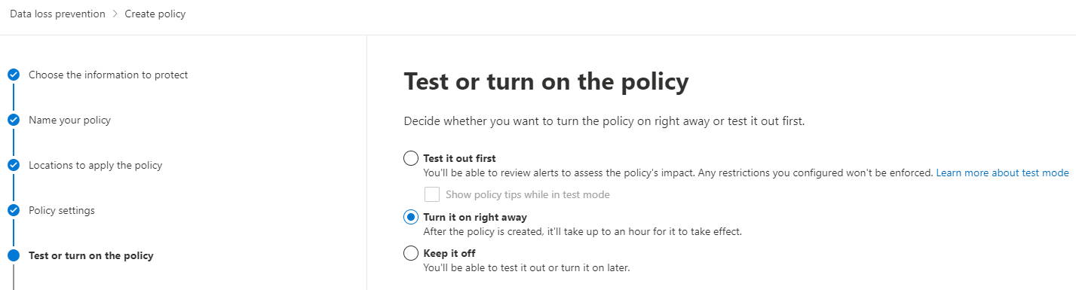

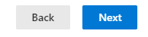

1. Click on **Turn it on right away** Radio button and again click on **Next button.**
2. At last you will see **Review your Policy and Create it section & click on submit to create policy.**

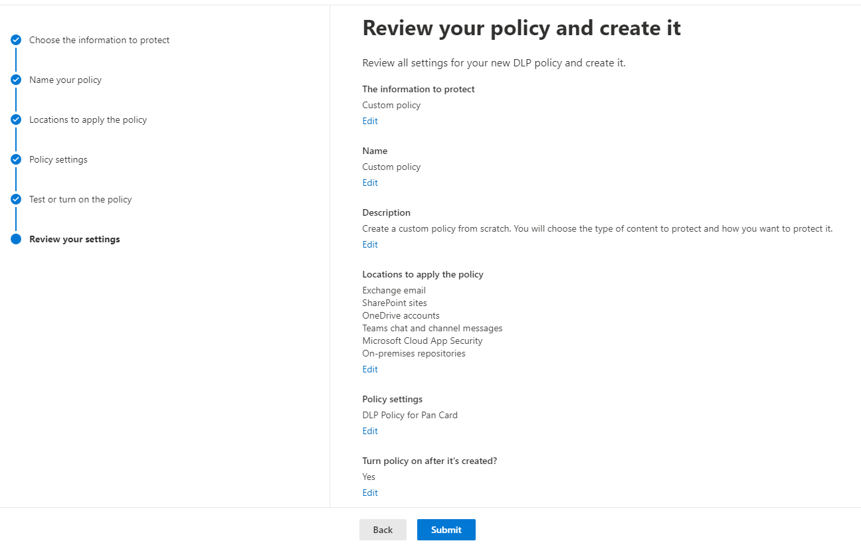

1. After successful completion of creating **DPL policy** lets check whether the policy is affected in organization or not.
2. Every time you send confidential information to outside your organization the mail should be encrypt shown below.

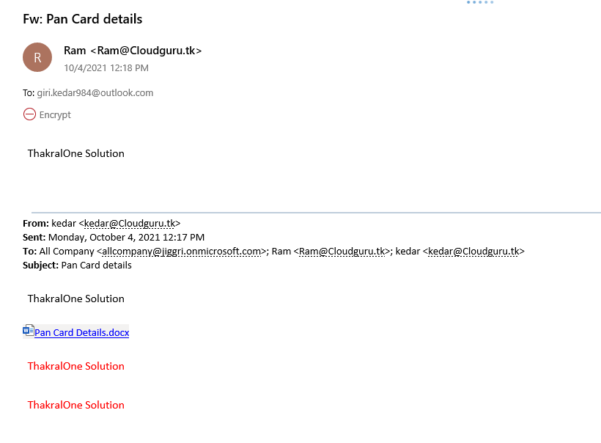

# Sensitive Info types

Sensitive Info types are the Patterns that are used to identity the information that reside inside the organization. some examples of sensitive info are (Credit card number, Bank account number, financial document & SSF etc.).

The step-by-step process of creating Sensitive info types are mentioned below: -

1. Go <https://compliance.microsoft.com>
2. Provide valid credential to Login
3. Successful login will navigate you to Compliance center Dashboard.
4. Click on **Data Classification** blade

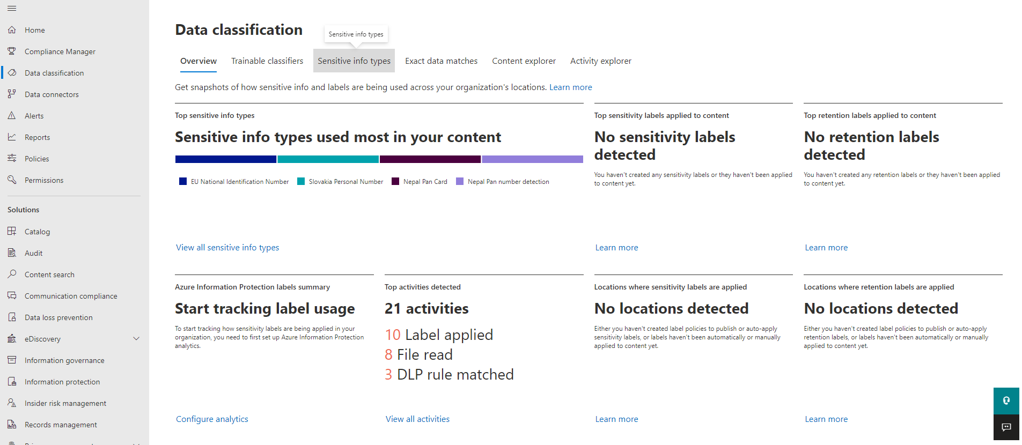

1. After Clicking on **Data Classification Blade** will navigate you to **Overview** section of Data classification
2. Click on **Sensitive info types navbar > Create sensitive info types**

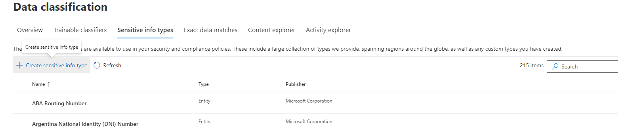

1. **Name your sensitive info types** sectionwill open and Provide the related information & Click on **Next**.

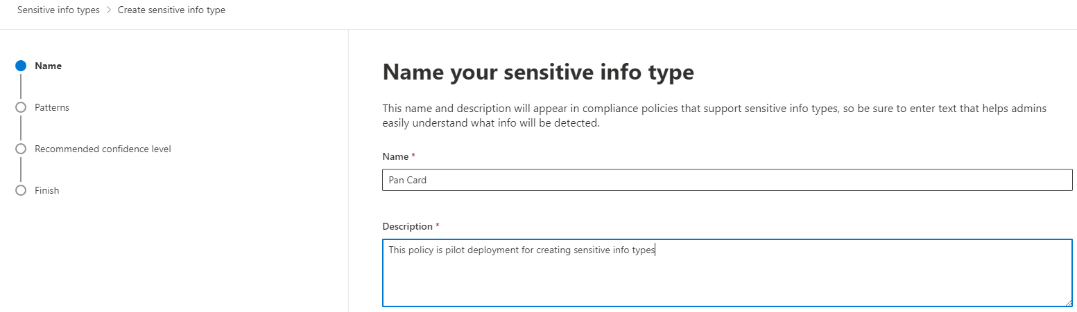



1. After click on **Next** will navigate you to **Define patterns for this sensitive info type >** **Create Pattern.**

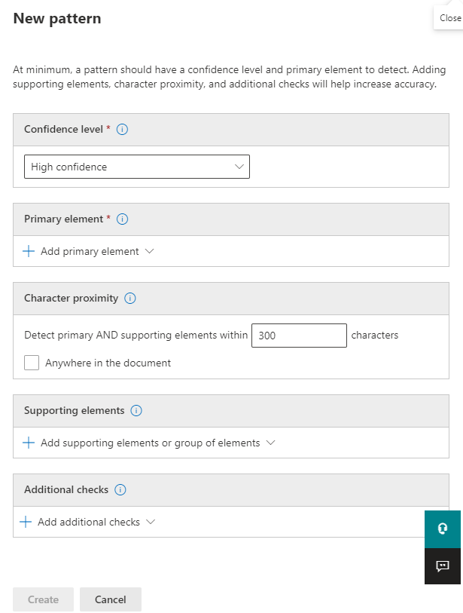

1. Set the confidence level > Medium
2. Click on **Add Primary Element > Regular Expression.**

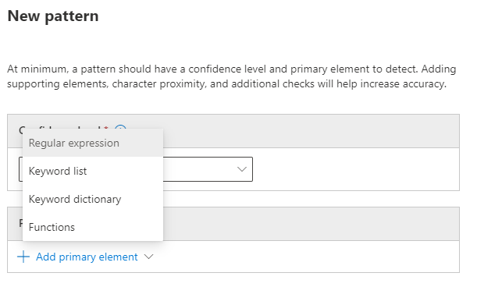

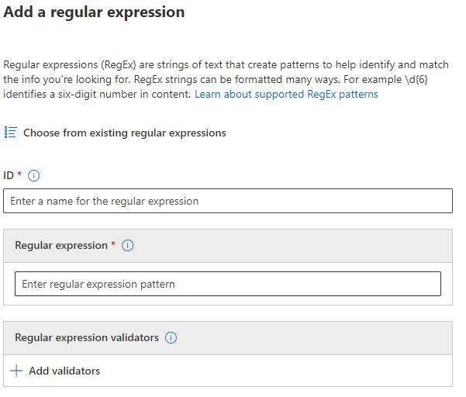

1. Provide ID & Regular expression and click on **Done button**. Or follow along with the screenshot.

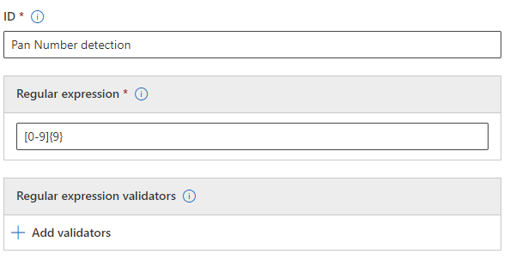

1. After creating **Primary element > Regular Expression,** Set the Character Proximity & Click on **Anywhere in the Document** Checkbox.

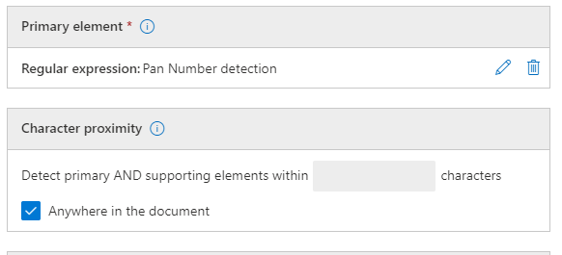

1. Locate the supporting elements > **Add Supporting elements or groups of elements >keyword list**

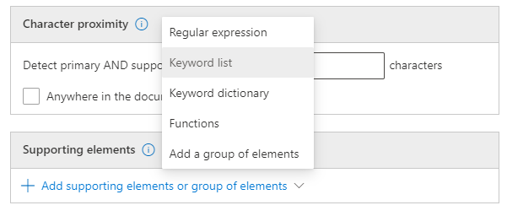

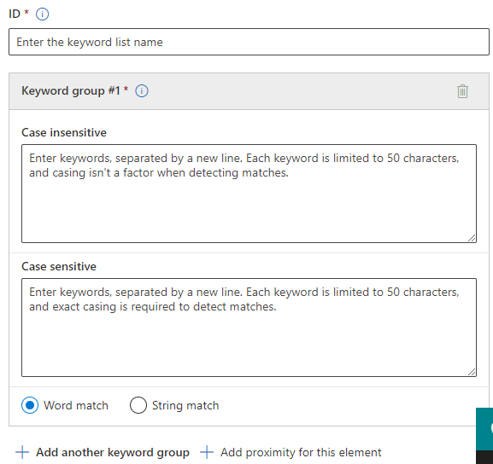

1. Provide the Corresponding details & click on **Done** > **Create** or follow along with the screenshot.

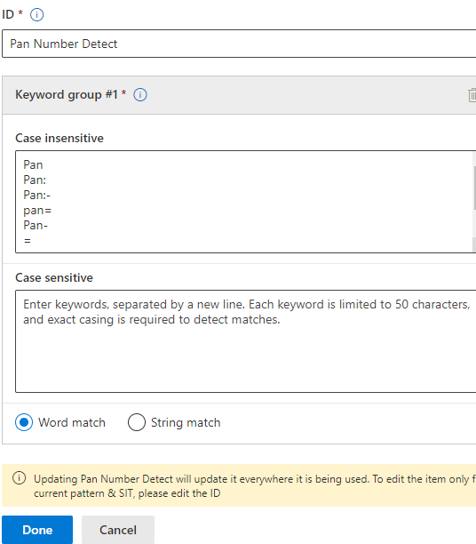

1. After **Defining the patterns for this sensitive info types > Next.**

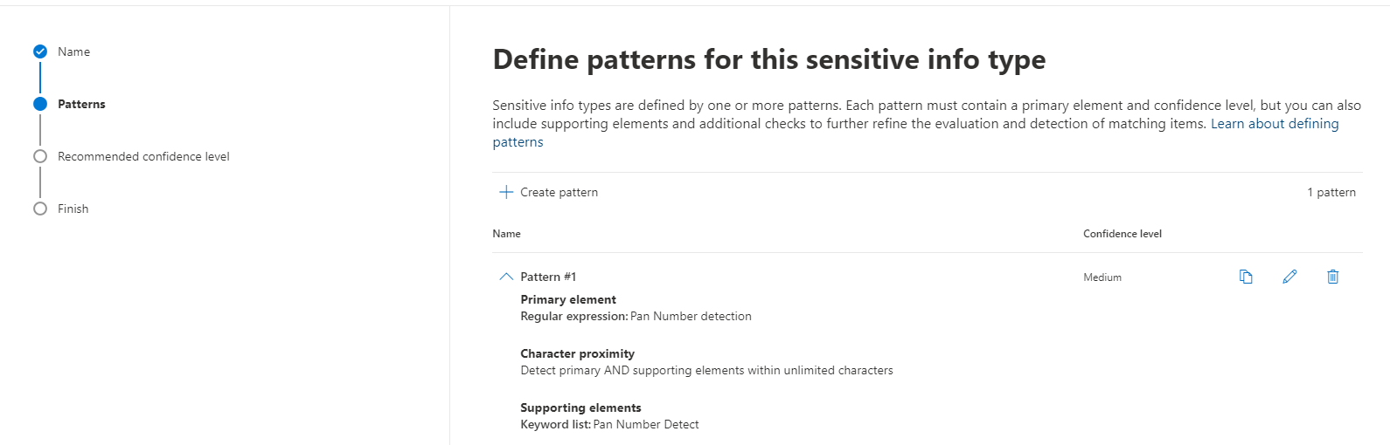



1. Set the Confidence level according to your requirement & click **Next**. Or follow along with the screenshot below.

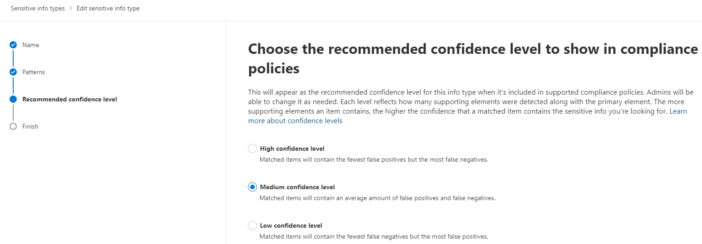



1. Finally, **Review settings and finish** will appear > **Save.**

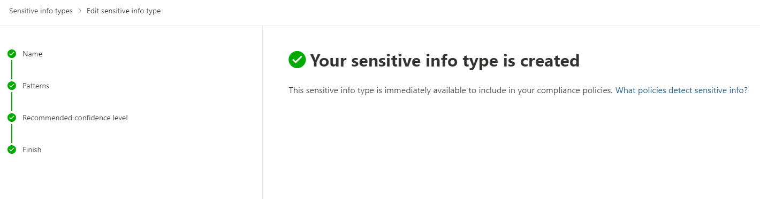

1. Click on **Done.**
2. To Check whether it work or not there is feature for test.
3. Go back to the policy you created, click on policy you created.
4. Clicking on Policy will open side pane with the name of policy.

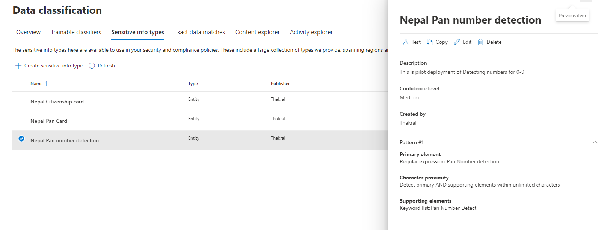

1. Click on **Test** button > **Upload File >** Locate the files > **Test Button**

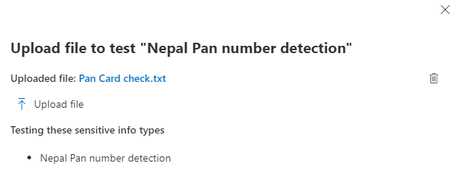



1. Finally, if the file consist of pan card details it will show the result screenshot below.

